**CLASS 1: (Day 39)**

Create a New Maven Project

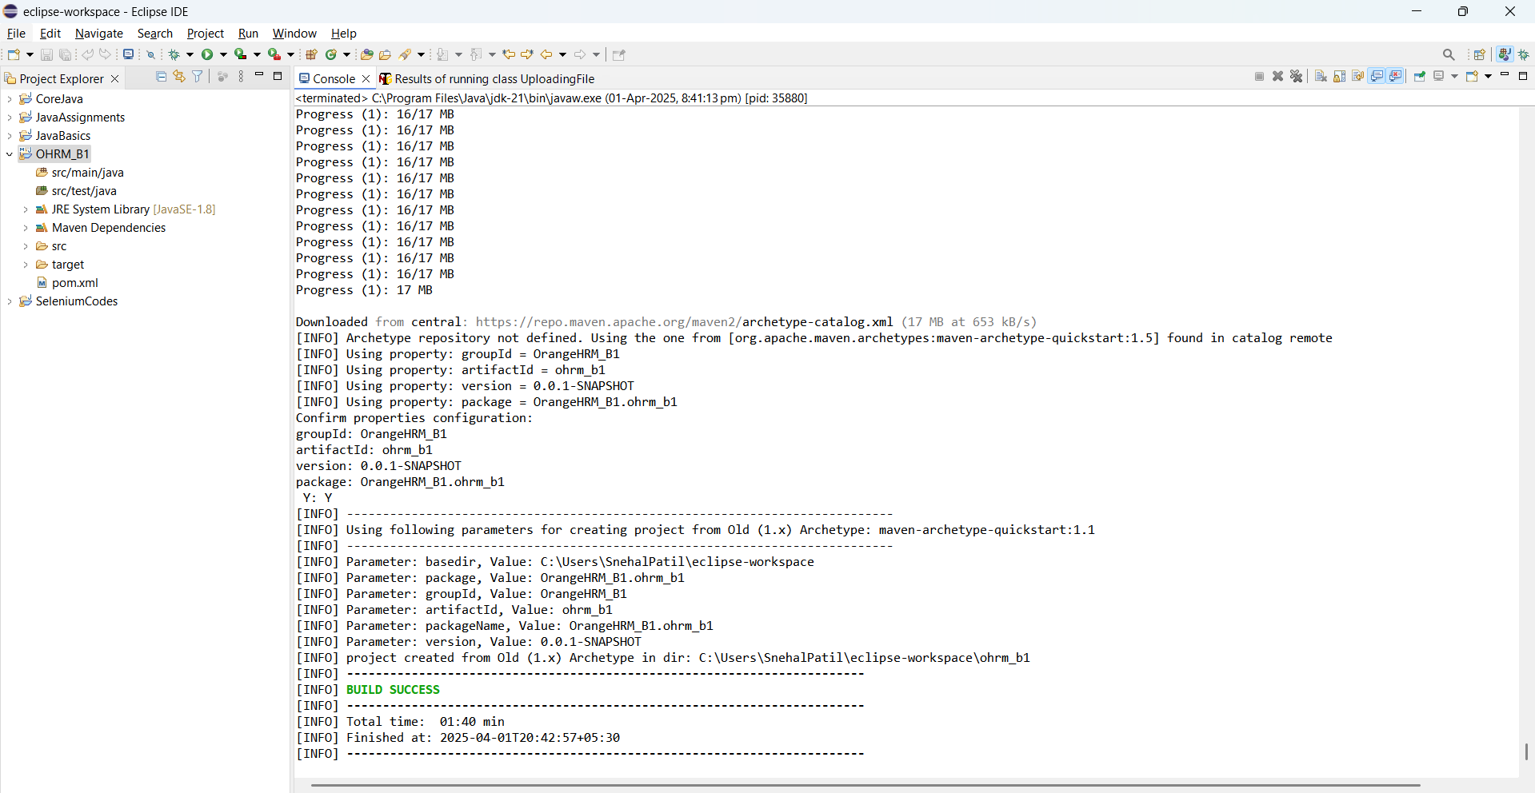

Package format :  
com.orangeHr.qa.testcases

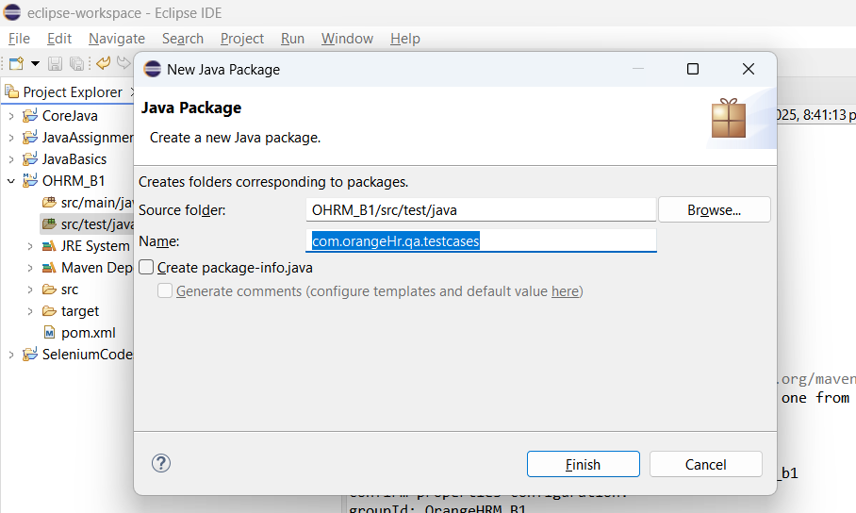

Configure TestNG and Selenium libraries / add dependencies in POM file

<https://mvnrepository.com/> >> Selenium Java

Selenium :

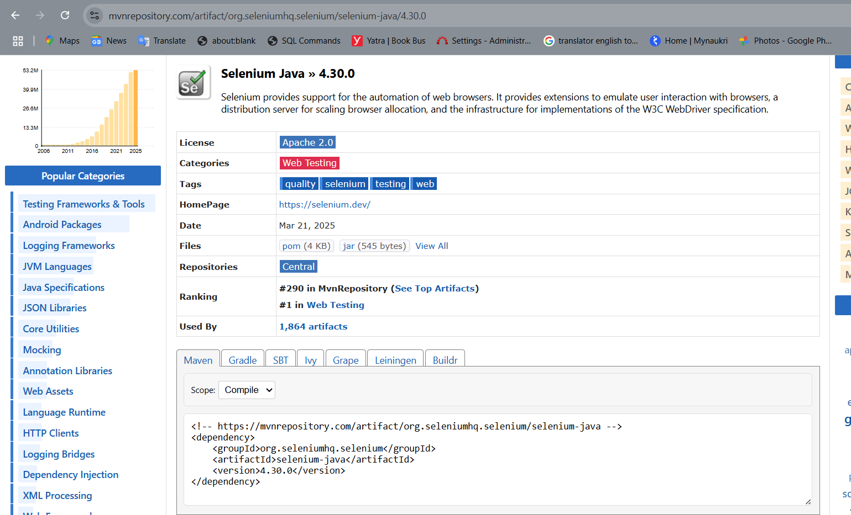

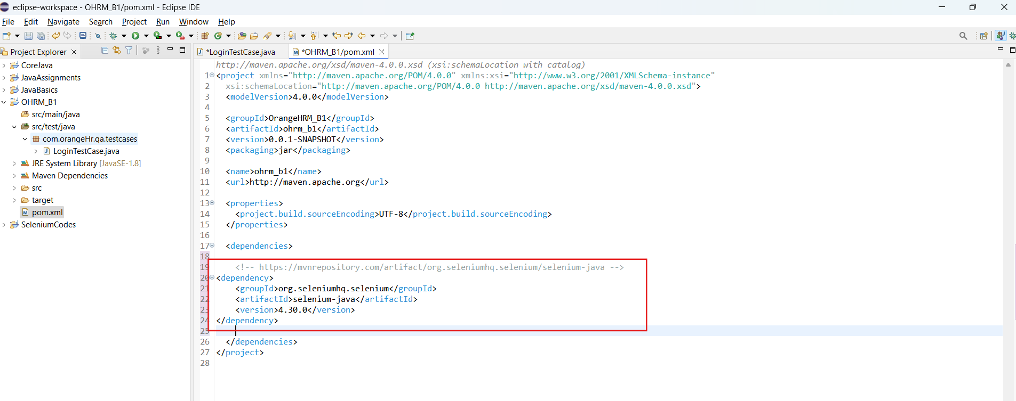

TestNG :

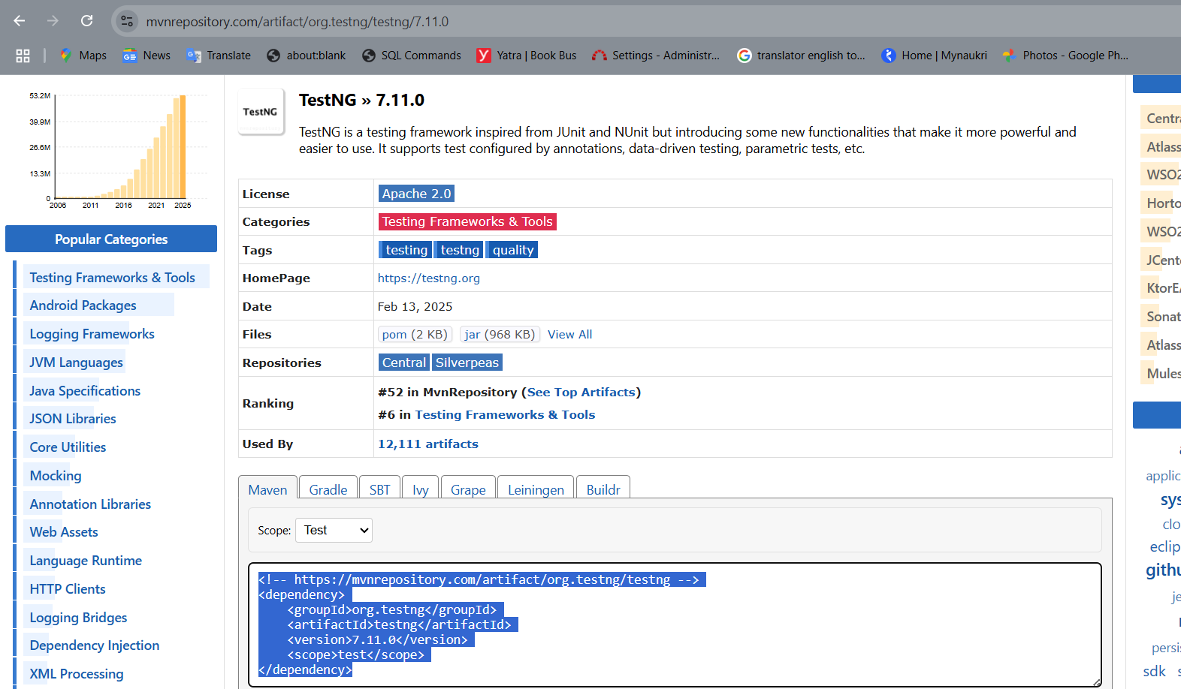

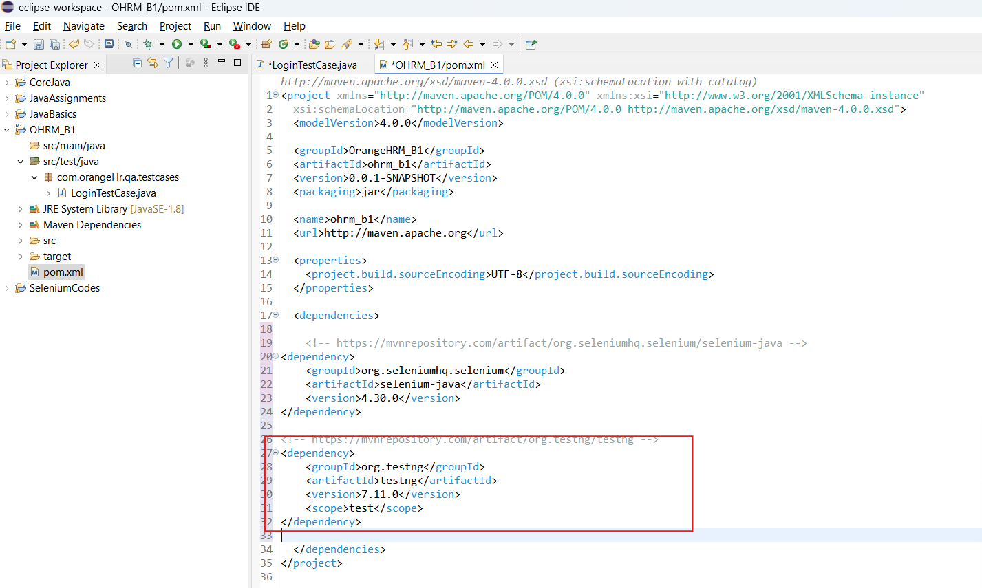

Eclipse:

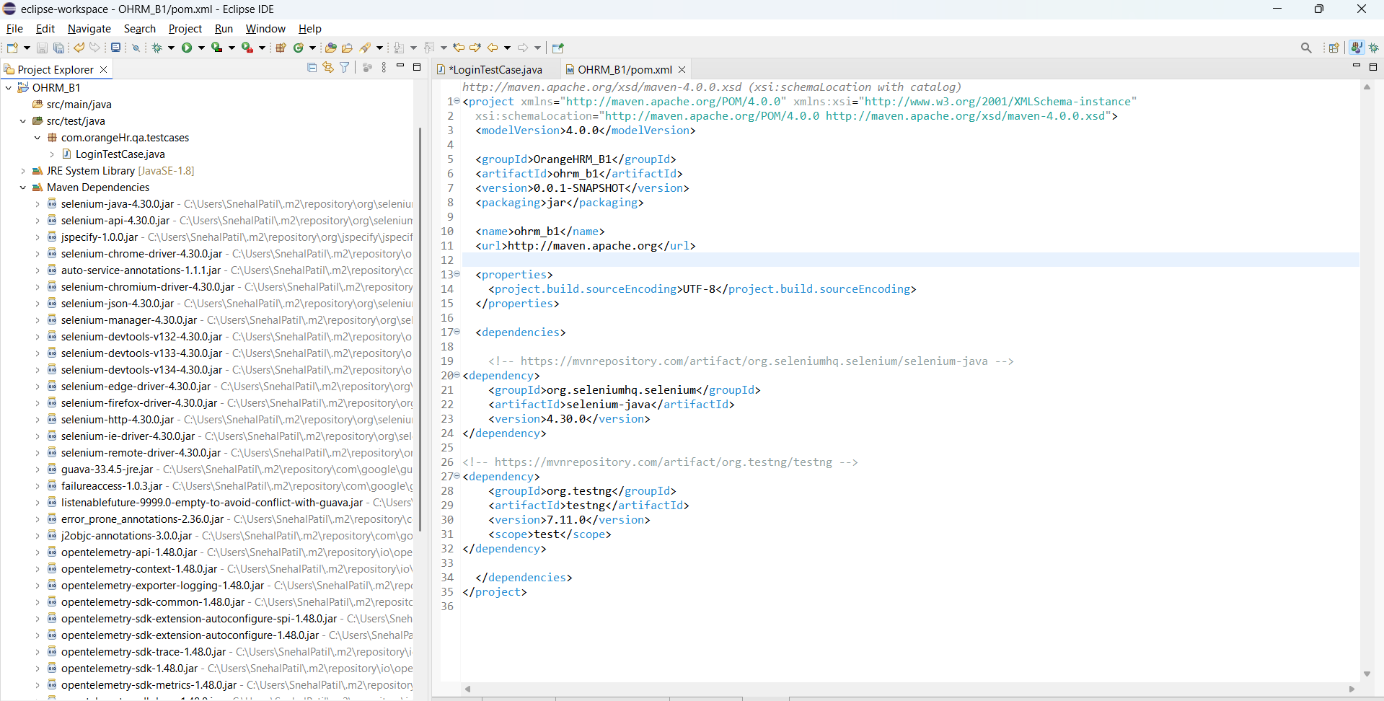

Login ->

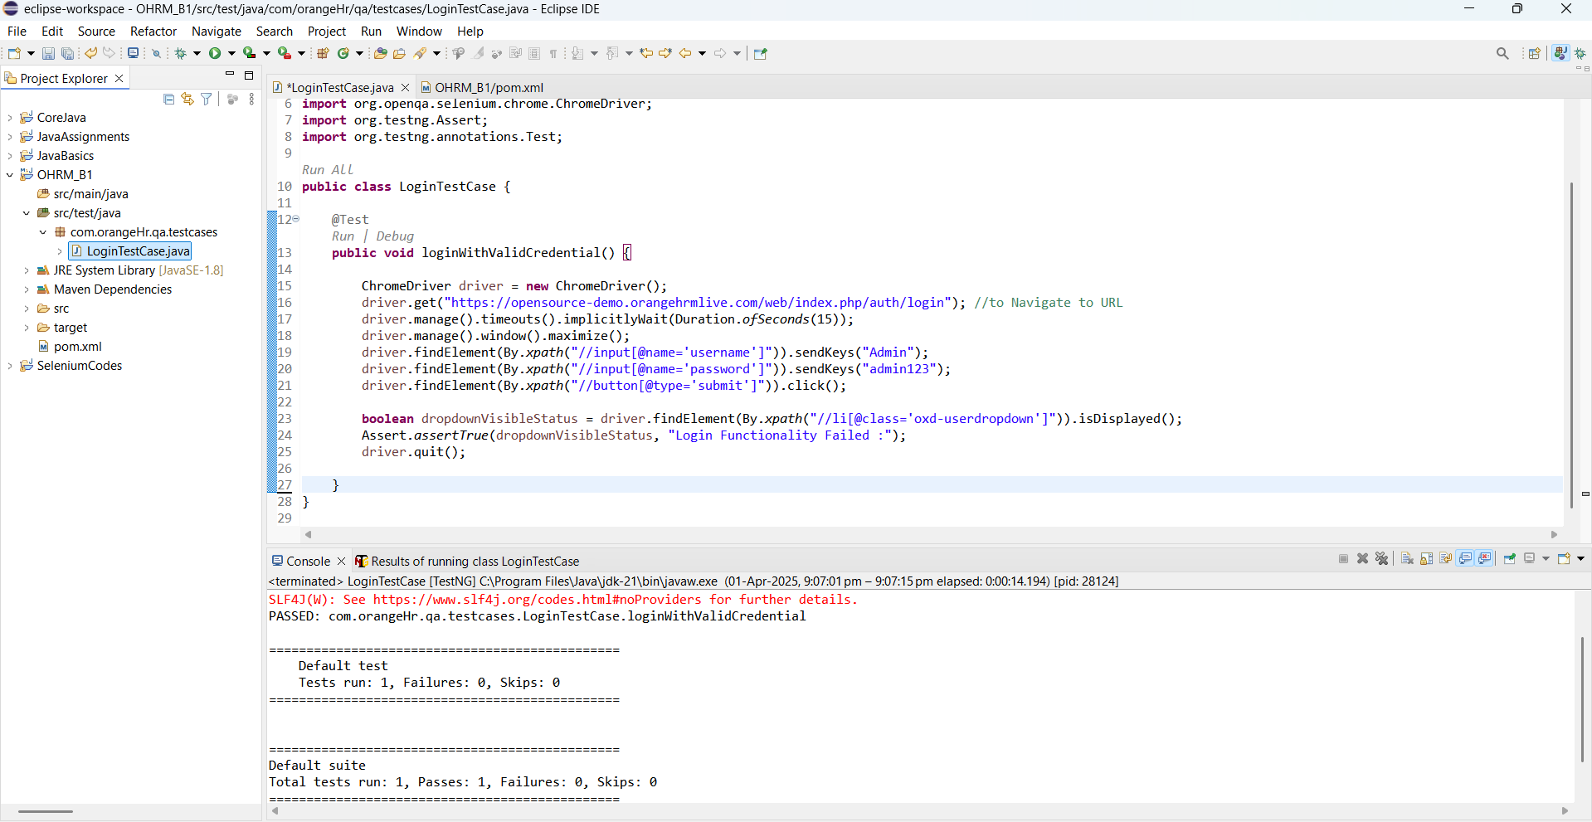

Valid and Invalid Credentials Test cases :

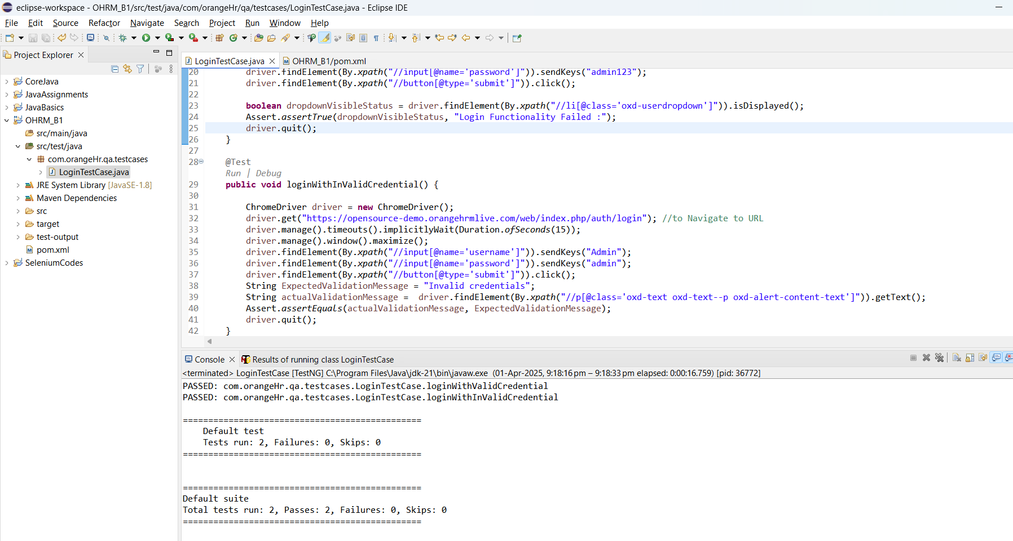

In case of multiple test cases failed -

1. Order of execution of the test cases is not maintained.
2. Browser is kept open

To overcome these 2 issues ->

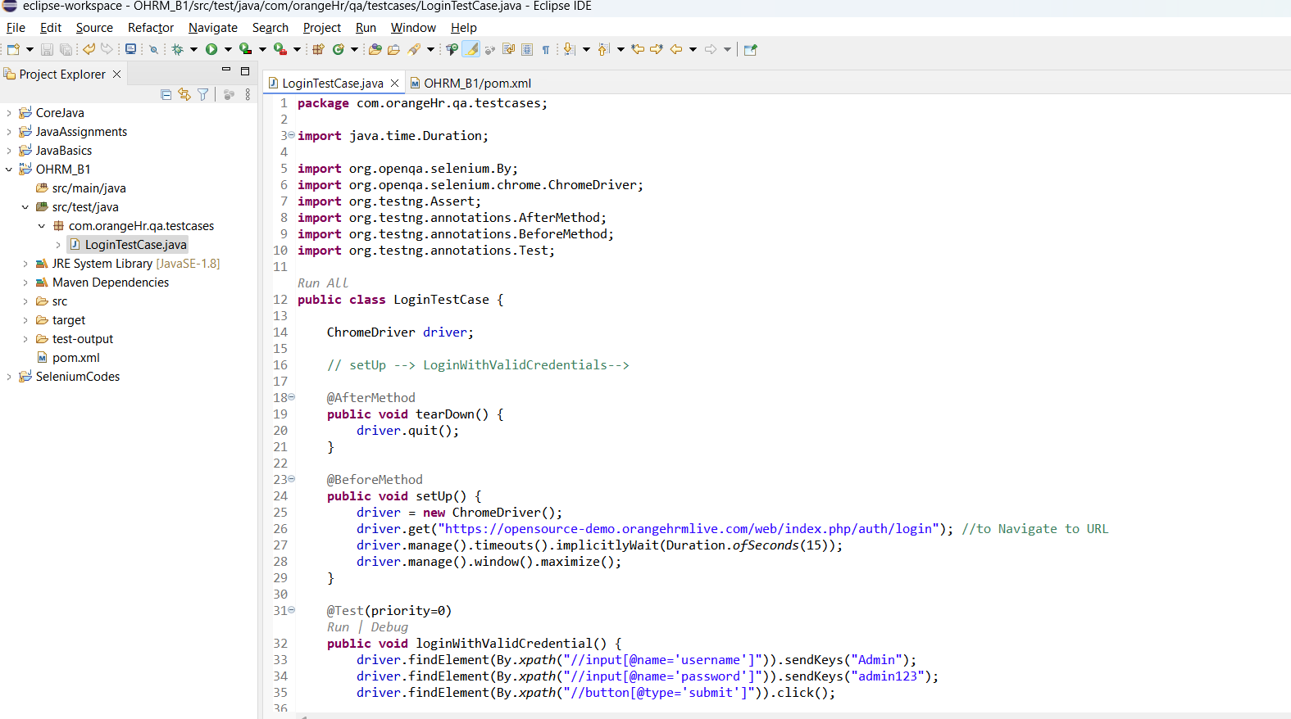

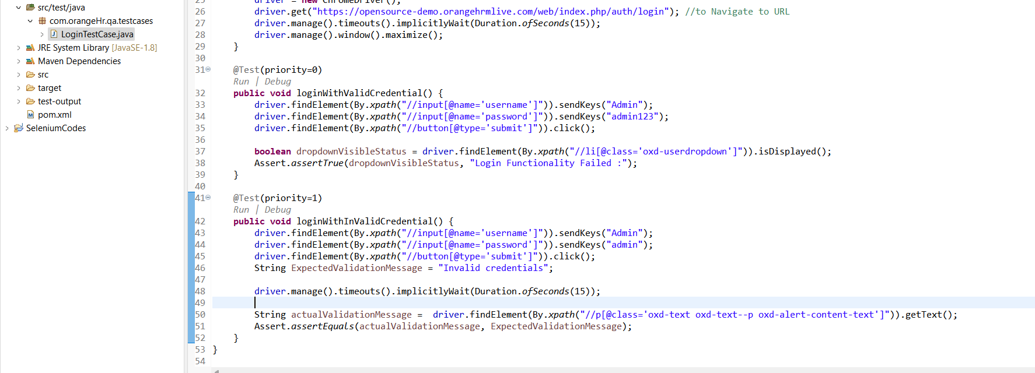

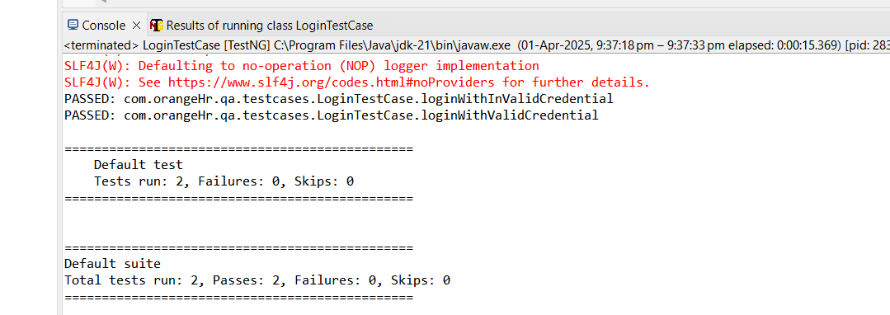

Assignment for Admin Test Case:

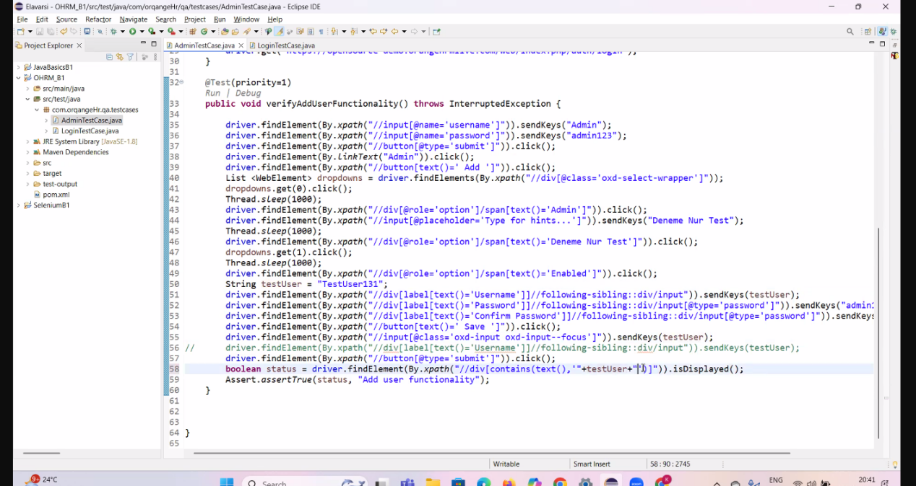

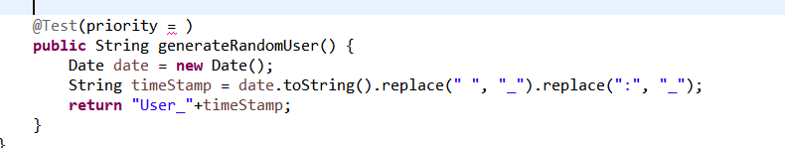

**CLASS 2: (Day 40)**

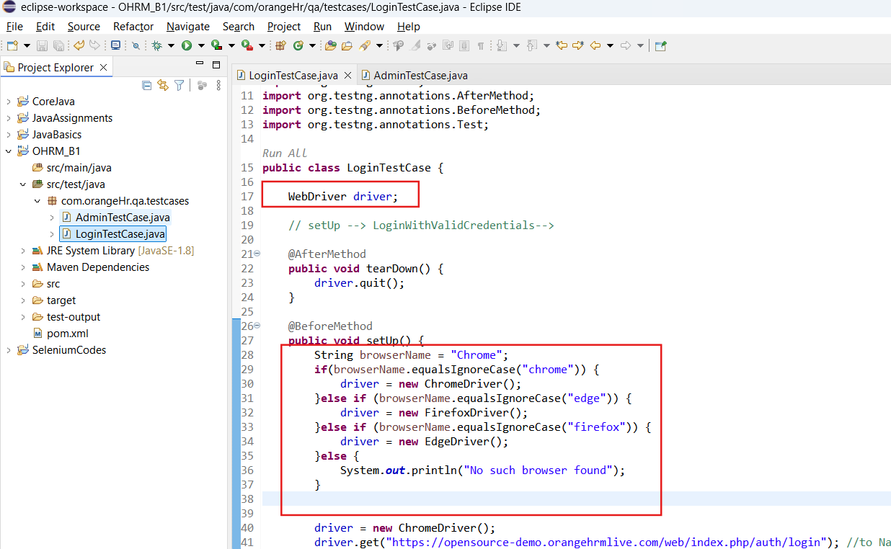

For Random user and Random Email creation - to avoid the duplicate code -

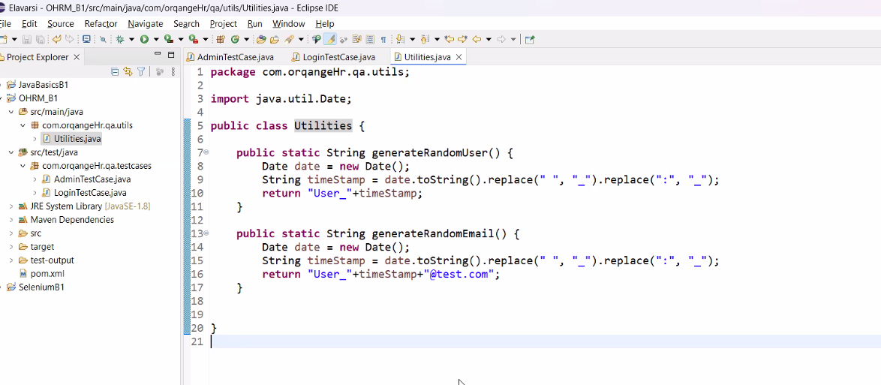

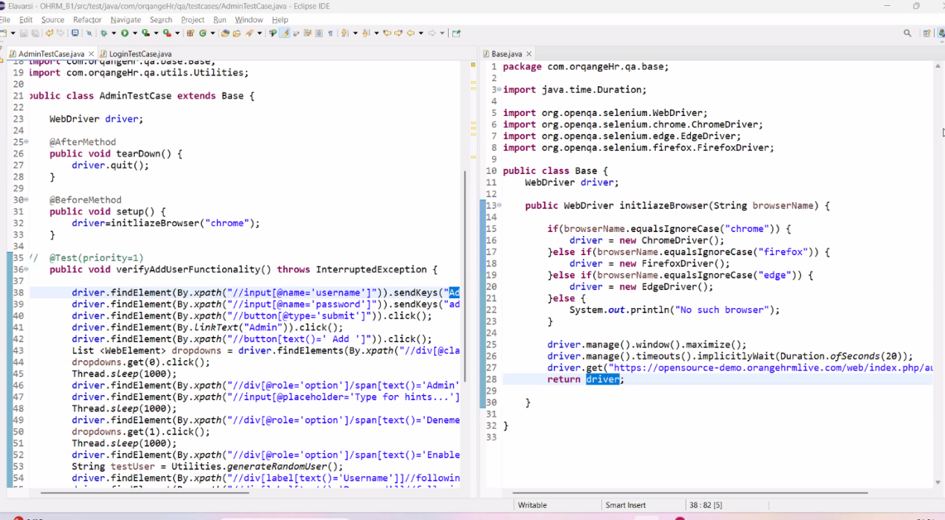

**CLASS 3: (Day 41)**

**Create a XML file**

To run/execute both the Admin and Login Class at once we can create XML file and through which we can achieve the ask.

Create a XML file

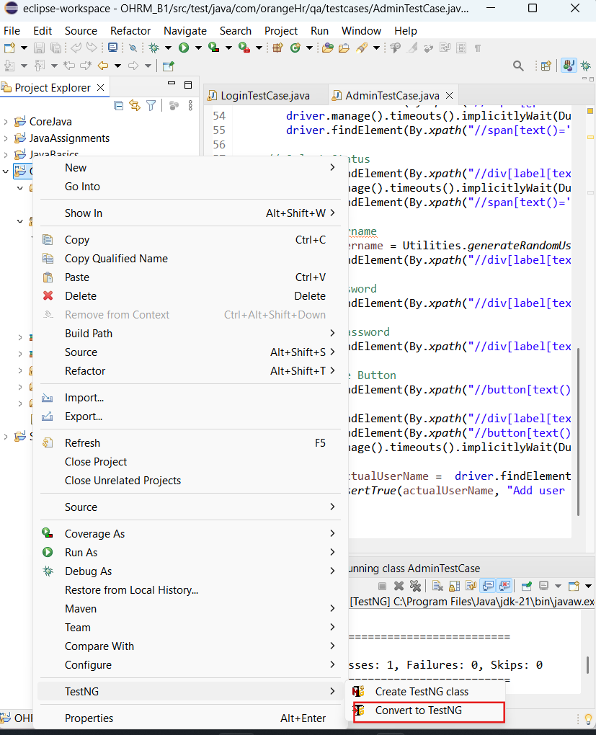

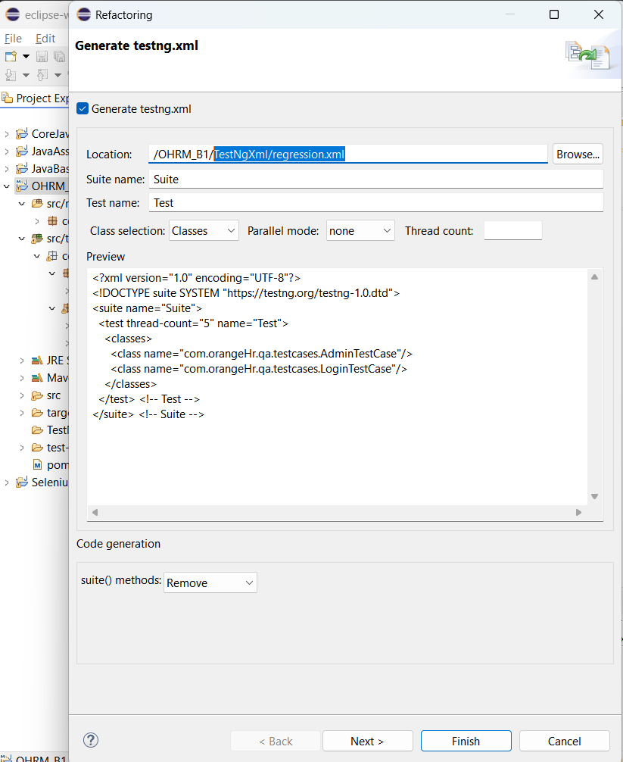

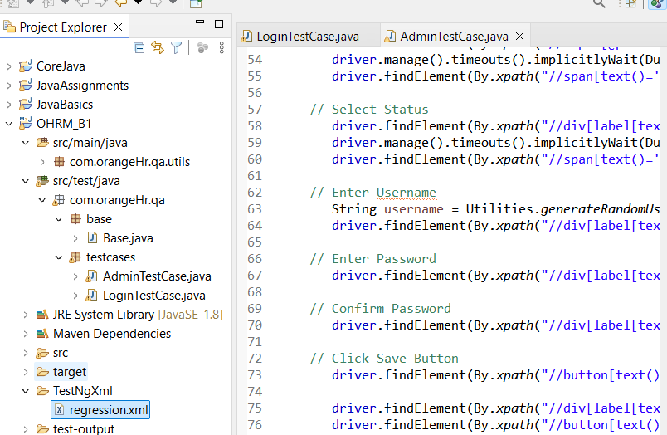

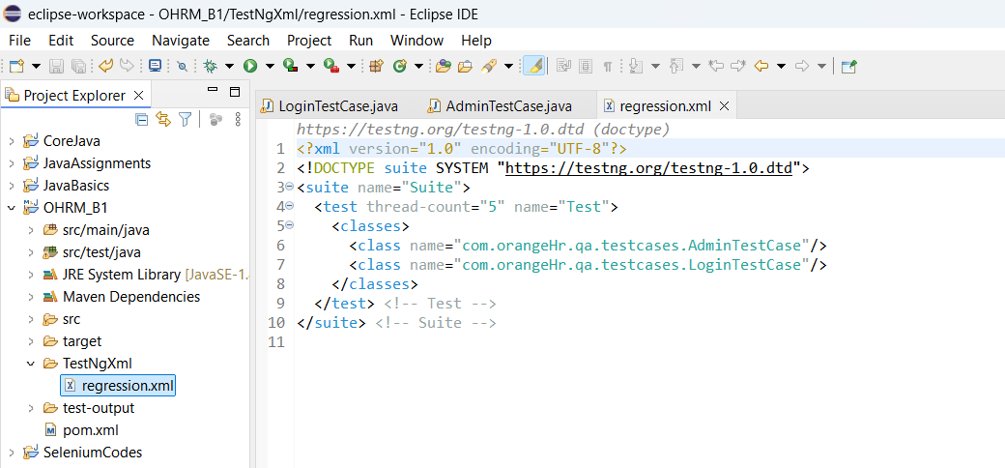  
  
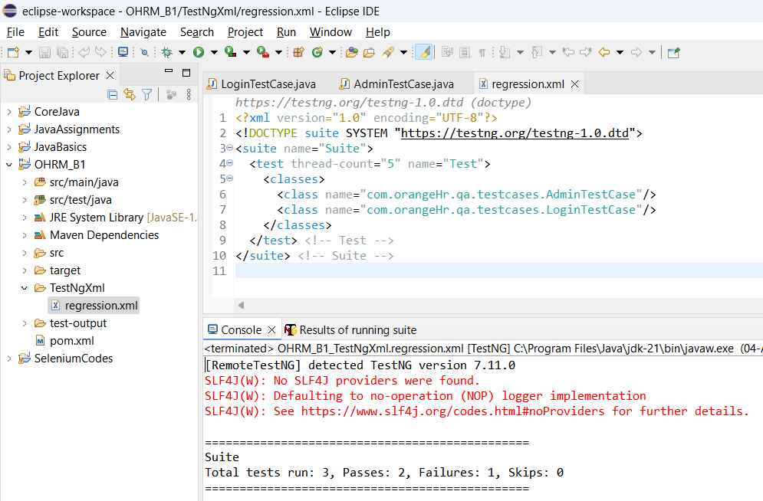

**How to get rid of Hard coder values like Browser, credentials ->**

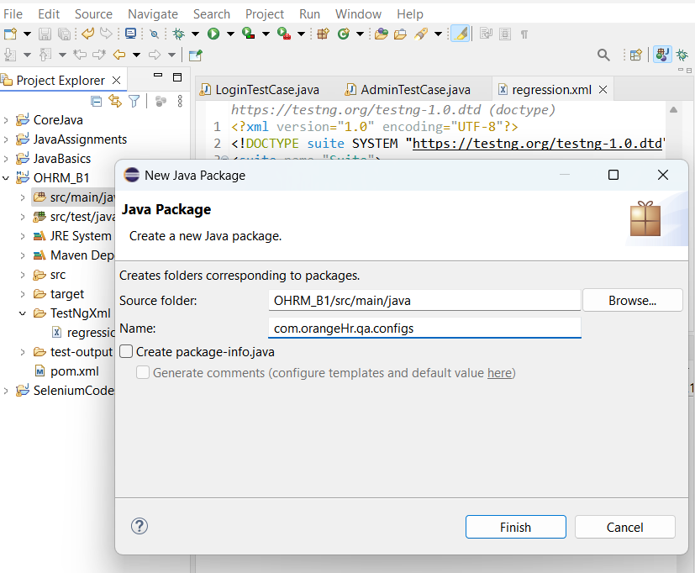

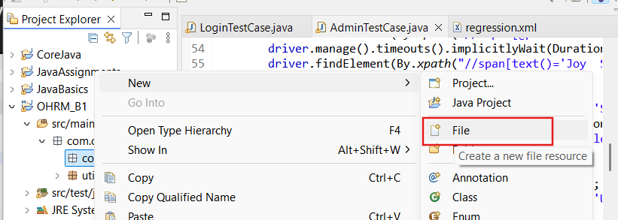

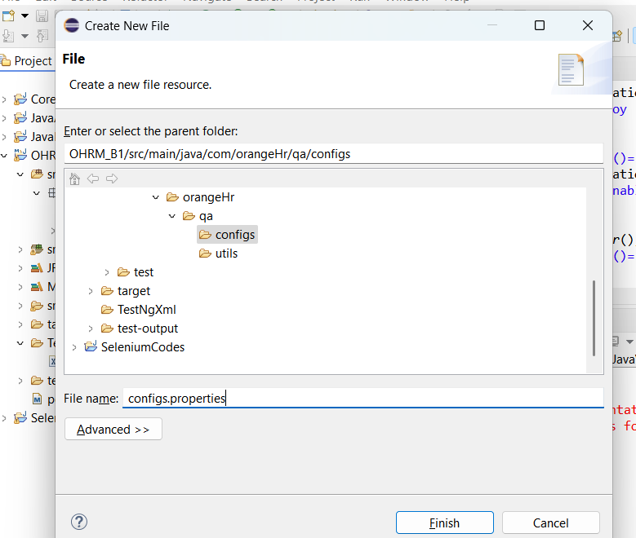

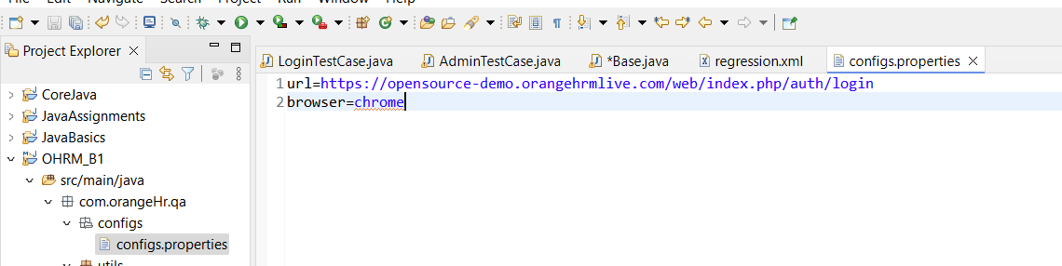

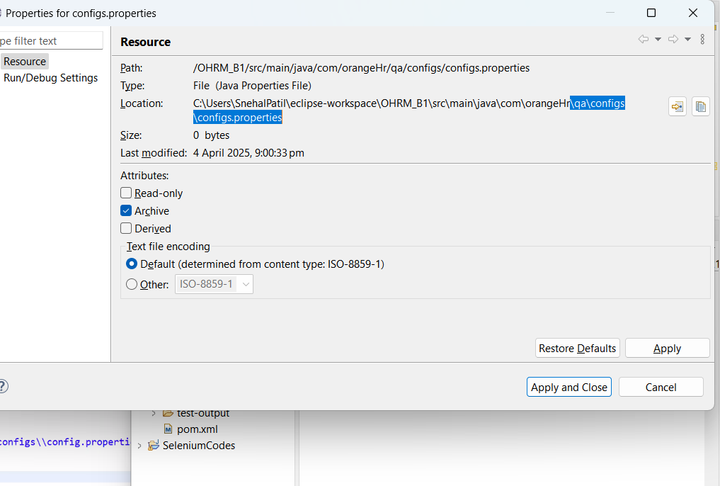

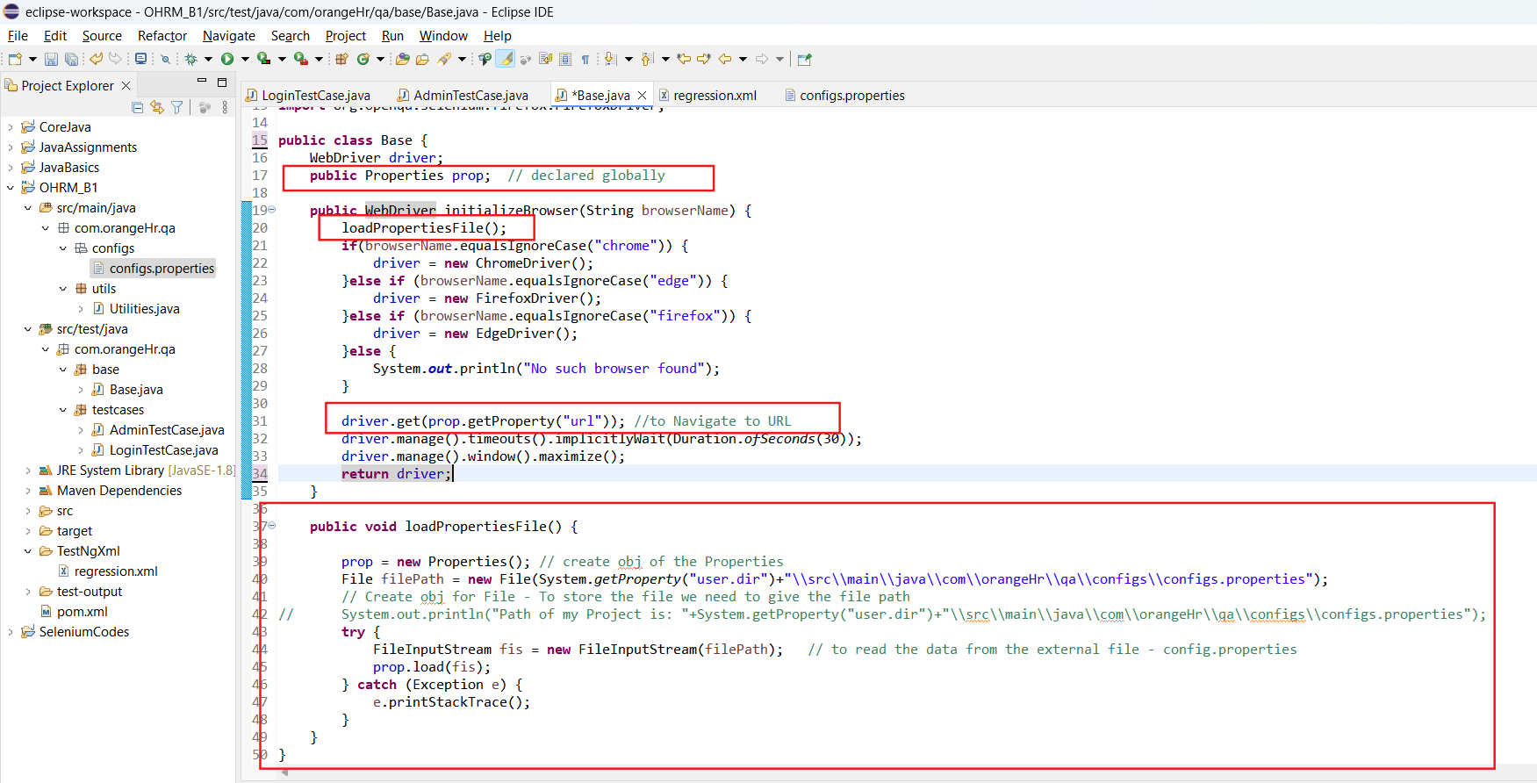

LoginTestCase class:

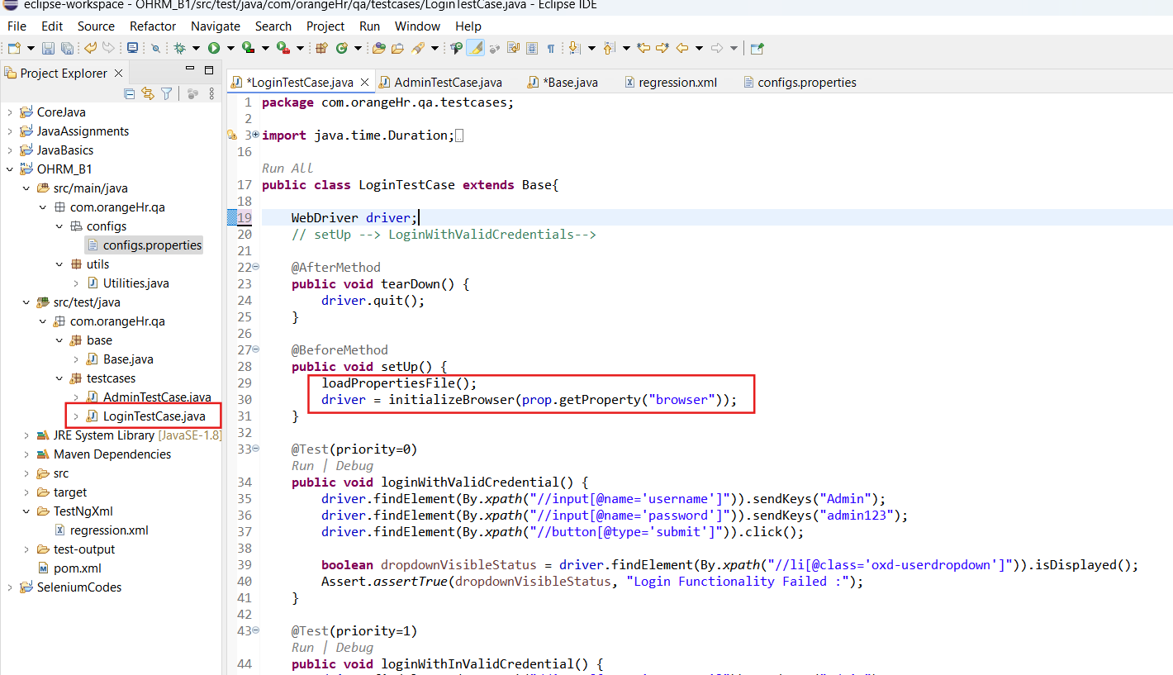

AdminTestCase class:

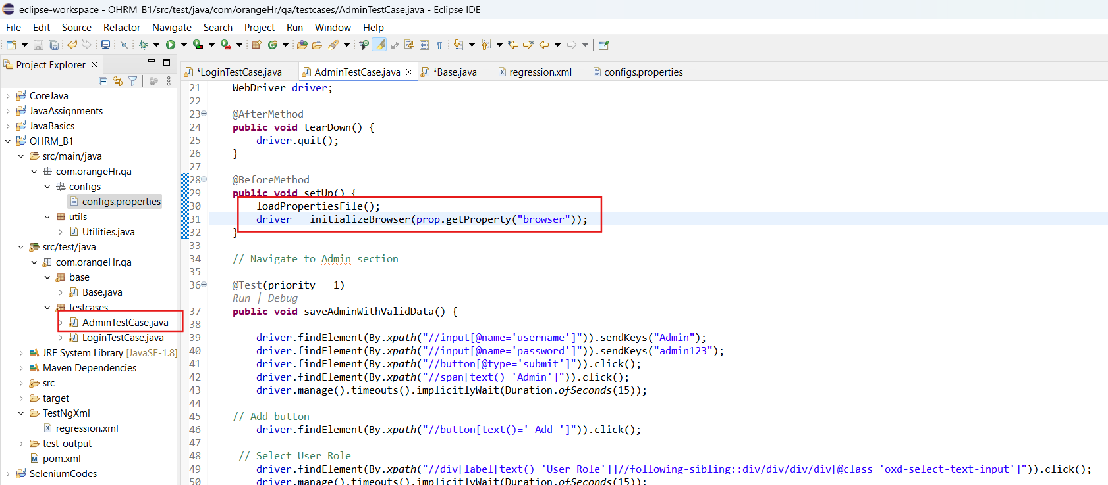

**CLASS 4: (Day 42)**

loadPropertiesFile() - under the setup method we are calling, to avoid calling this multiple time, we can handle it in a better way.

Created a constructor in Base class - for the loadPropertiesFile() ‘

So whenever this base class object is created/ one of the object is created of course this constructor is going to get called

So when this constructor gets called, whenever the object is created of the transparency class constructor is going to click.

The test engine execution starts, If the constructor is there the first part is it will go and execute the constructor., constructor is not there then immediately it will go to the @Test in that test method. We are written one more method for at before method so before running this it will run,   
when this login test starts executing the constructor is going to execute first.

Before going to a test, it’s parent class constructor. Super always refers to his base parent class. So when we say super it is going to super class constructor that means base class constructor.

In base class - we are calling the load properties so whenever the respective test cases starts executing it will call the constructor and that constructor intents calls the base class constructor.

That is what super will do.

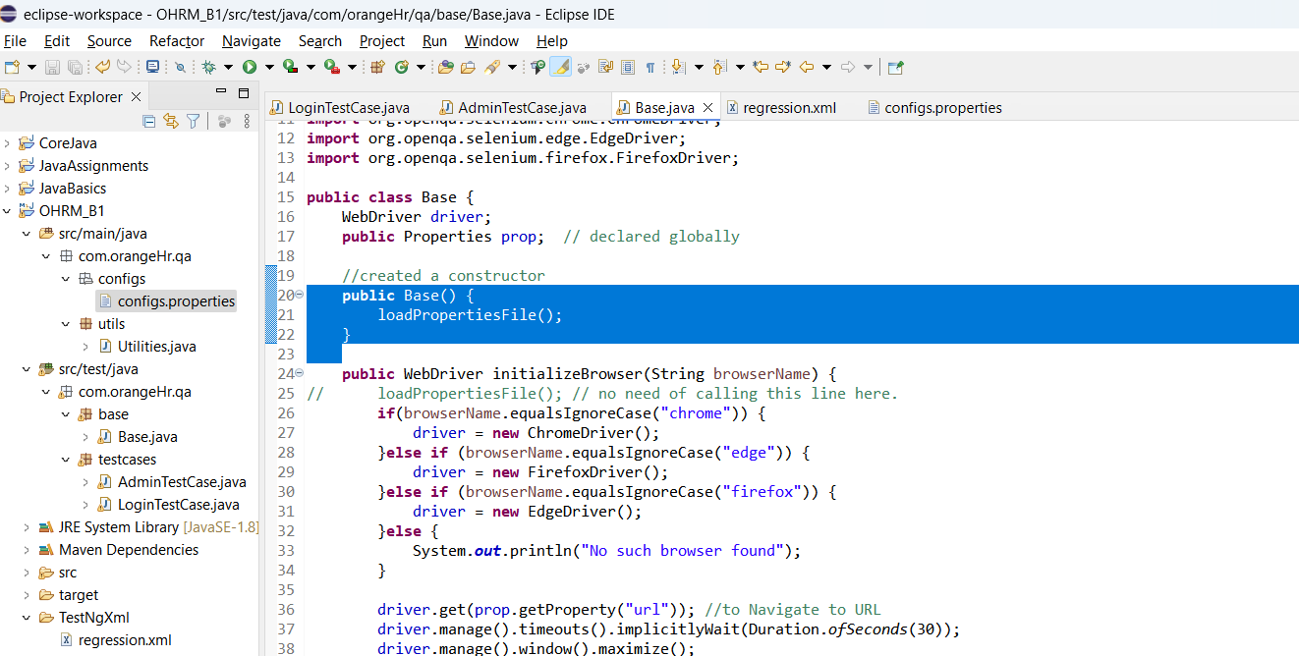

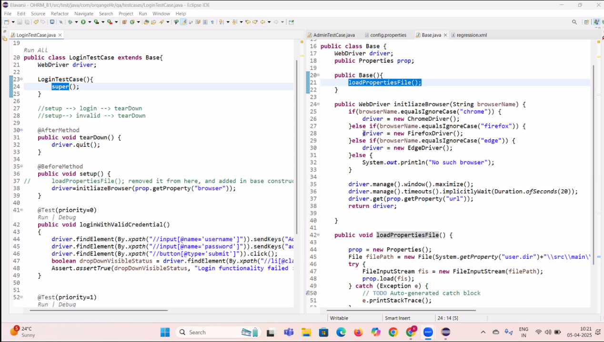

Username & Password ->

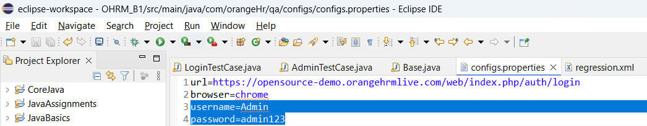

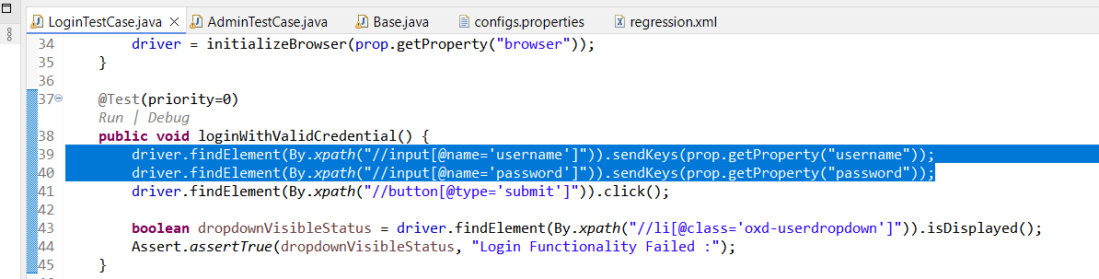

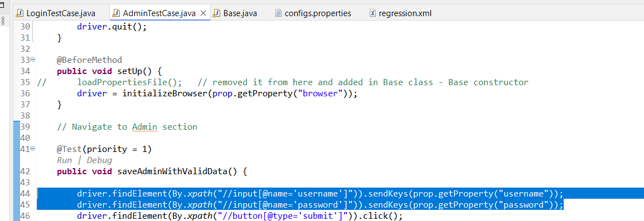

**How to make the hard coded time to dynamic:**

driver.manage().timeouts().implicitlyWait(Duration.*ofSeconds*(20));

driver.manage().timeouts().pageLoadTimeout(Duration.*ofSeconds*(30));

Go to utilities file >

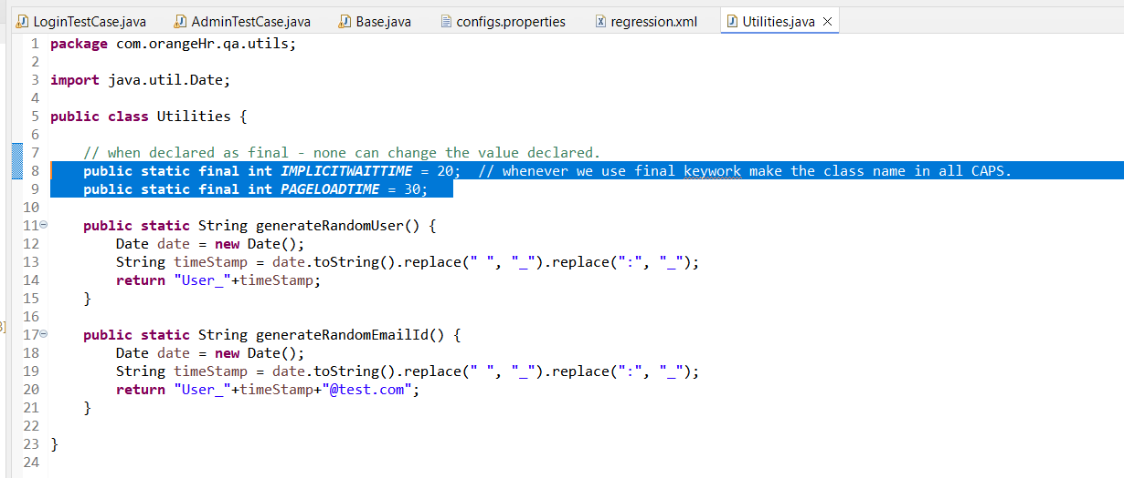

Now in Base class - we can pass the dynamic wait time >

driver.manage().timeouts().implicitlyWait(Duration.*ofSeconds*(Utilities.***IMPLICITWAITTIME***));

driver.manage().timeouts().pageLoadTimeout(Duration.*ofSeconds*(Utilities.***PAGELOADTIME***));

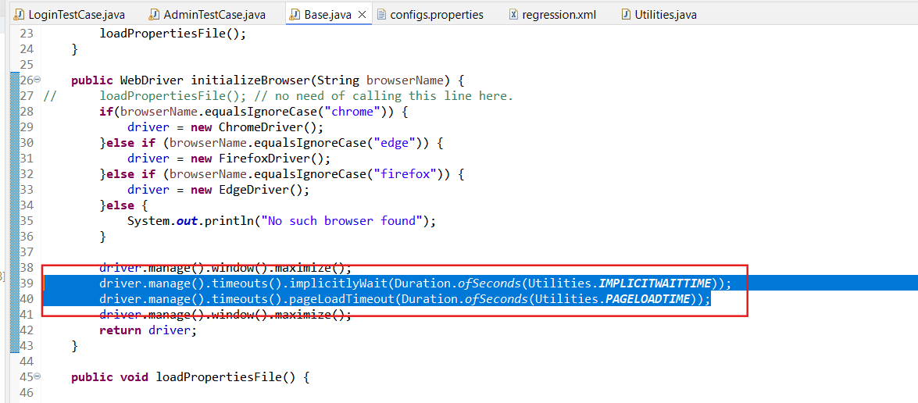

**How to get rid of the Password / Employee name / confirm password field hard coded data?:**

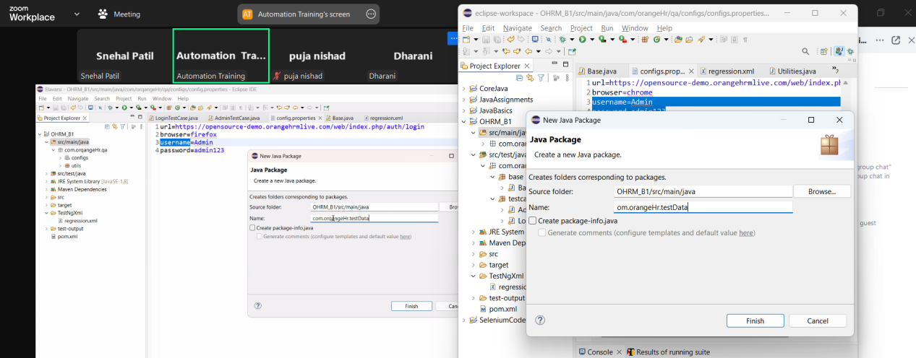

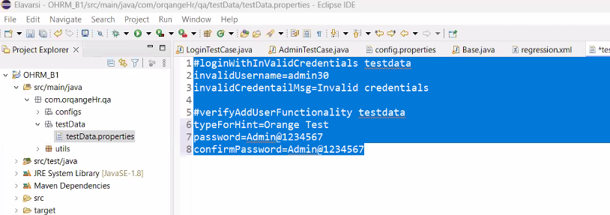

Create one more method in Base class to load the data:

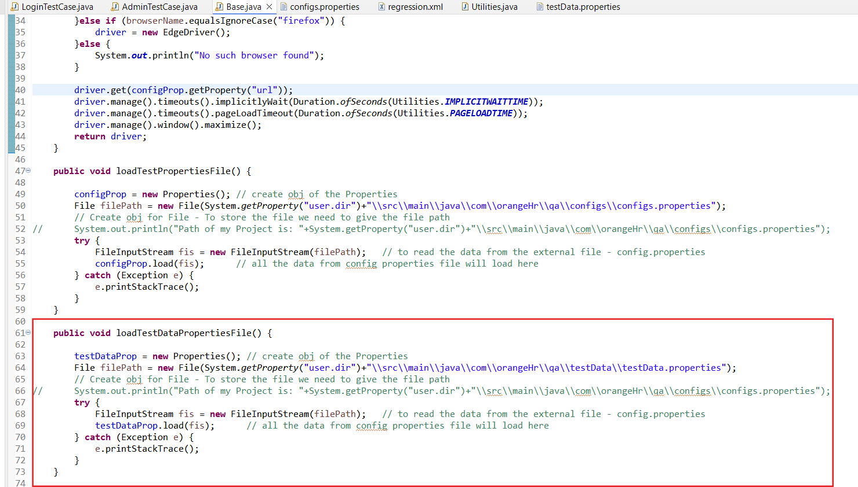

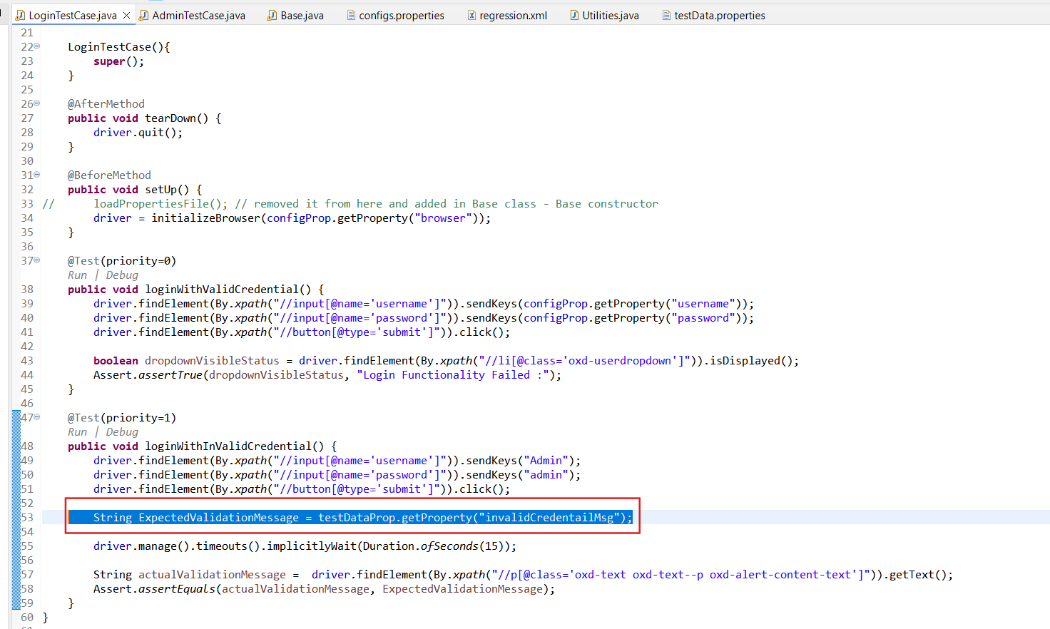

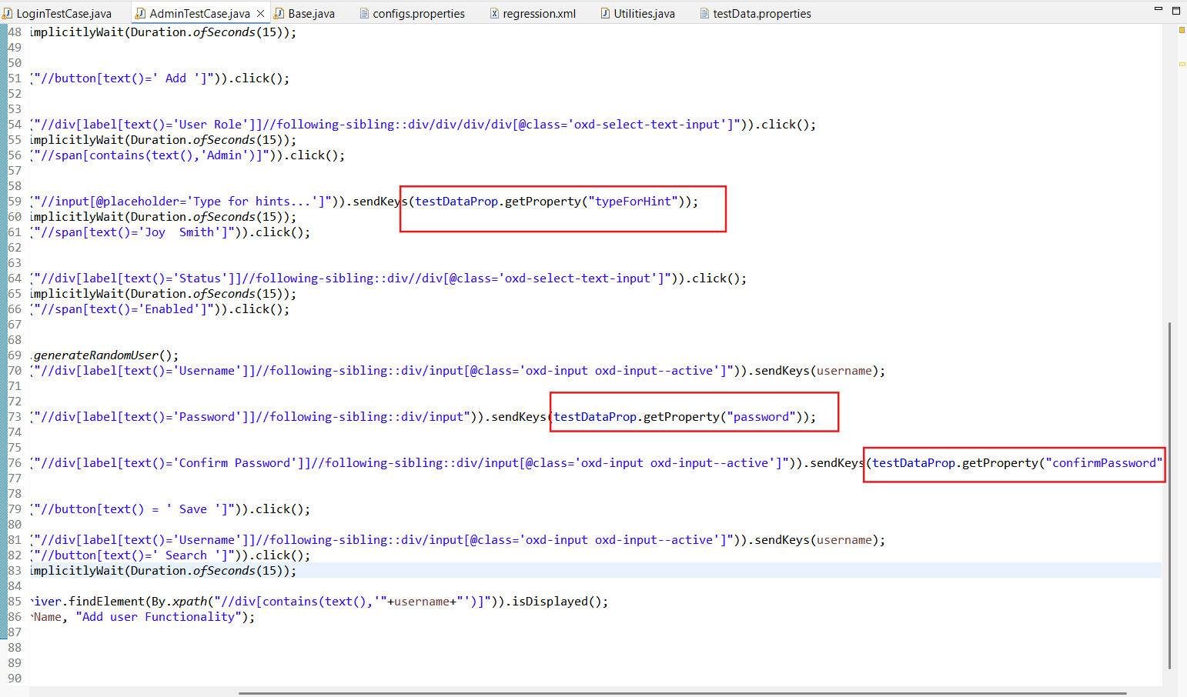

How to avoid the multiple methods in Base class for the loading properties:

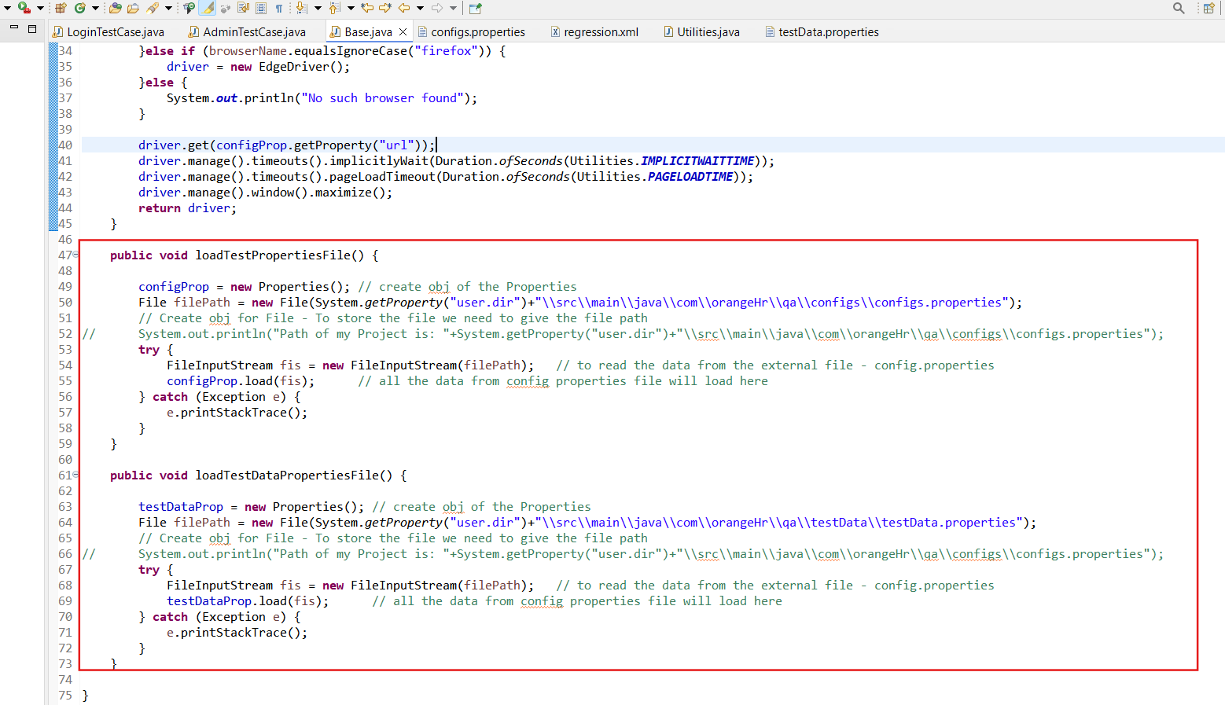

Re-factoring these 2 methods as one in Base class->>

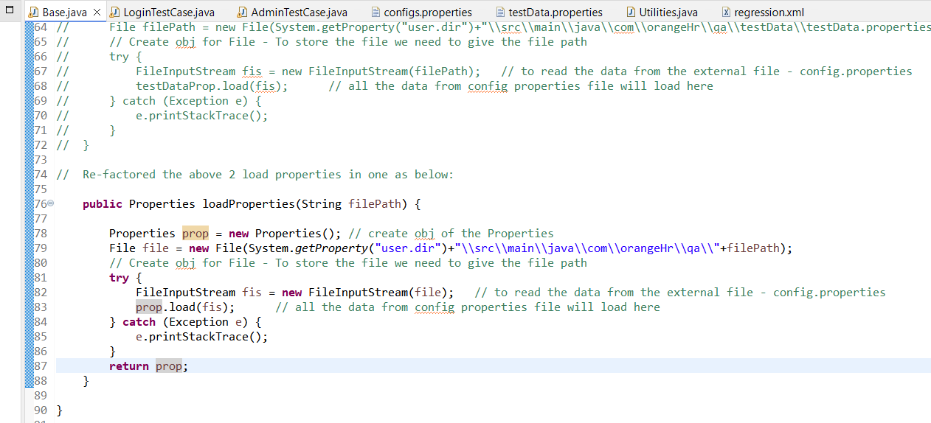

Updated in the Base class Base Constructor ->

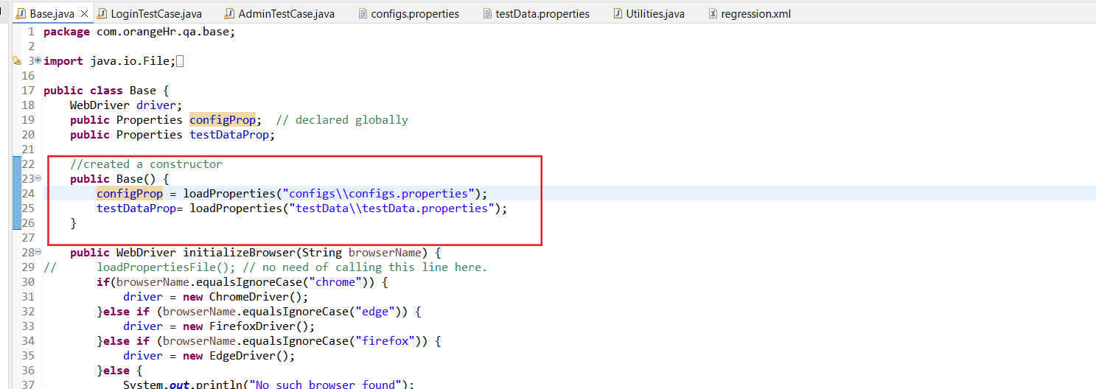

**Execute the code now -**

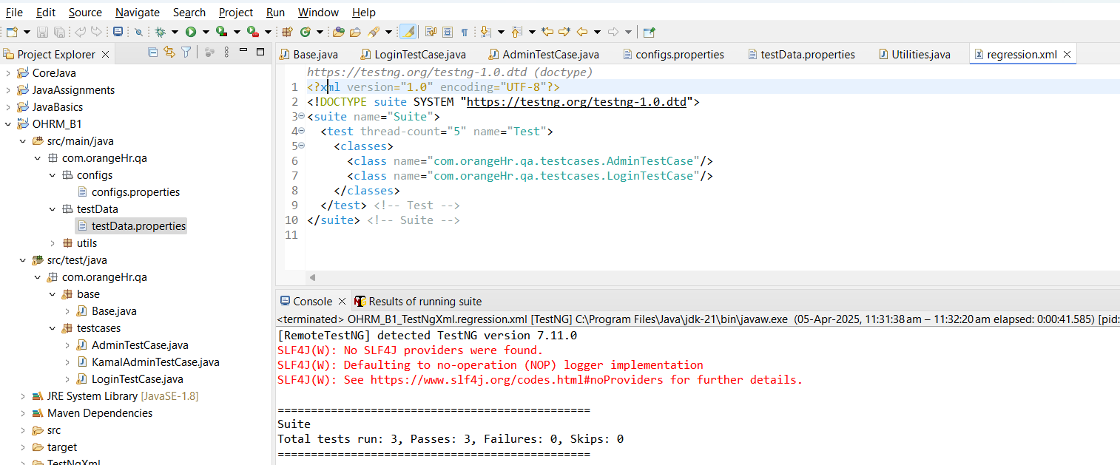

**CLASS 5: (Day 43)**

**For Test data reading - JSON   
  
Disadvantage of the reading data from property file:**

* In config / test data property files we can not have the duplicate Keys related to test data level.
* In Property file we can not add the duplicate keys for the different values.   
  In case of duplicate keys, it will take most latest updated value.

In Property file only high level data is maintained. But test case level data is not maintained with Property File.

**Data Driven Testing:**

Data Driven Testing

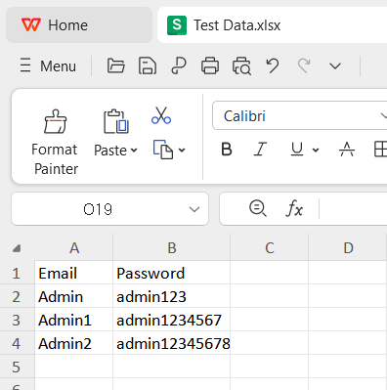  
  
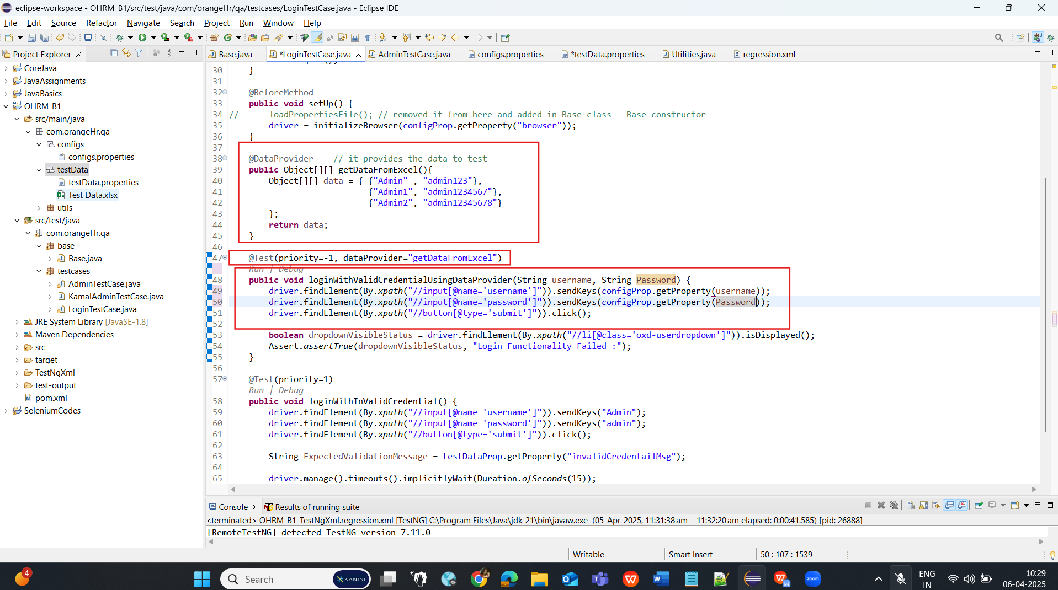

// download these dependancies:

// 1. Apache POI Common

// 2. Apache POI API Based On OPC and OOXML Schemas

// 3. Apache POI

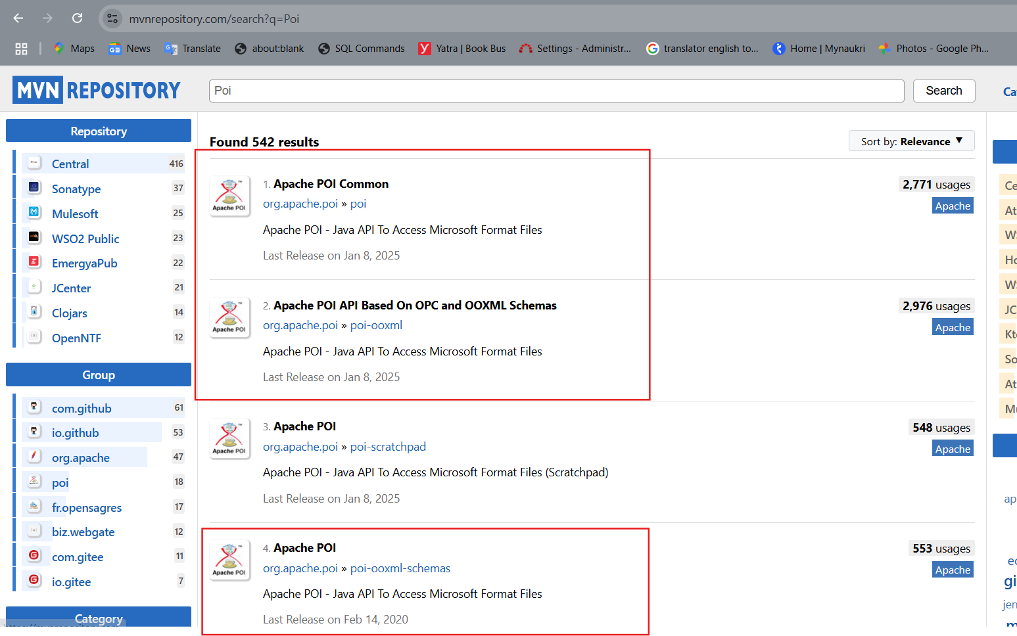

Syntax to convert integer to String:

Integer.*toString*((**int**)cell.getNumericCellValue());

**CLASS 6: (Day 44)**

**JSON - JavaScript Object Notation**

* Easy for Maintenance
* Easily readable

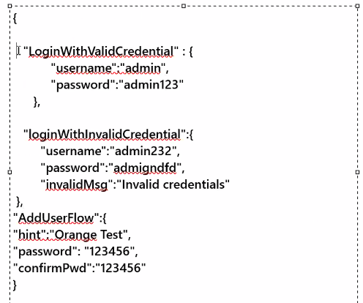

**Dependencies to be added:**

JSON  
jackson-databind

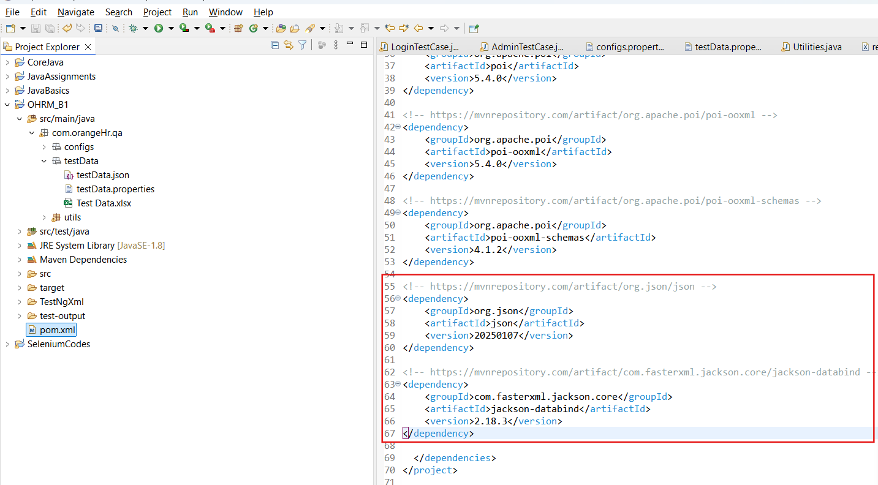

**Create a method in Utilities class to read the data from Json file:**

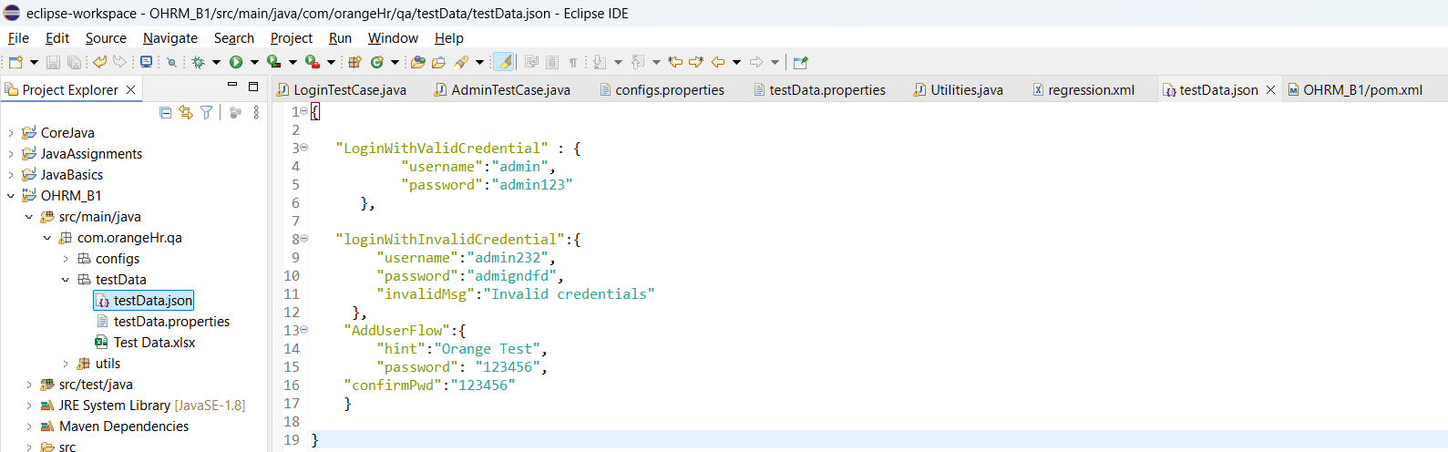

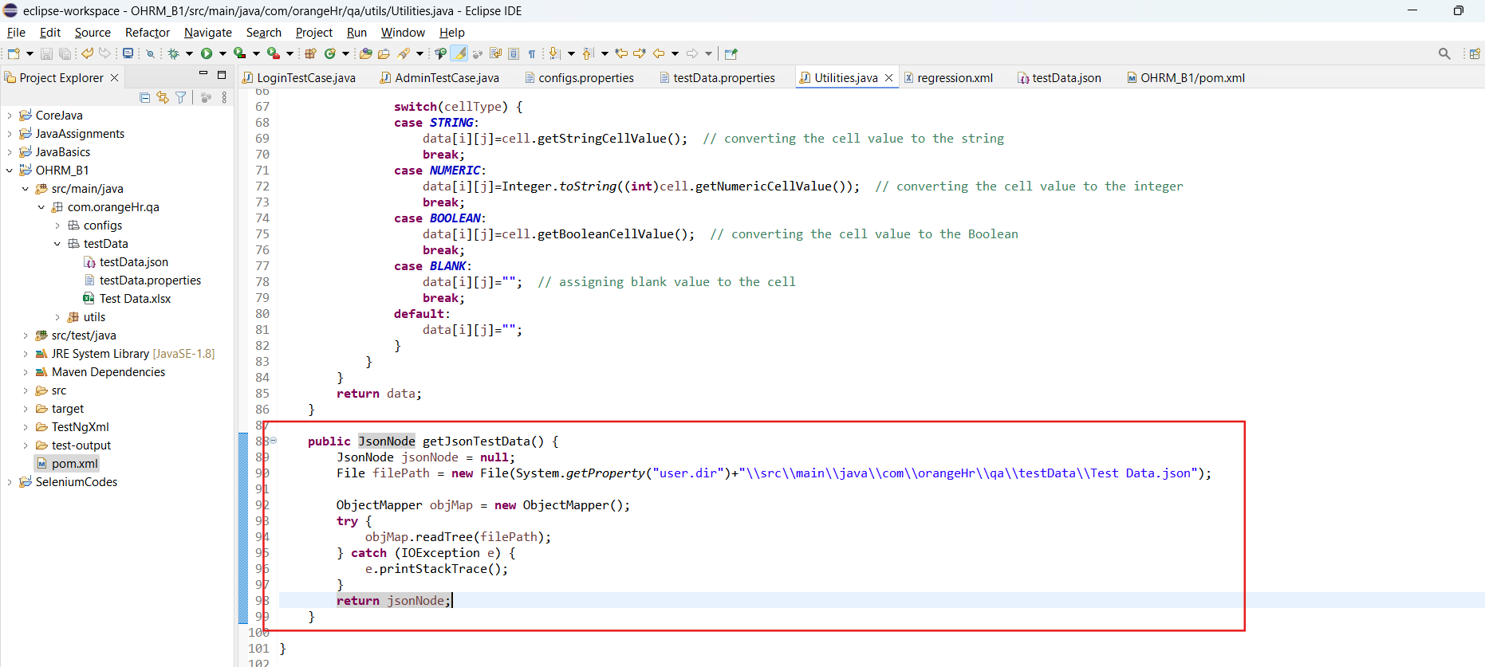

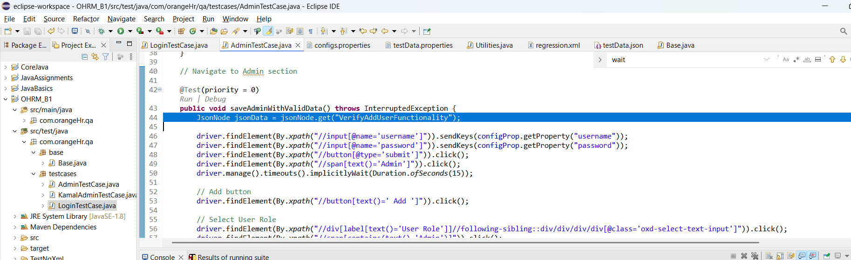

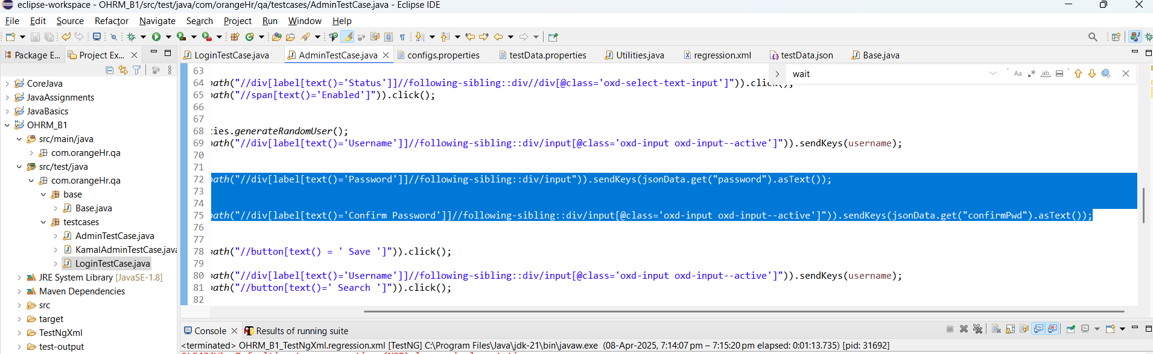

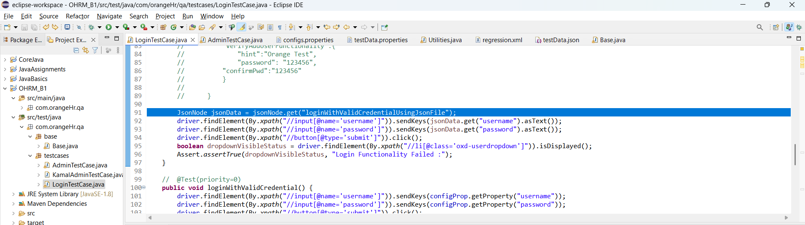

**CLASS 7: (Day 45)**

**PAGE OBJECT MODEL (CLASS):**All the element related to webpage will be kept in LoginPage

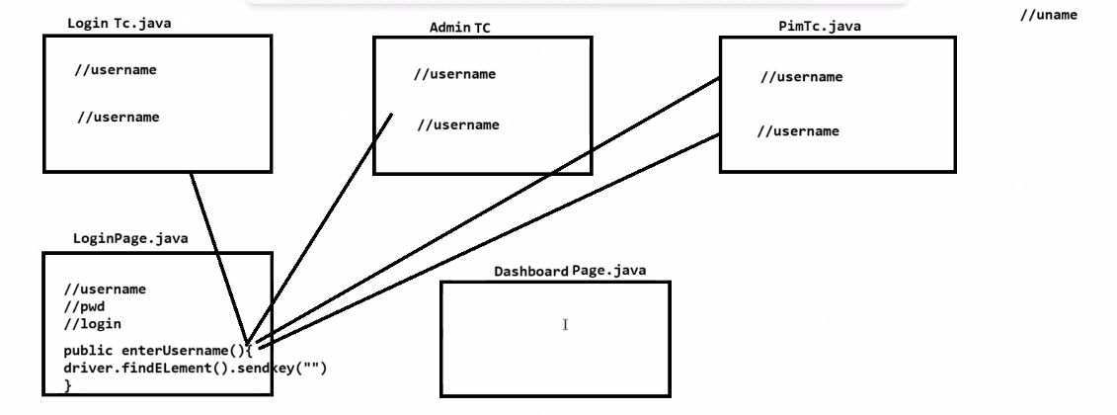

// Syntax to Store the xpath in the WebElement

@FindBy(xpath="//input[@name='username']")

WebElement username;

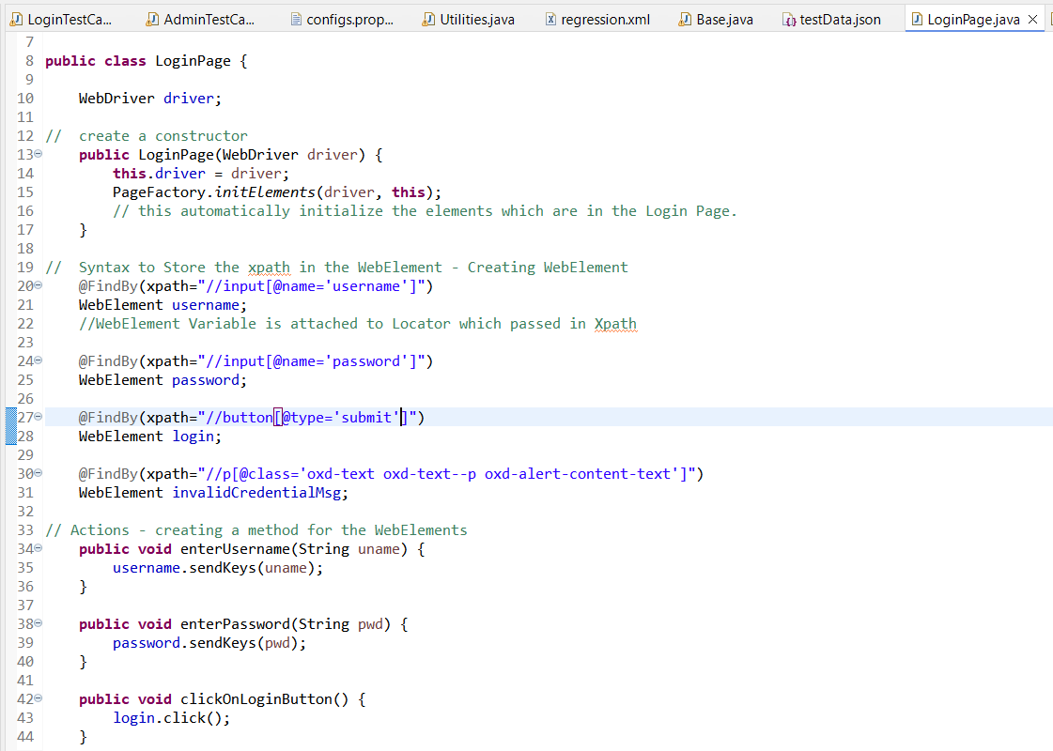

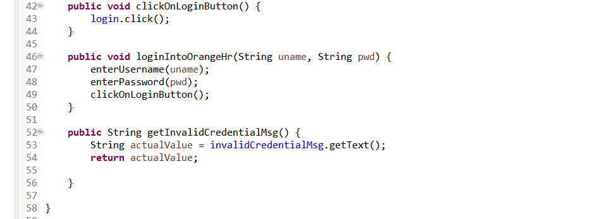

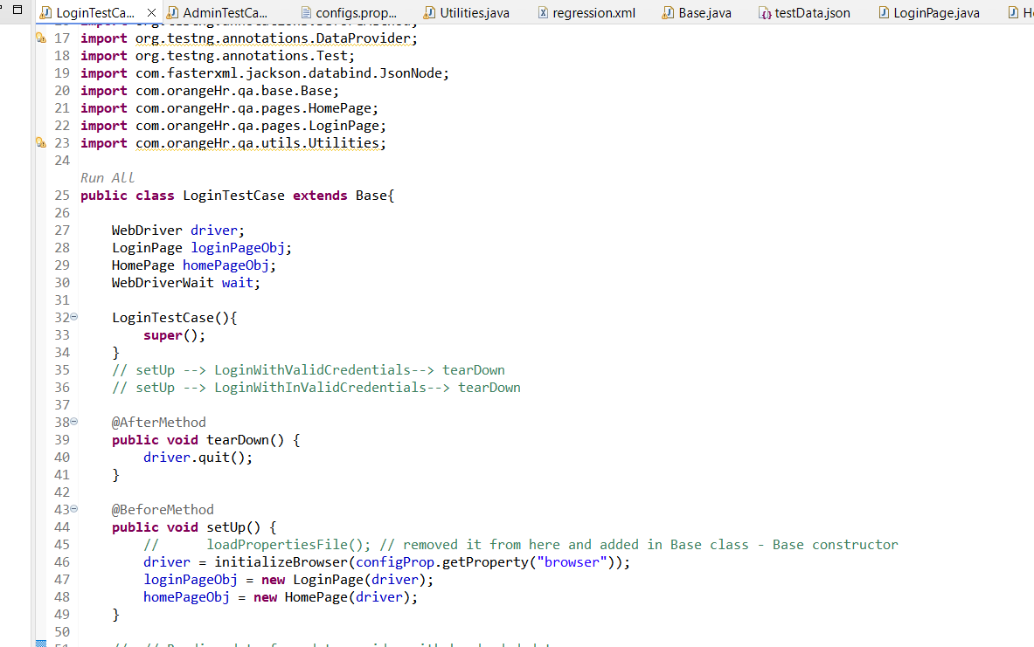

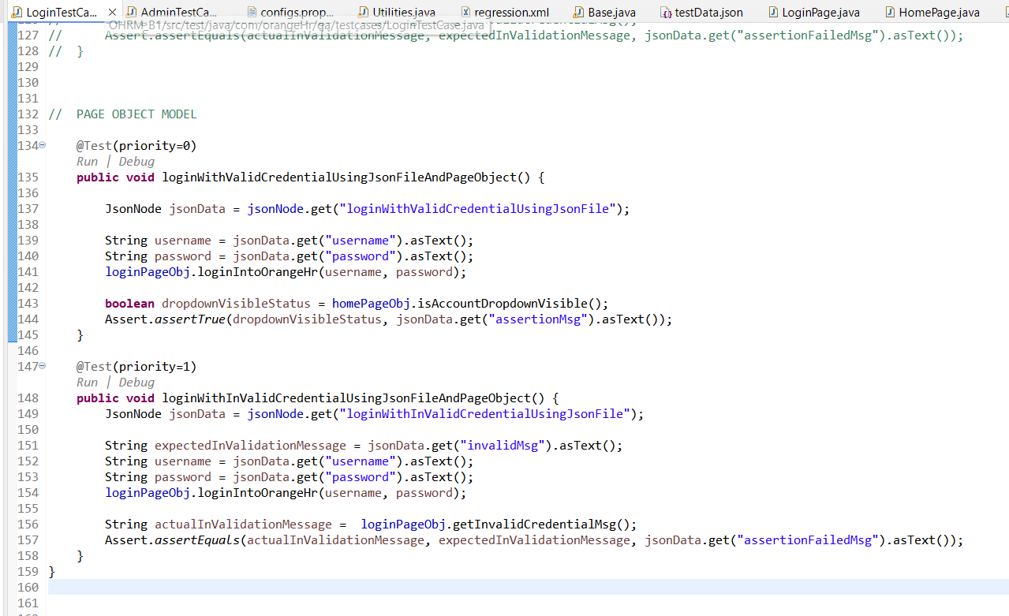

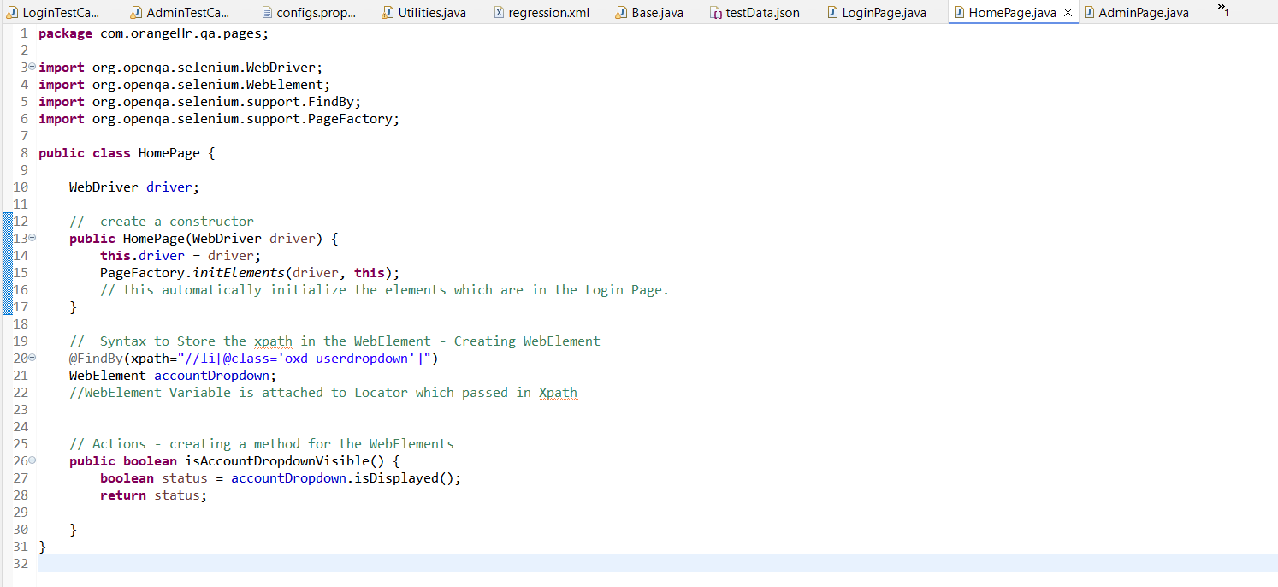

Admin Page

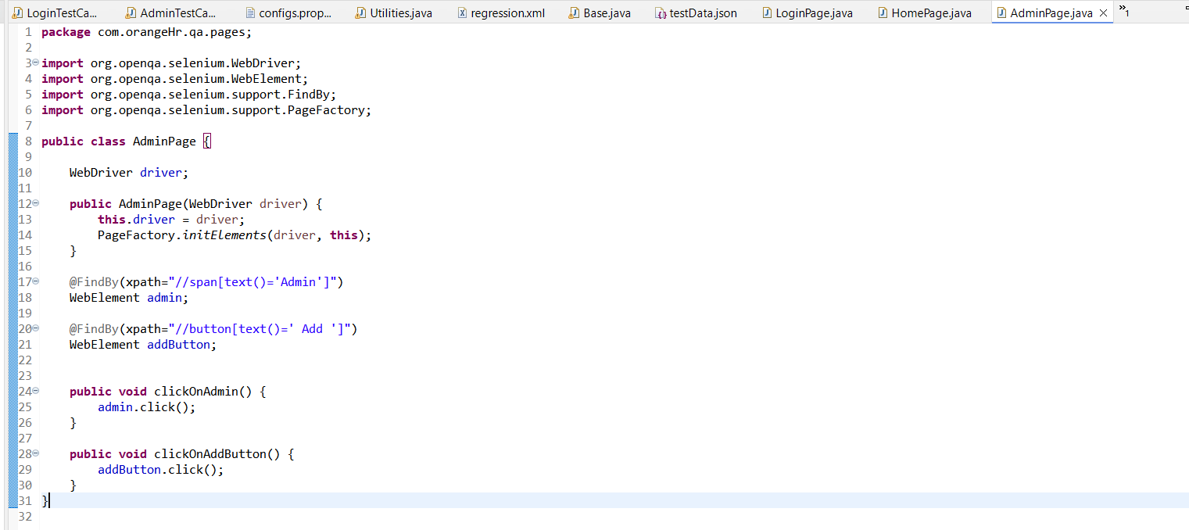

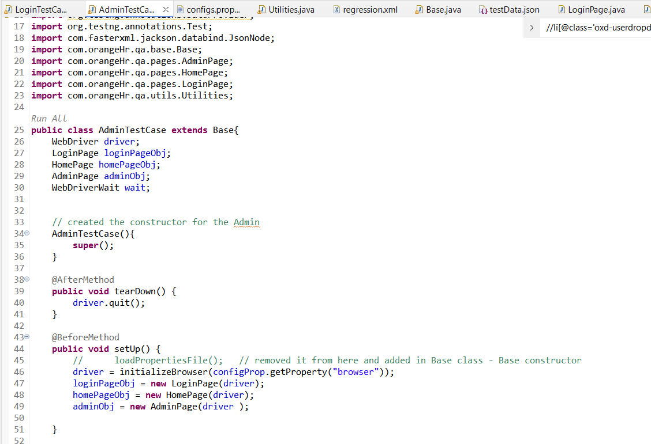

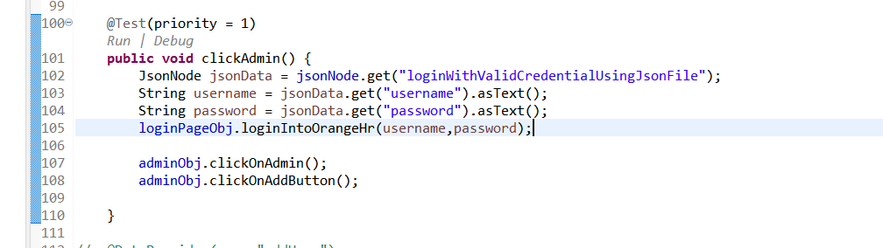

**CLASS 8: (Day 46)**

1. Create a Page.java class  
   in which we create the WebElement and the action for the WebElement.
2. In testData.json file update the required data.
3. Create a TestCase.Java - we will create a testcase for a new flow

In tetsrCase.java we will create a object of the Page.java,

Pass the testData and call the action methods

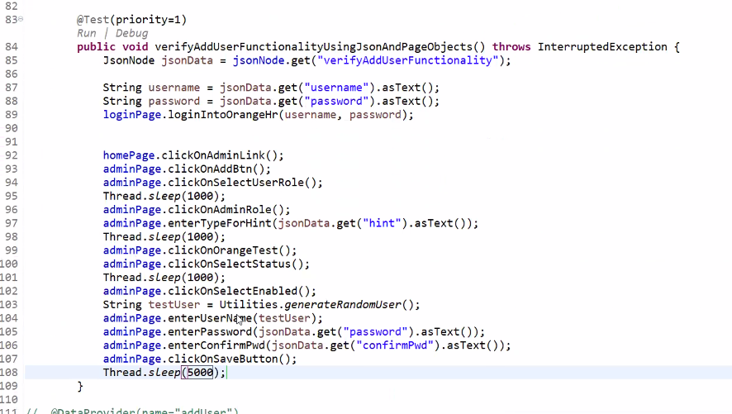  
  
  
**Problem Statement:**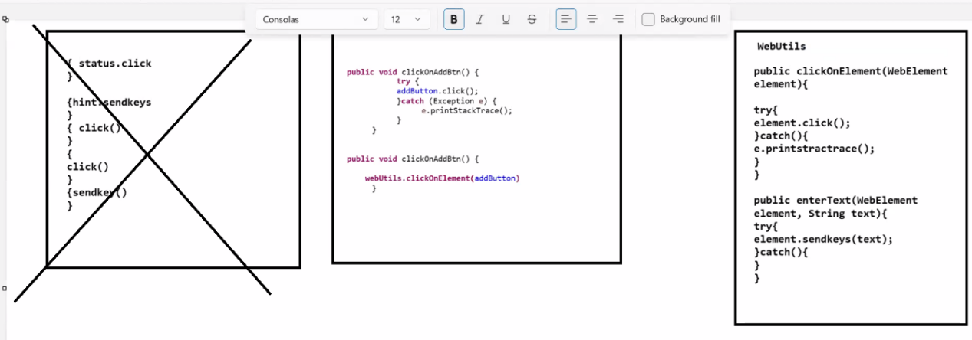

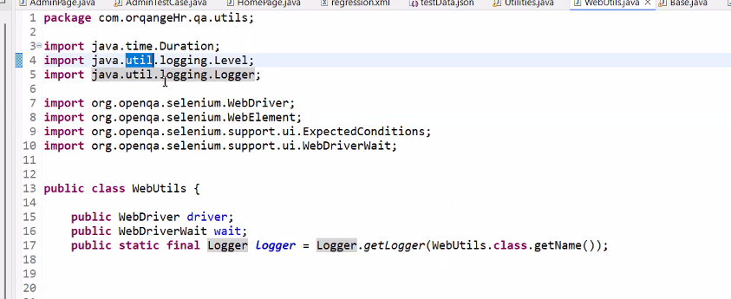

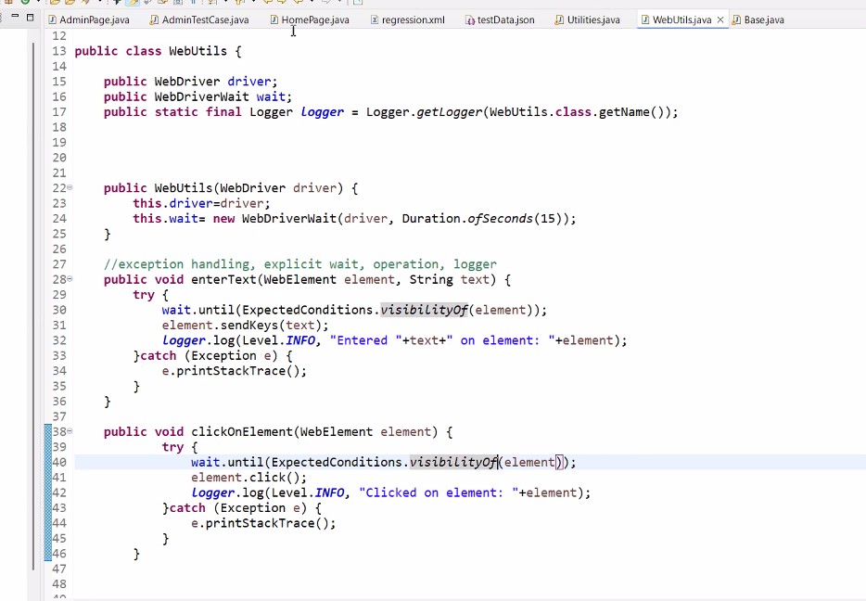

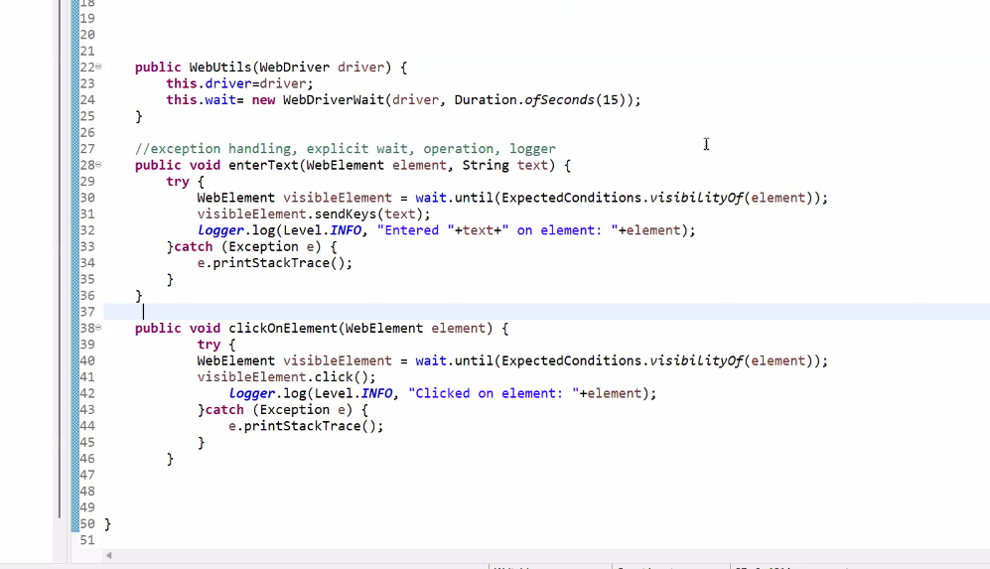

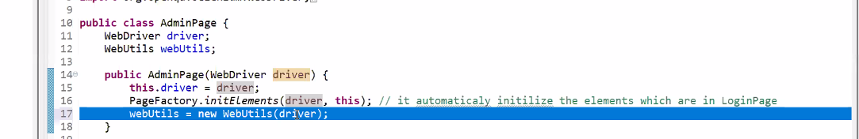

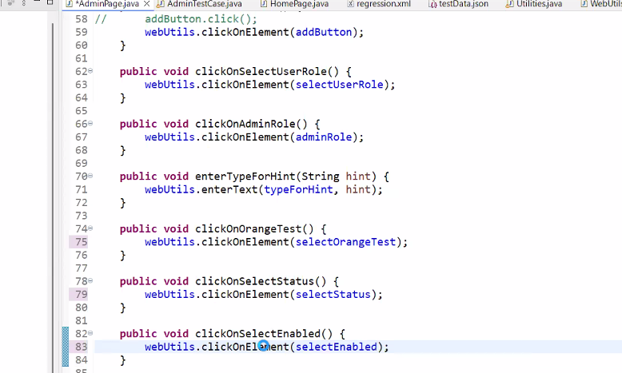

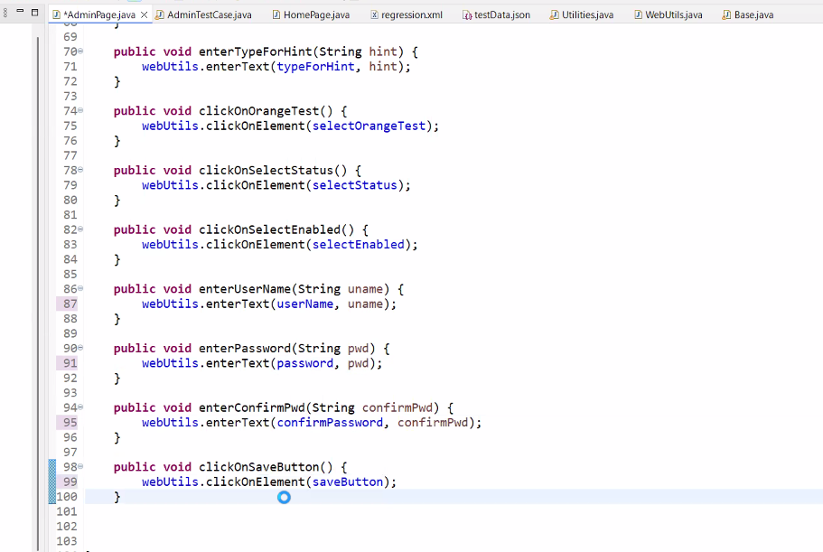

Flow:

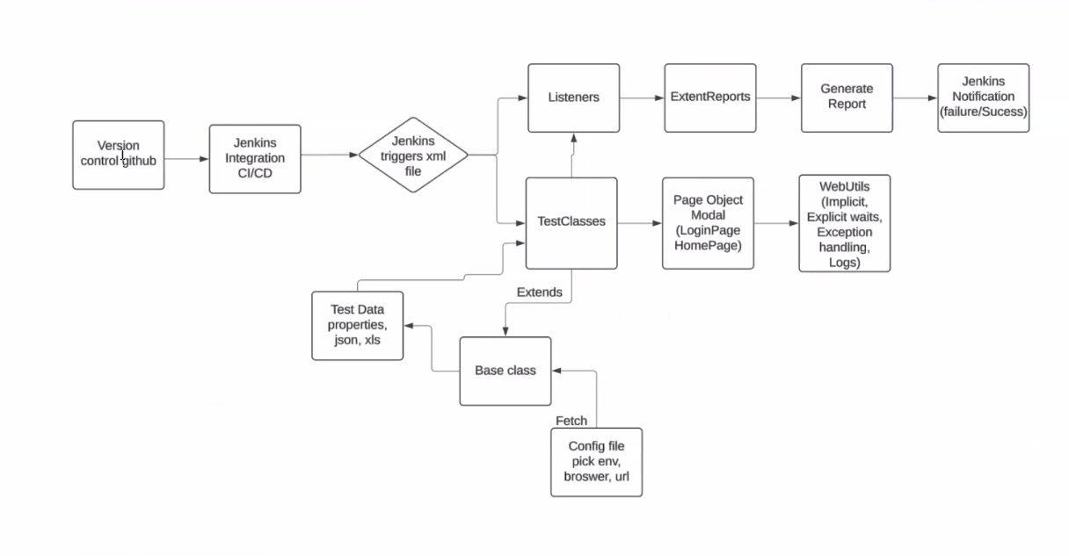

**CLASS 9: (Day 47)**

**Problem Statement:**

Create a object of all the page.java in one place and use everywhere in any test case classes instead of calling multiple page objects.

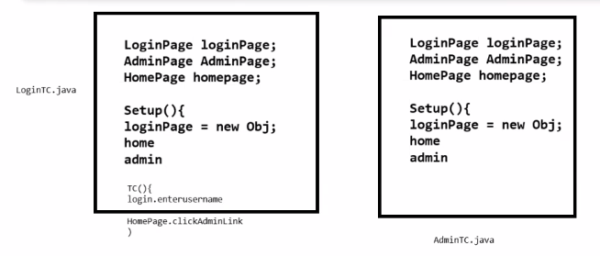  
  
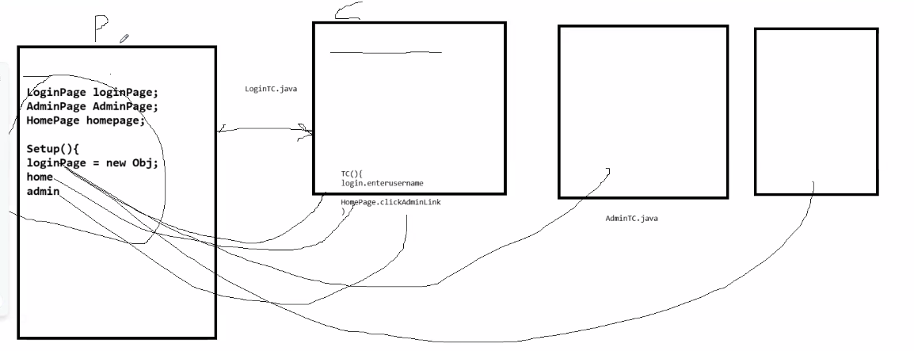  
  
In Base class, we can add the object of all the page.java classes

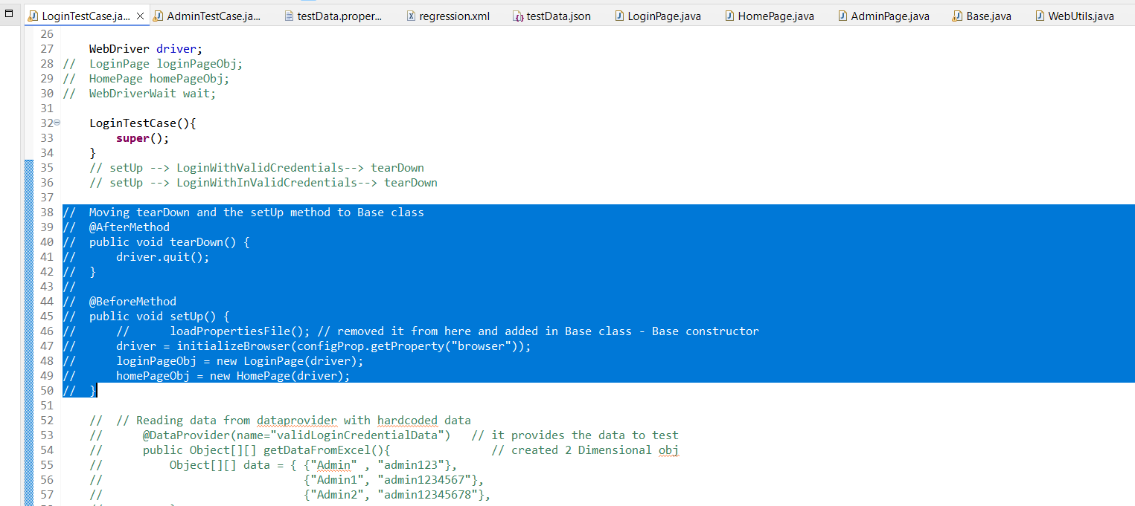

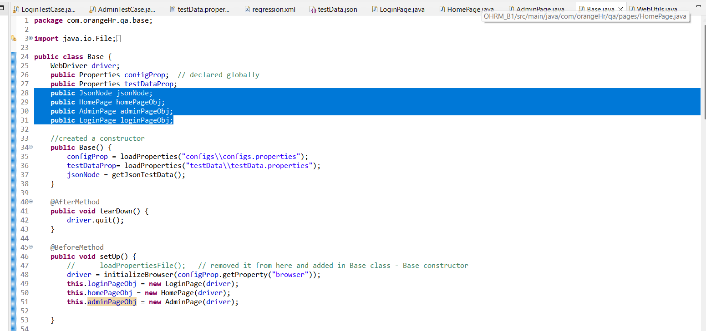

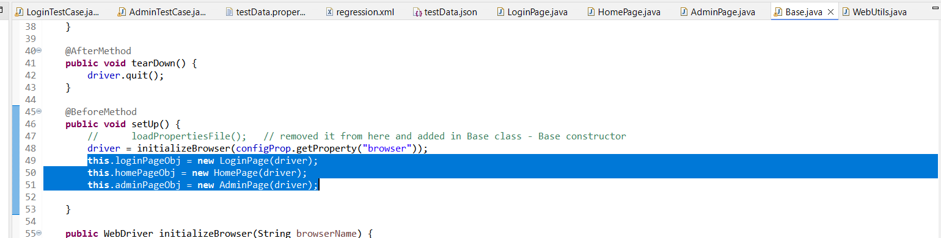

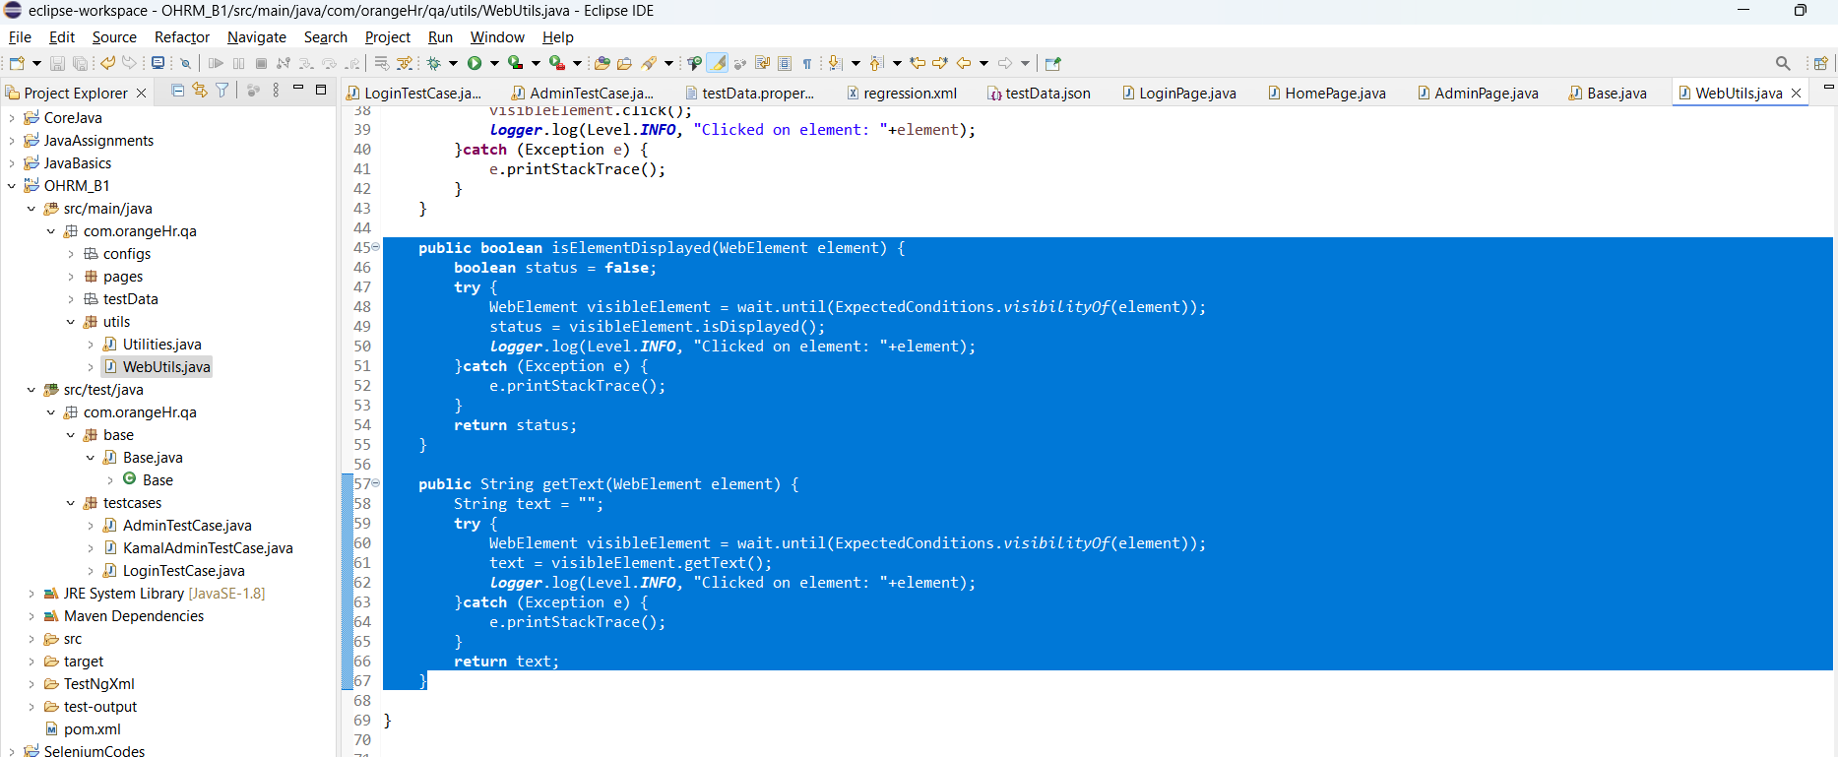

**CLASS 10: (Day 48)**

**Manual Testing Session:**

Agile Process - A software development process where we do releases in a short duration.

This release duration is -> Sprint

Sprint duration -> 1 week / 2 week / 1 month

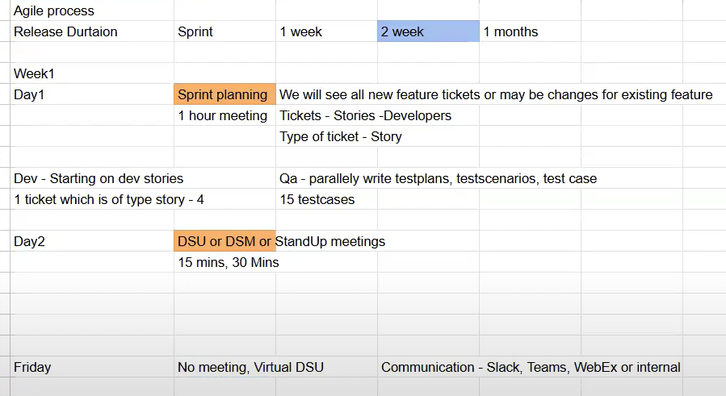

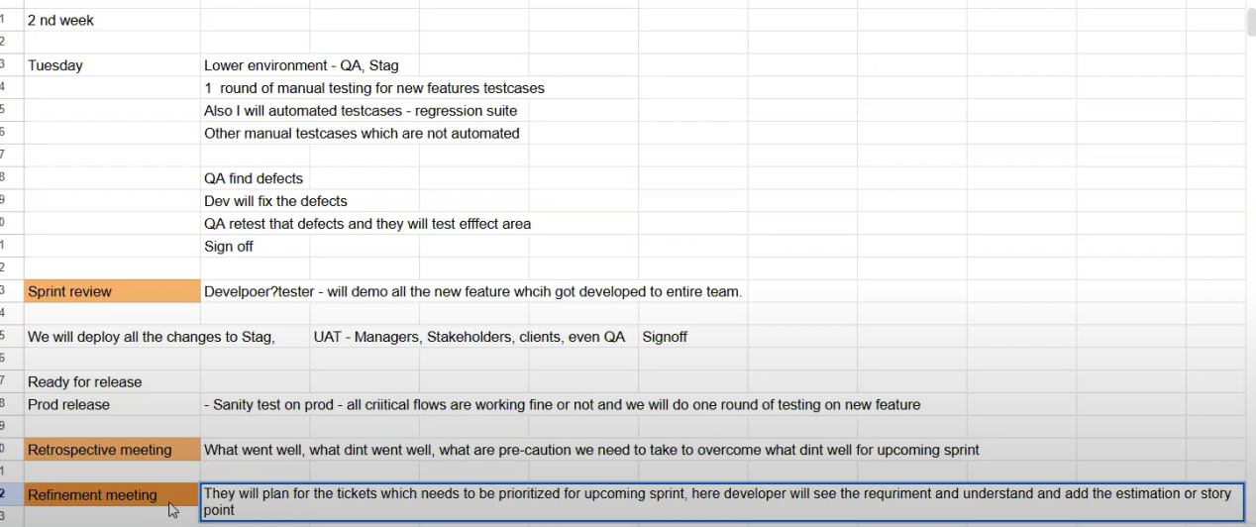

Epic -> parent of all the stories

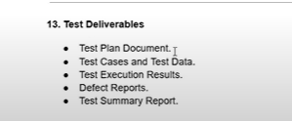

**CLASS 11: (Day 49)**

**Listeners:**

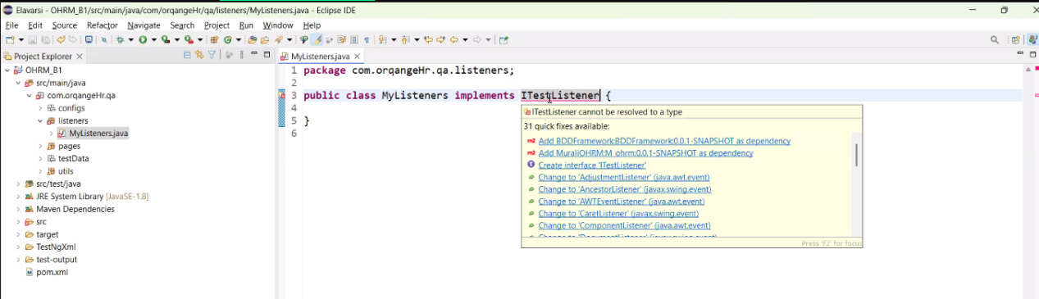

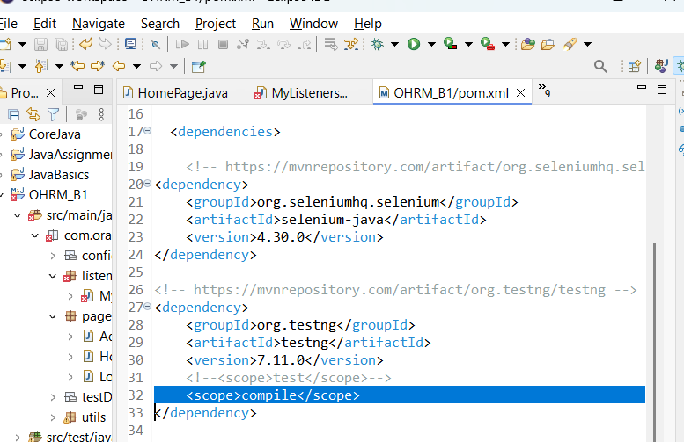

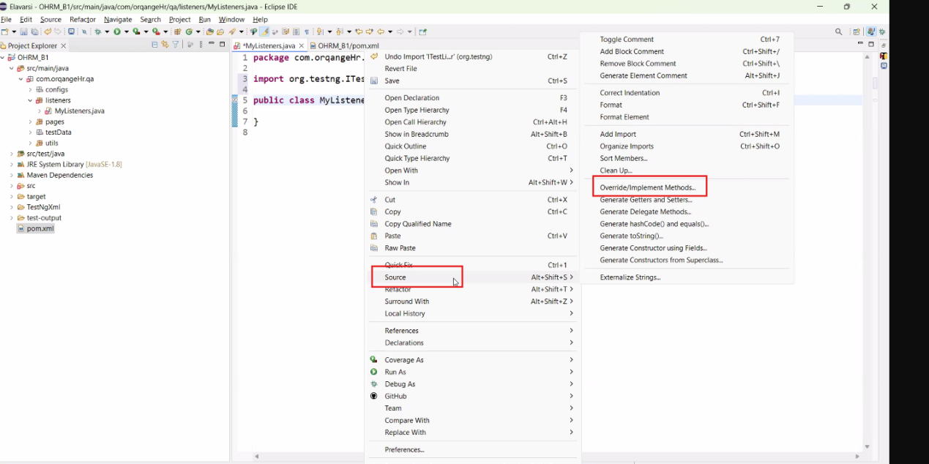

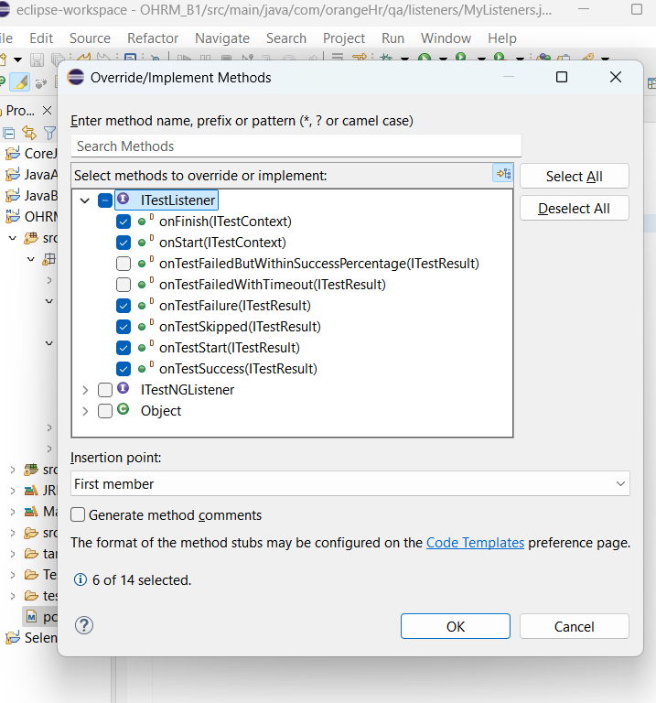

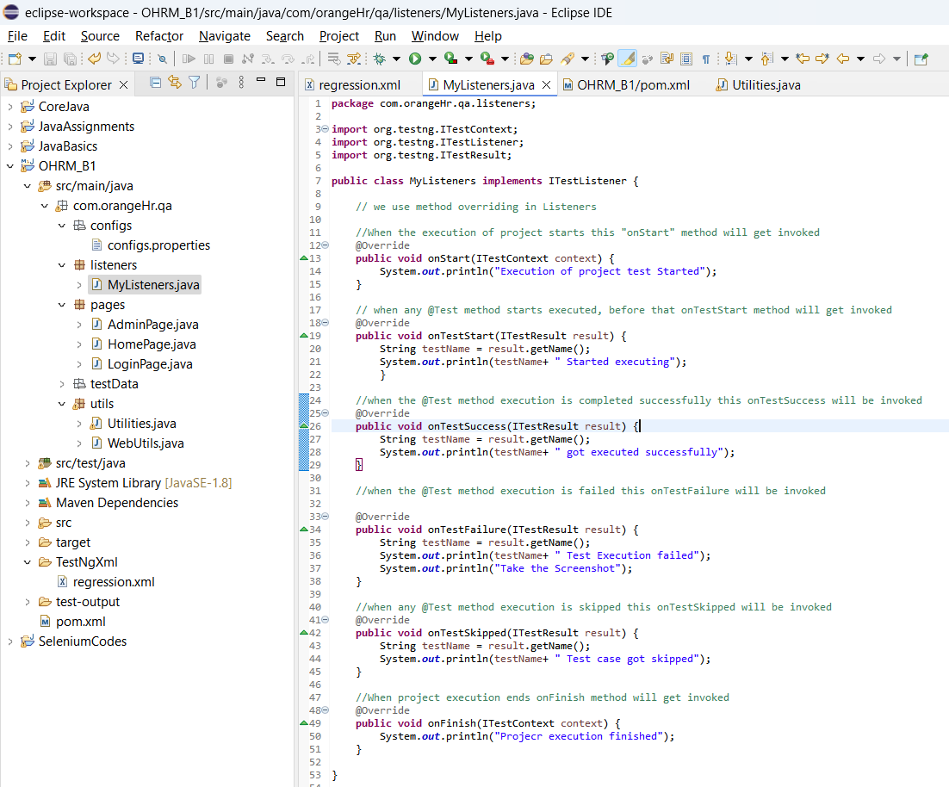

Create a connection between testNg and Listeners :  
(copy the Listener package path without “.java” extention)

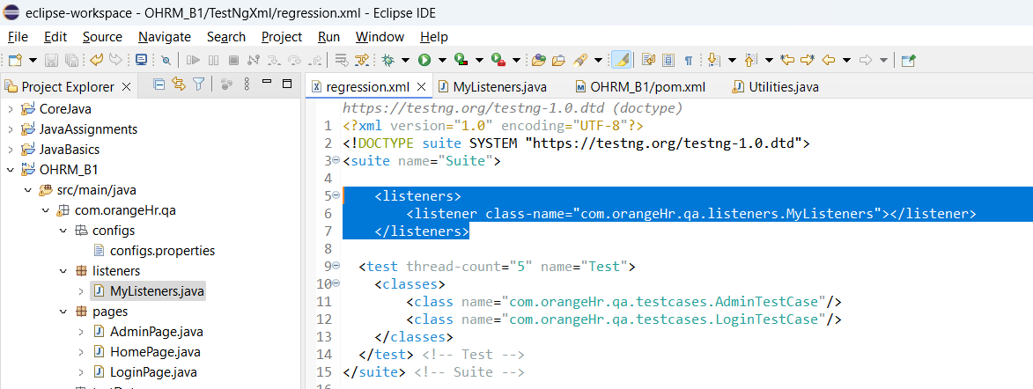

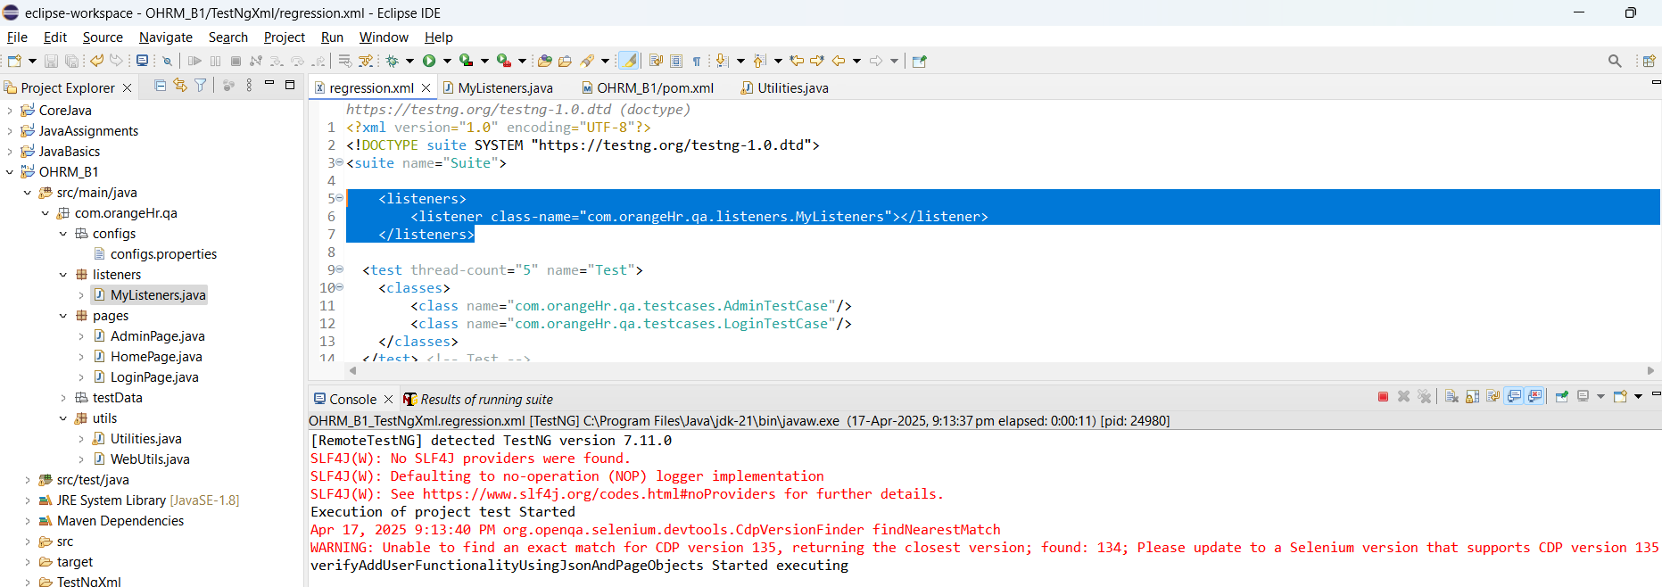

**CLASS 12: (Day 50)**

**ExtentReporter:**

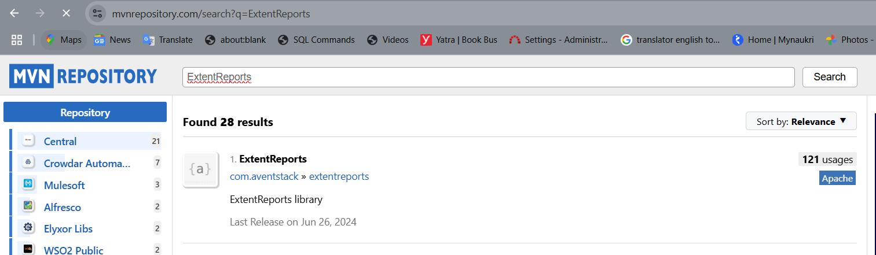

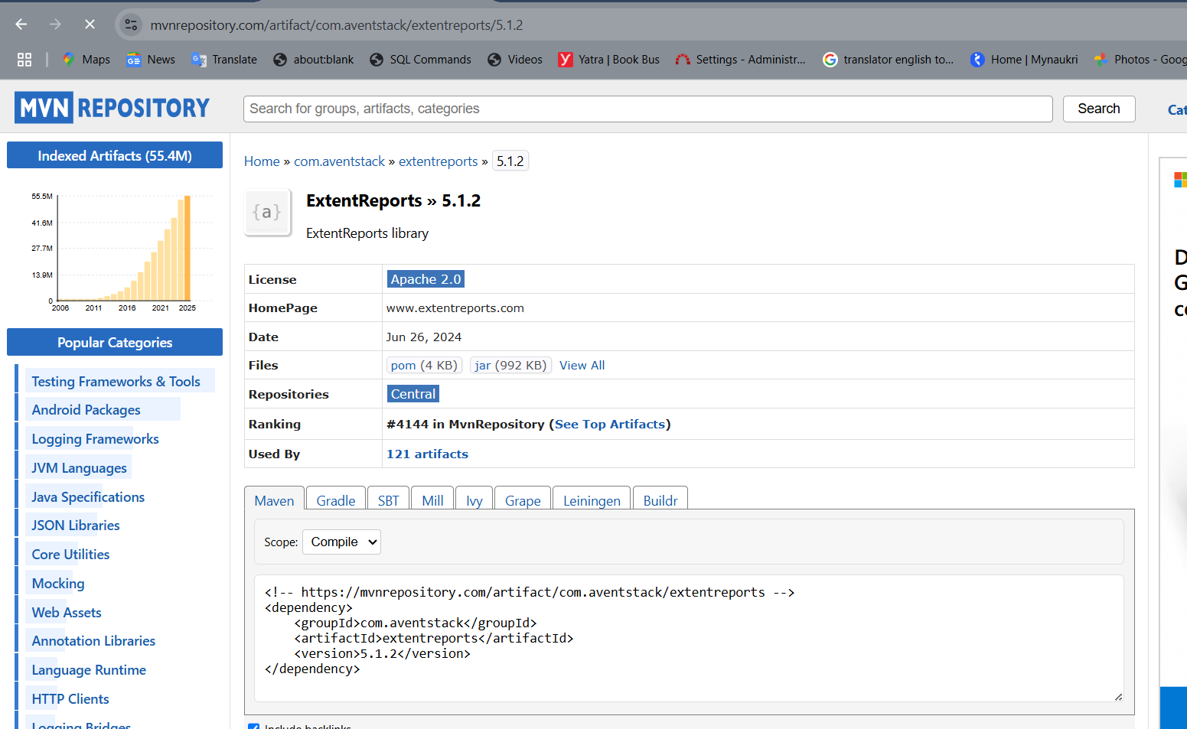

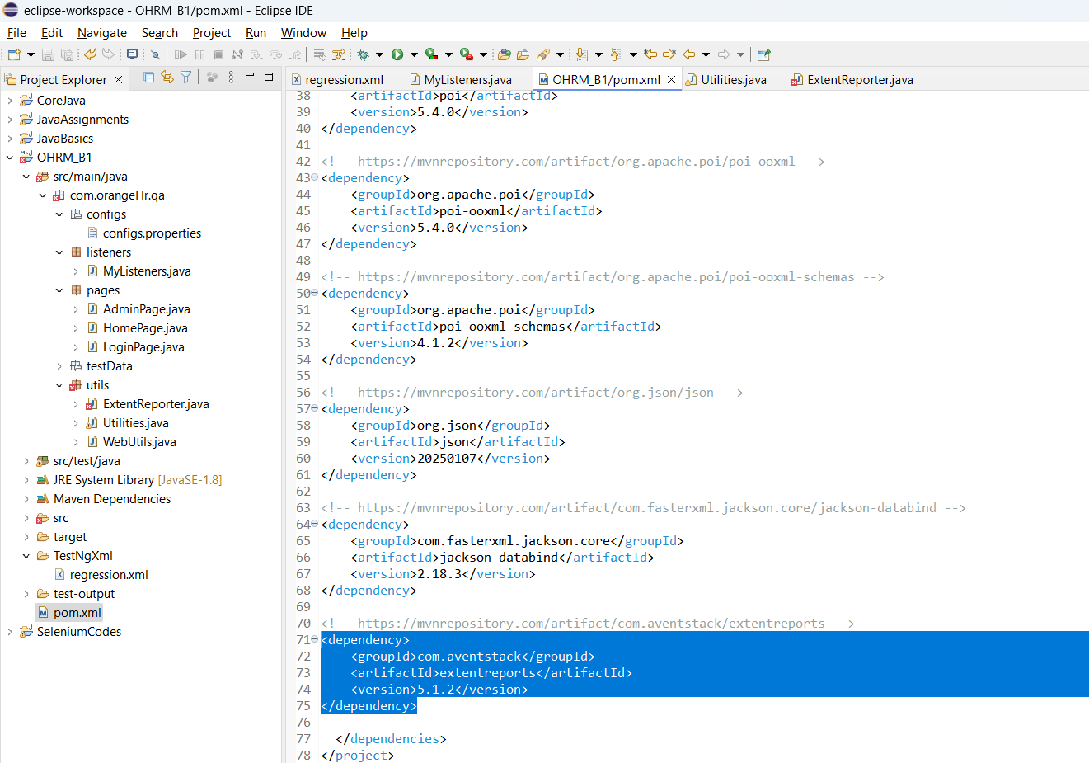

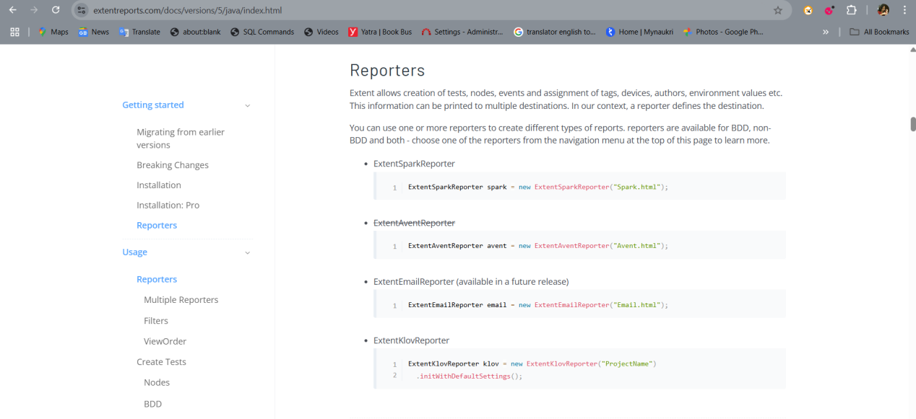

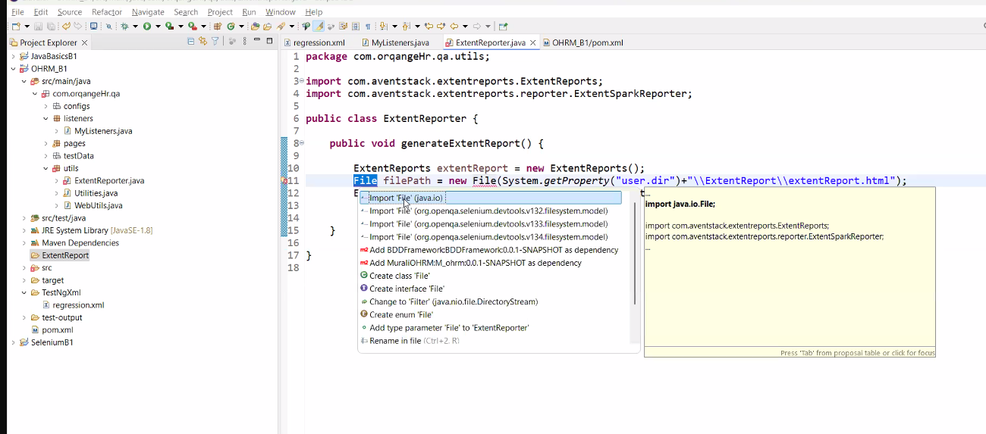

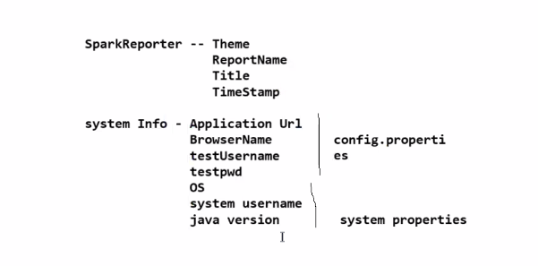

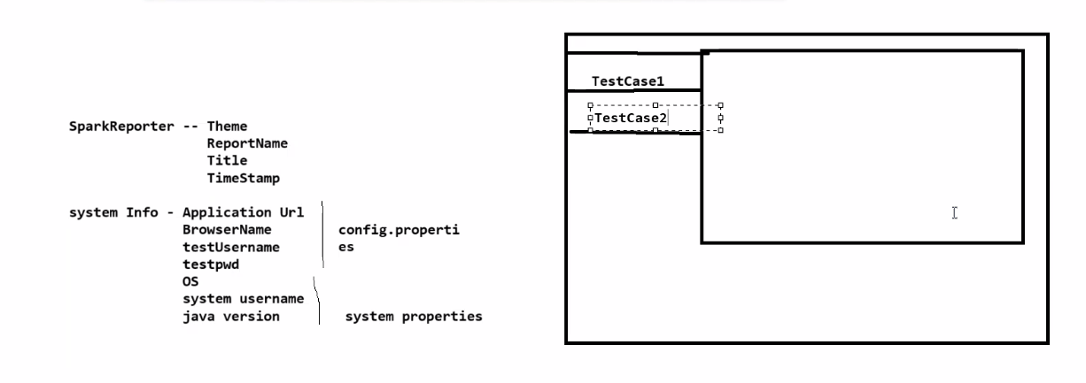 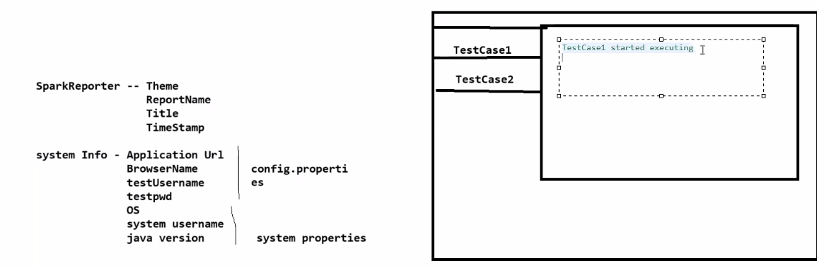

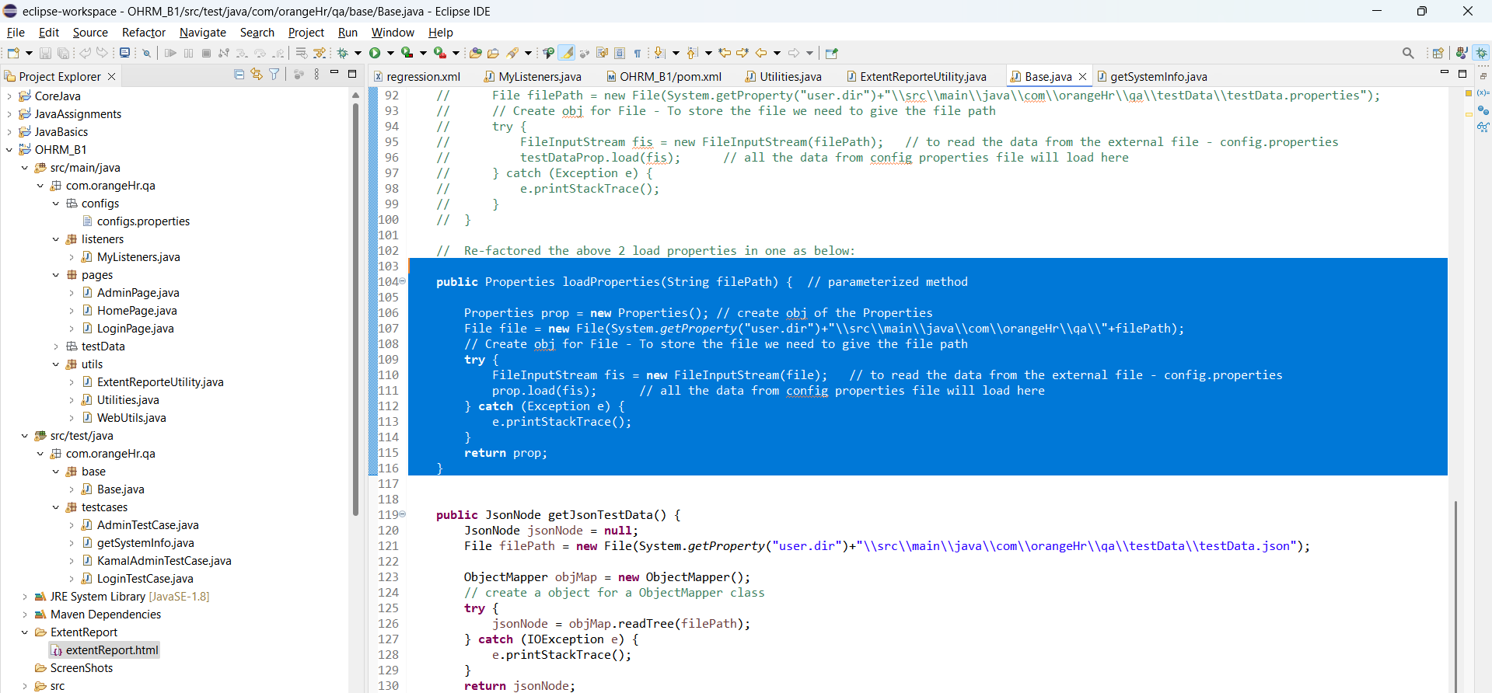

Copy the loadProperties method From Base class to Utilities class:

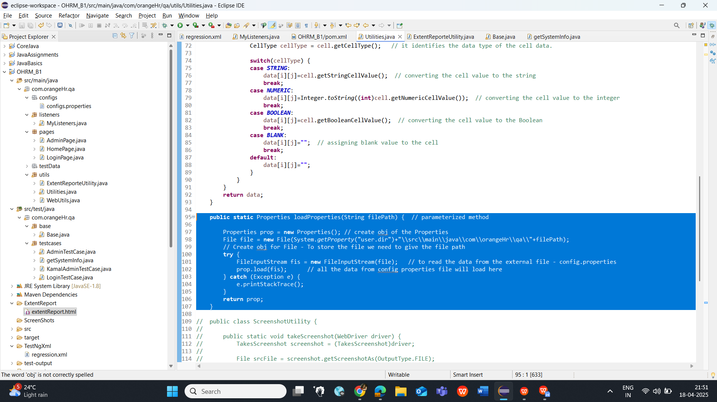

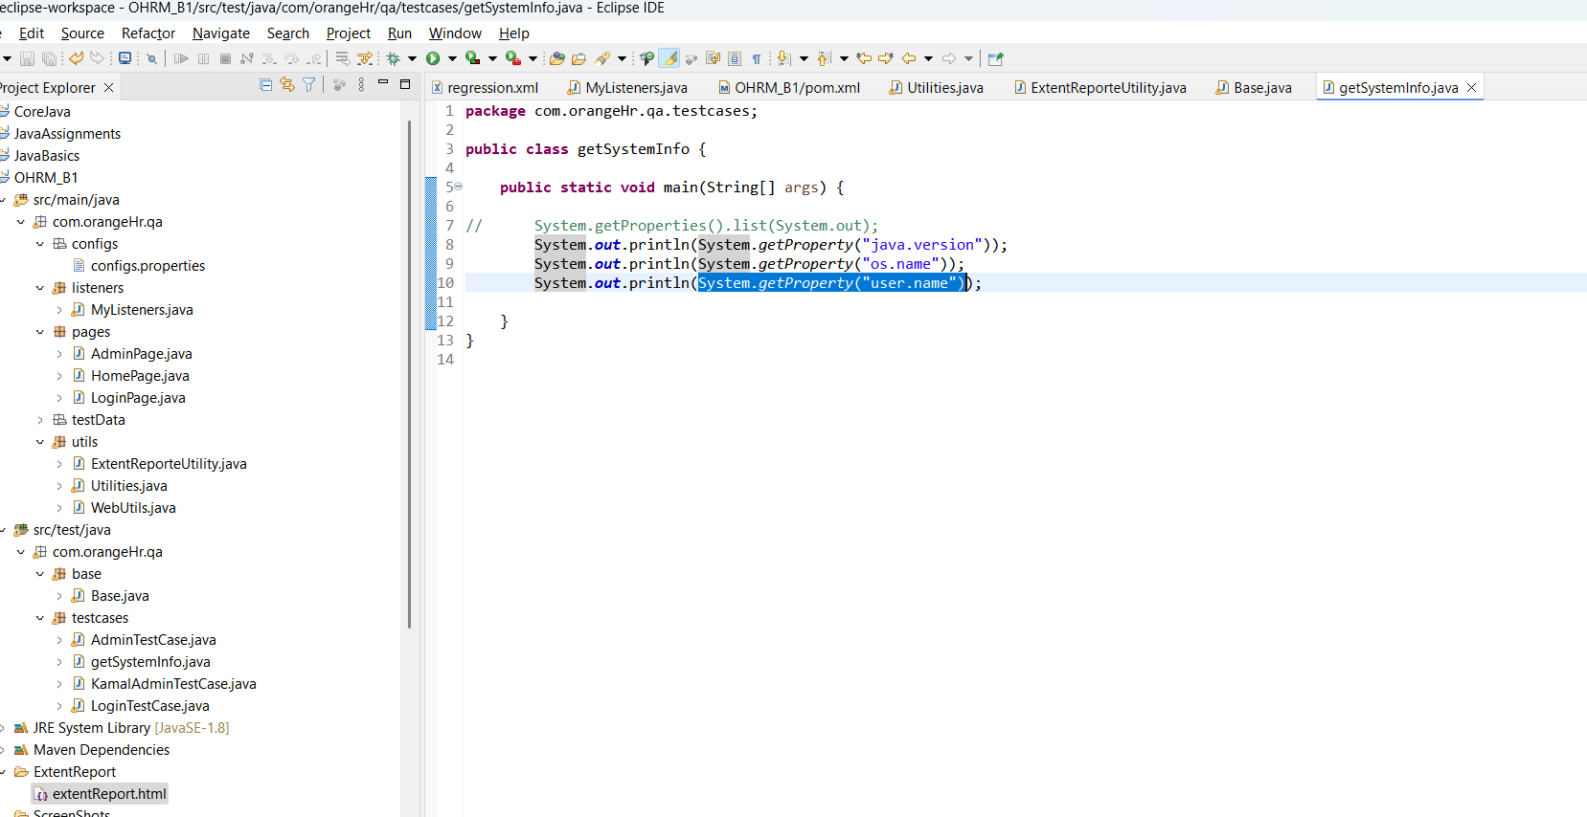

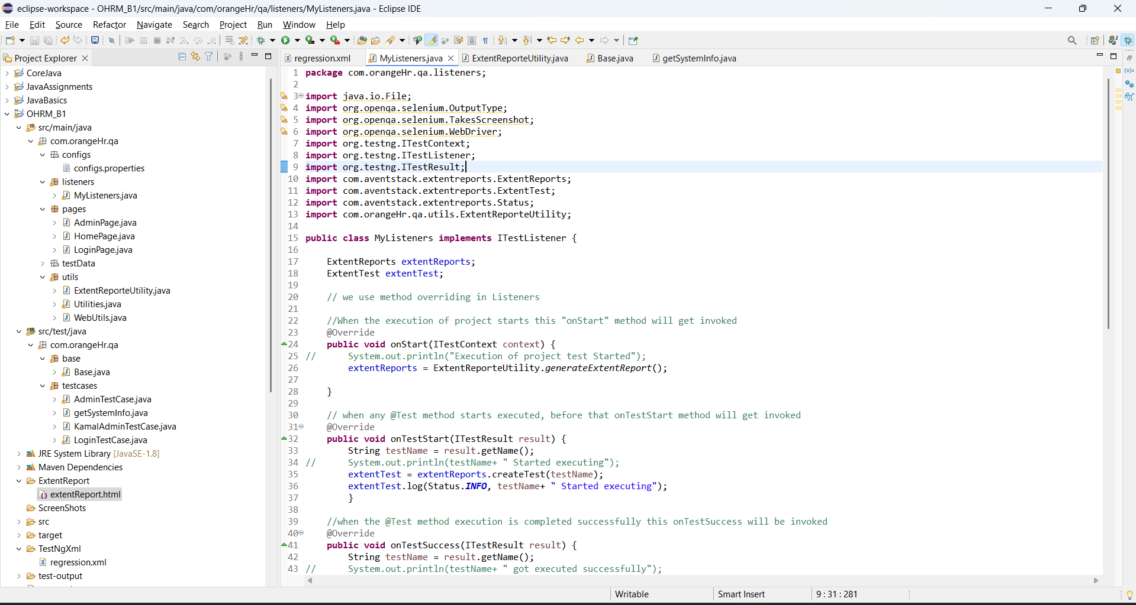

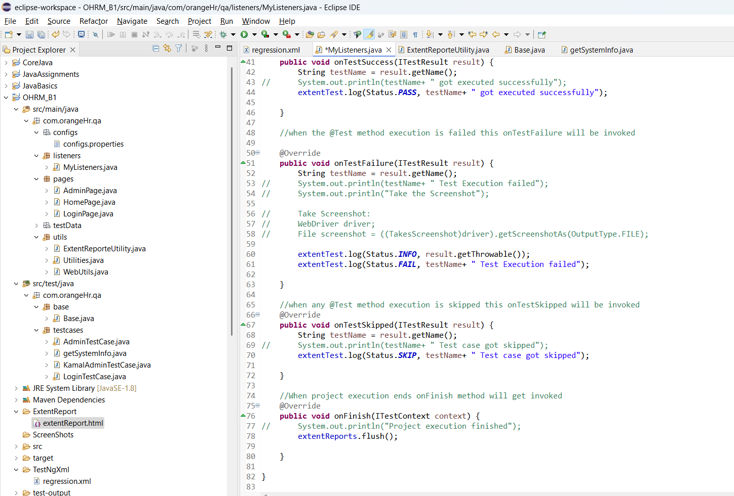

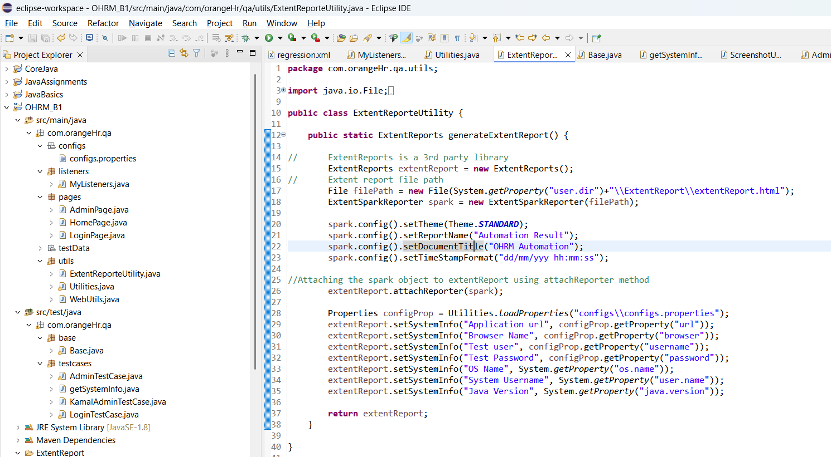

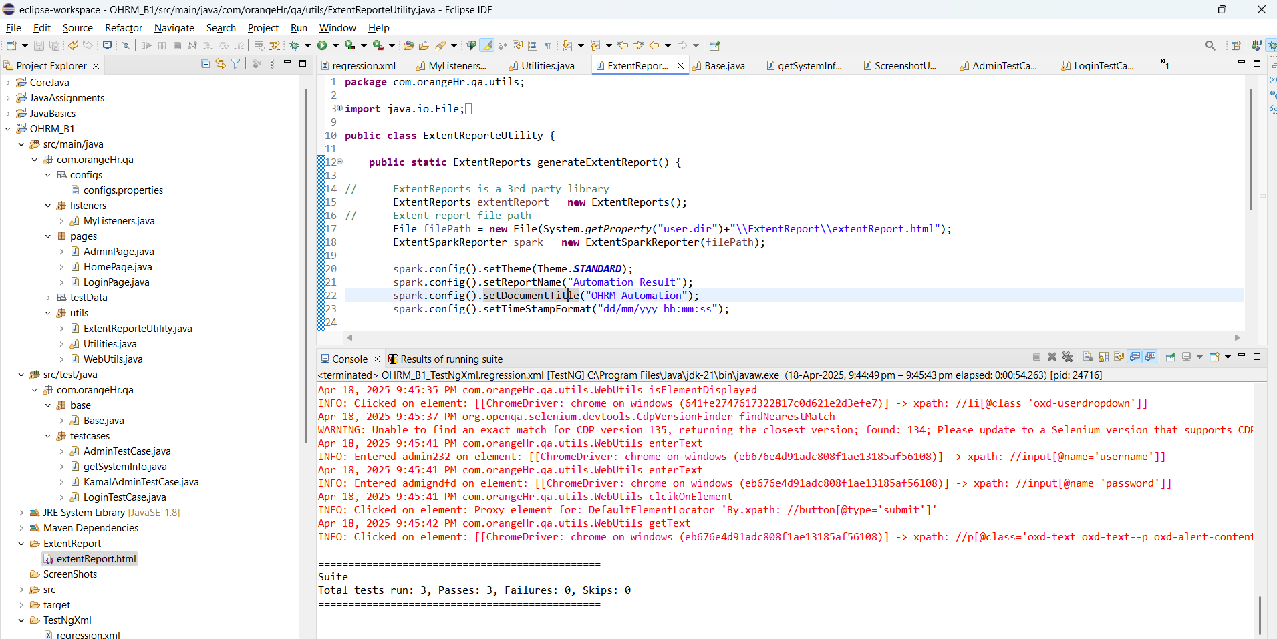

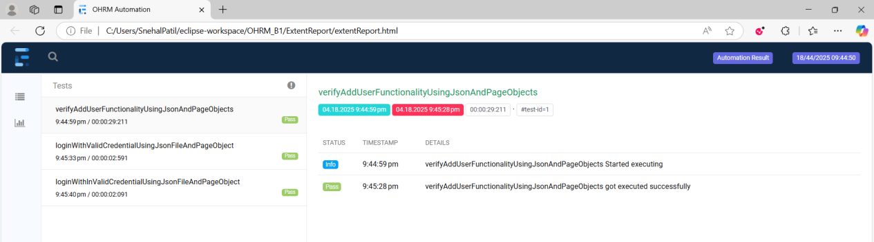

**CLASS 13: (Day 51)**

**ThreadLocal:**

Multiple Browser / multiple testcases running at a time parallelly,

to avoid the confusion for the extent report For which driver / testcase is running, we use ThreadLocal.

Each thread will be having it’s own driver.

Example Framework:

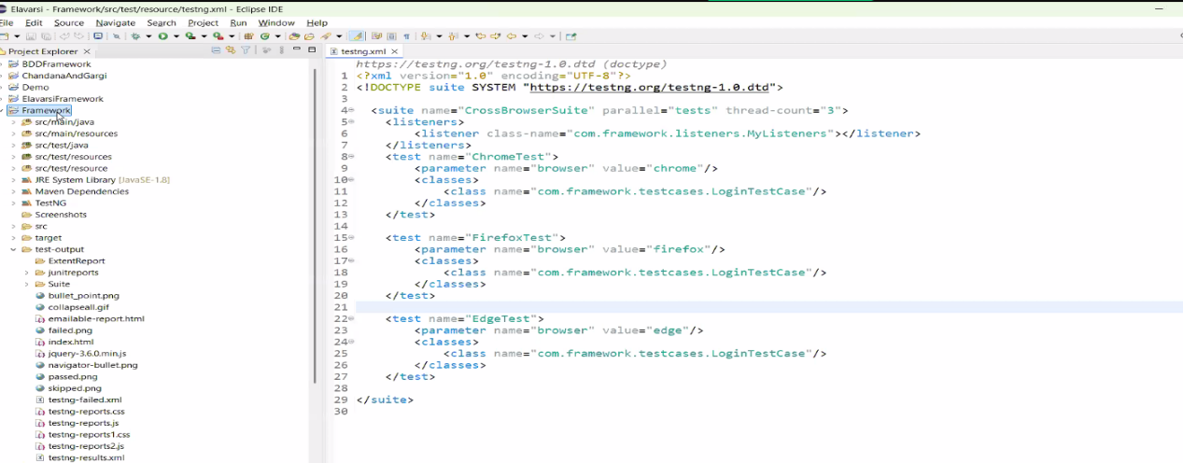

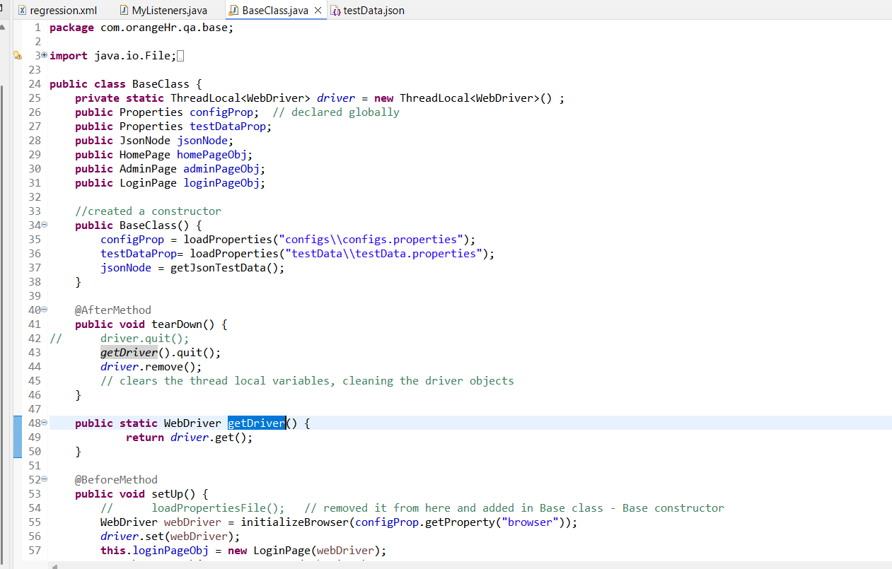

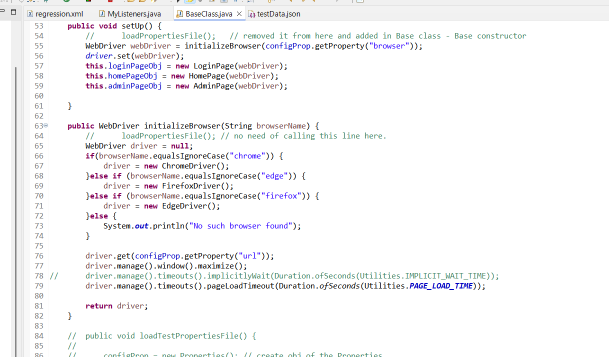

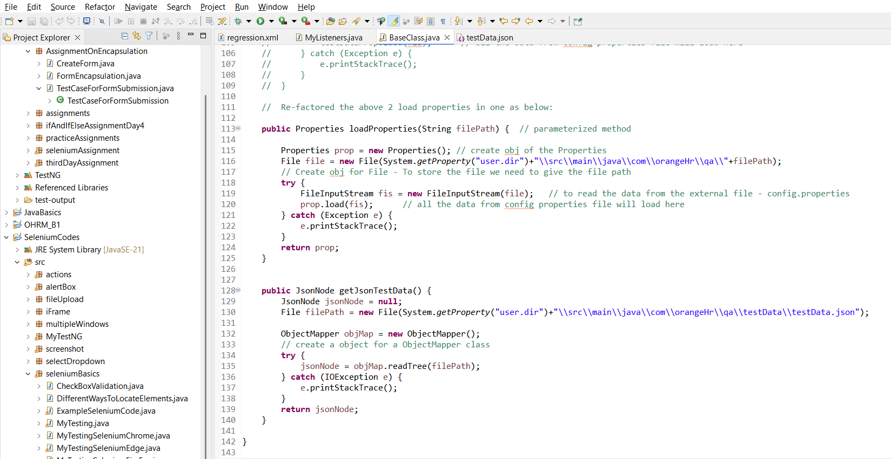

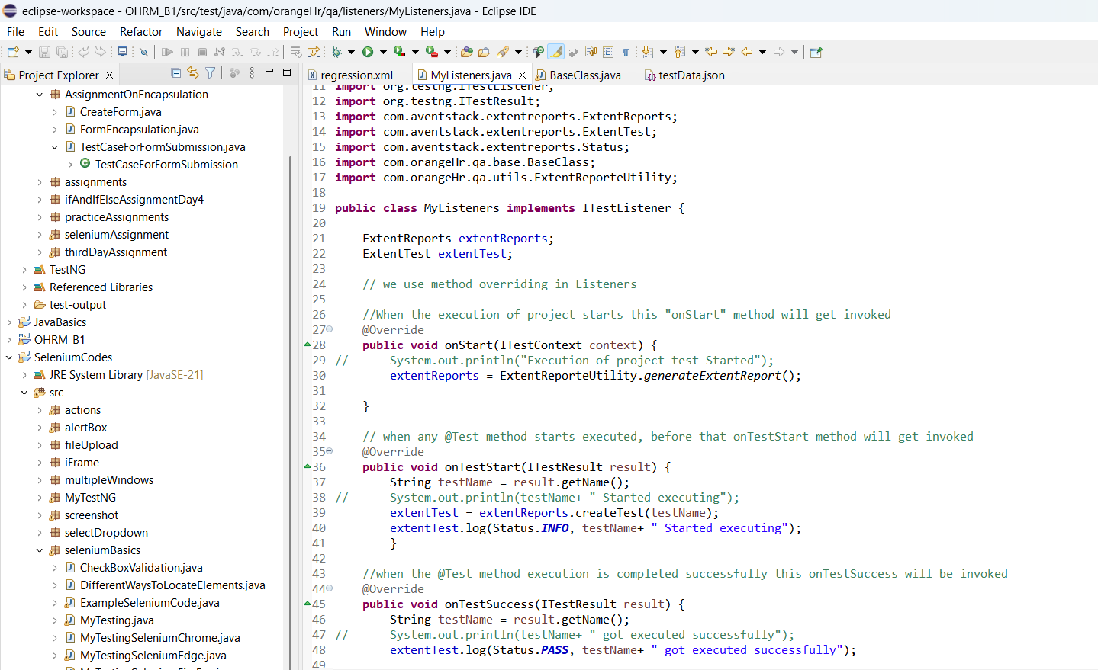

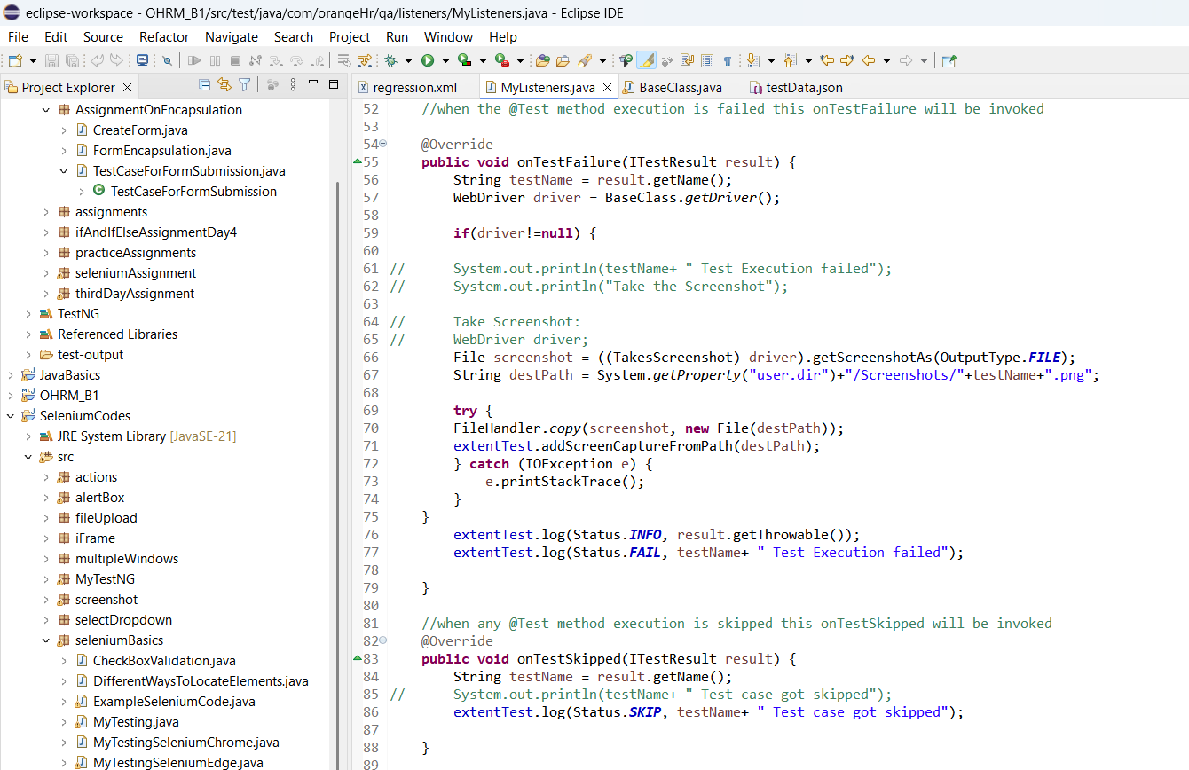

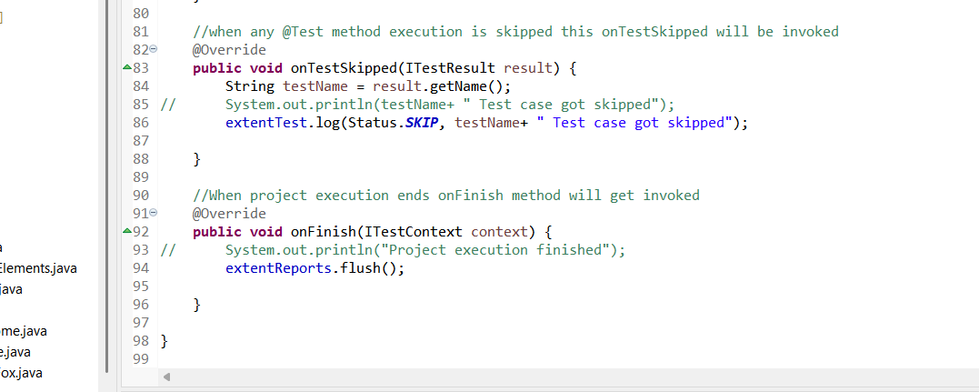

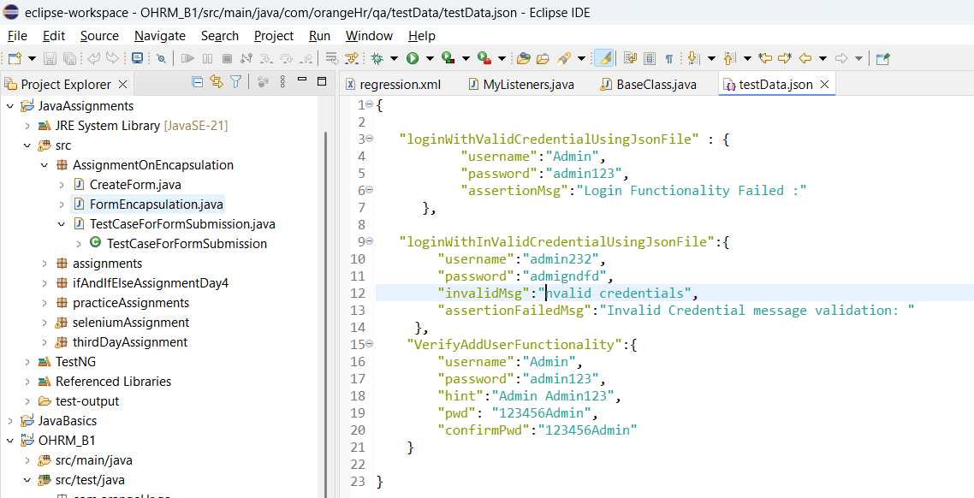

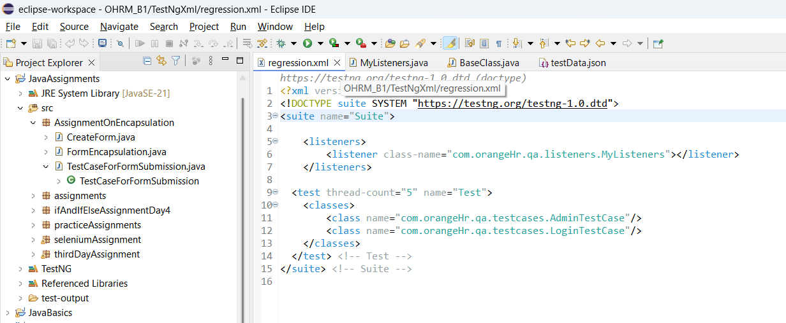

**CLASS 14: (Day 52)**

GITHUB - Pushing the code to GitHUB

Running the code through JenKins

CI - Continuous Integration

After finishing the code developer push their code to the shared Repository (GitHub / BitBucket).

One CI pipeline will be triggered while the code push, for the Unit testcase and Integration testcase written by the developer & API/UI automation testcases written by Testers,

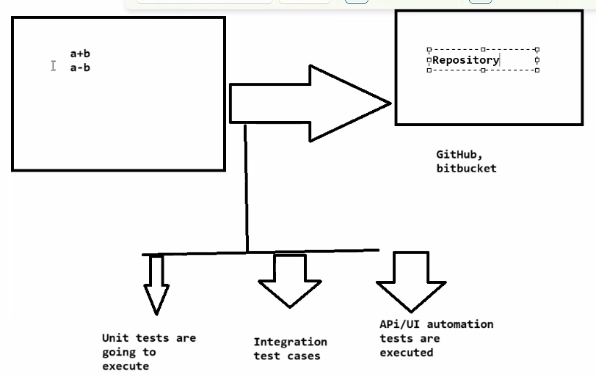

If any failure in the testcases, the code will not be pushed to the repository.

**What Happens in CI?:**

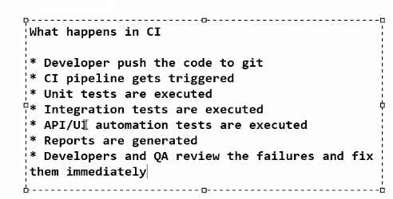

**Benefits of CI:**

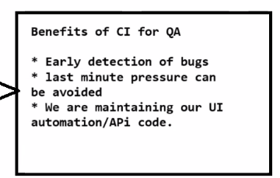

**Responsibilities of QA:**

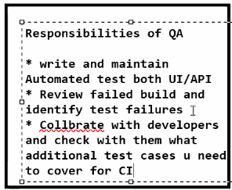

* Smoke Testing (Critical functionality) functionality can be implemented as part of CI - UI test.

**CD - Continuous Delivery & Continuous Deployment**

Next step for CI.

**Continuous Delivery:** Ready for the release at anytime but here we need the human approval.

**Continuous Deployment:** It will automatically released to the Prod /any environment.

**CD flow: (Prod deployment CD)**

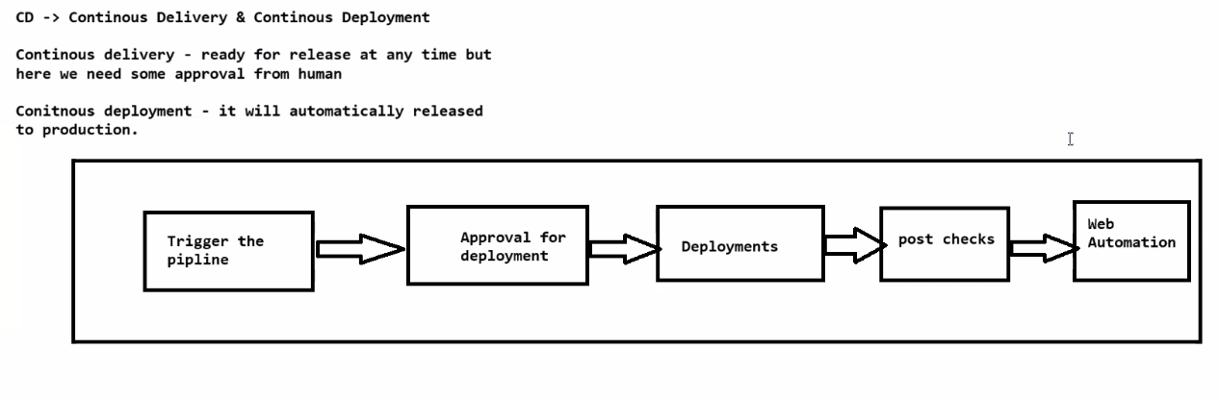

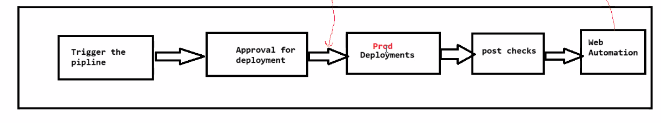

**Commonly used CI/CD Tools:**

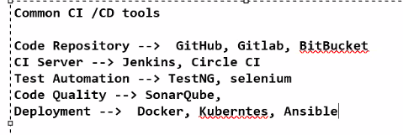

**CLASS 15: (Day 53)**

**MAVEN:**(Run the testcases through Maven):

Right click on the project name > Run As > Maven test.

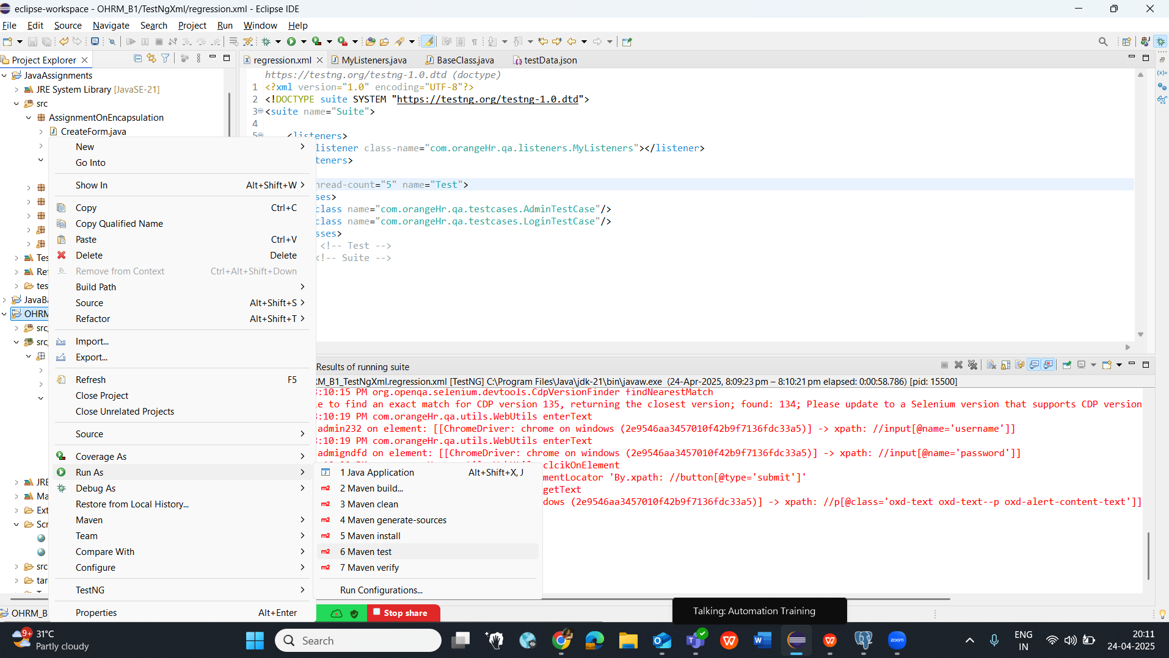

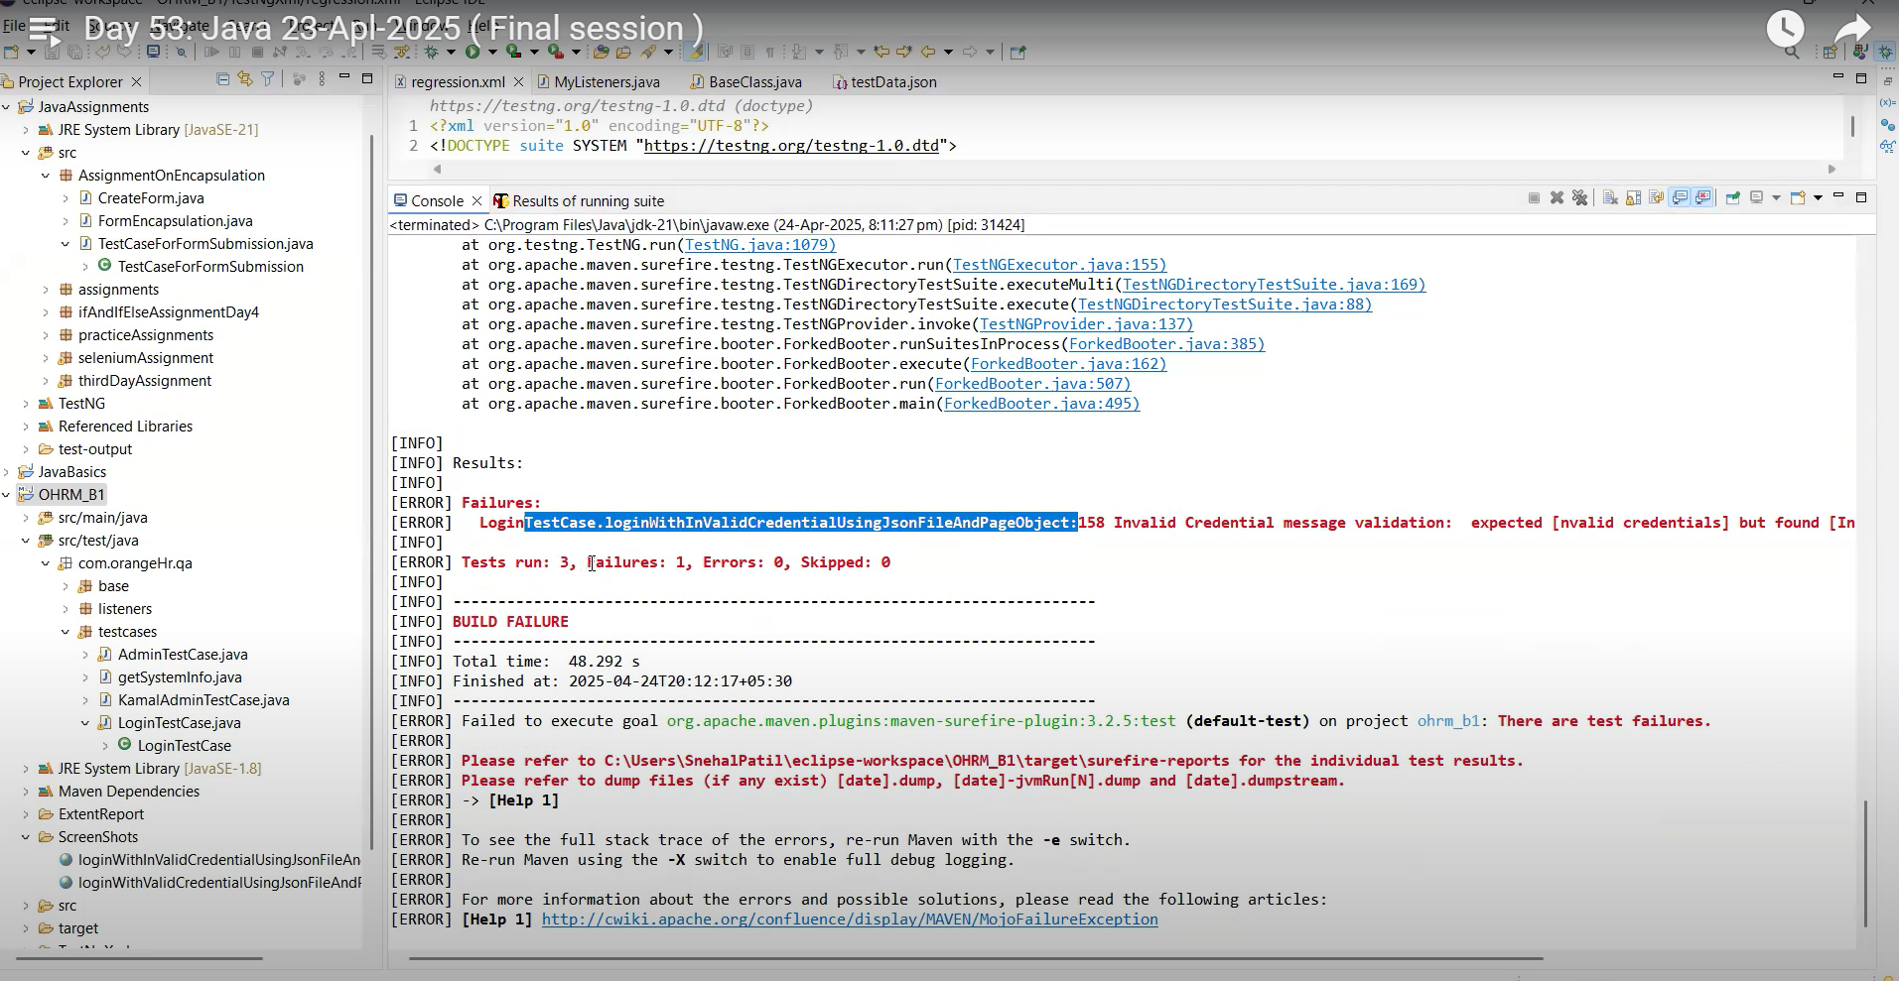

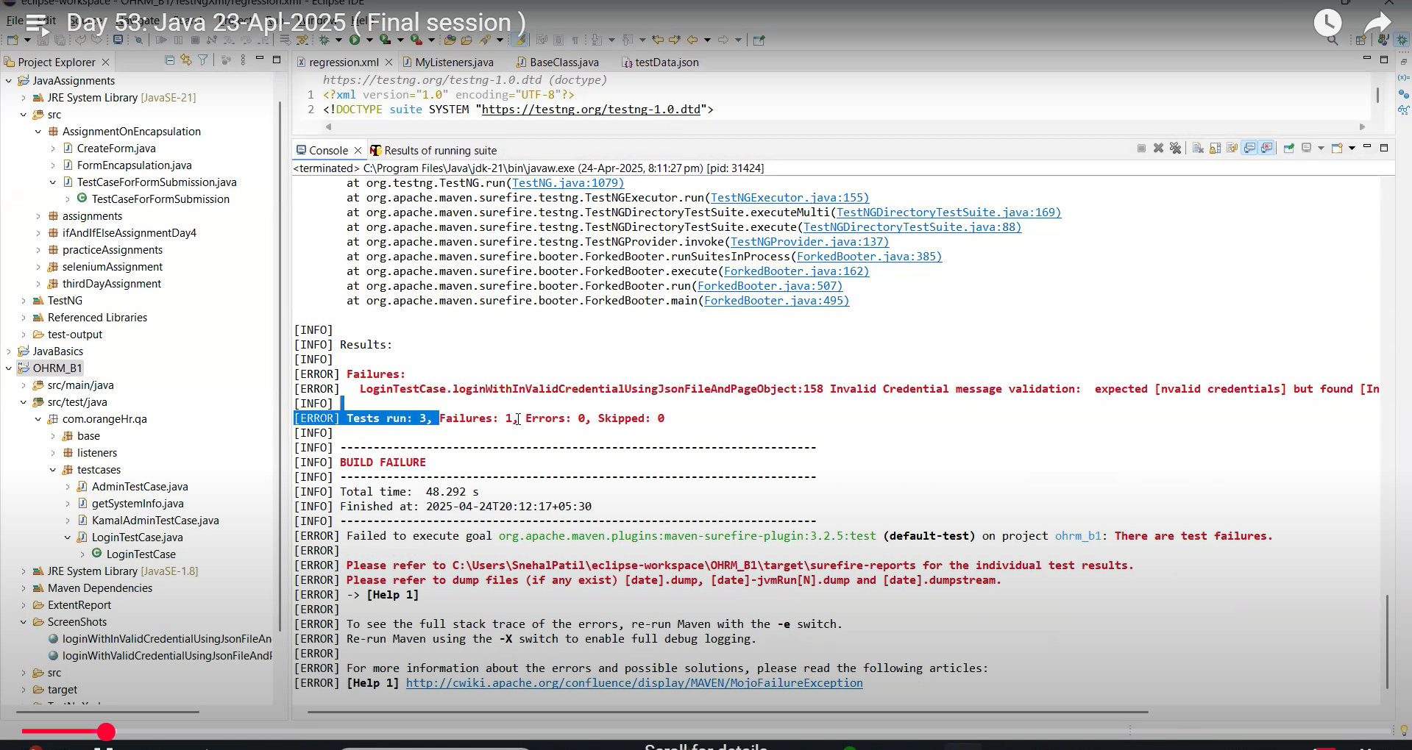

Update the code with correct data and rerun the code -

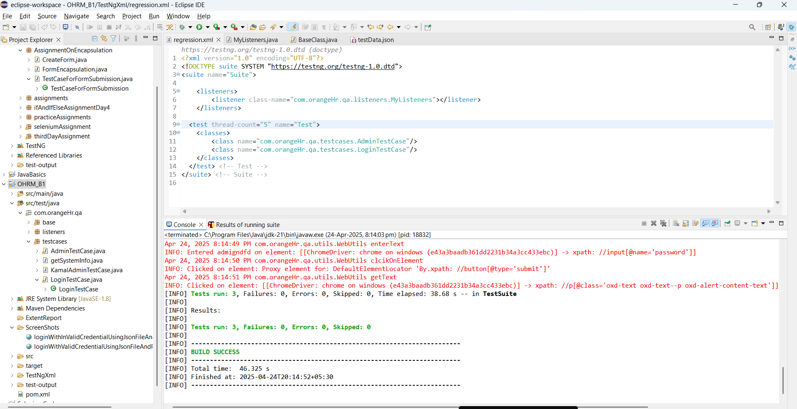

Extent report is not generated.

* Usually we run the Automation Framework through command line prompt.
* We need to establish a connection from pom.xml file to the testNG file.
* For the connection establishment, add few lines in the pom.xml & add a dependency - “Maven-Surefire-Plugin”

Connection establishment between : Maven ---> pom ----> testNG.xml

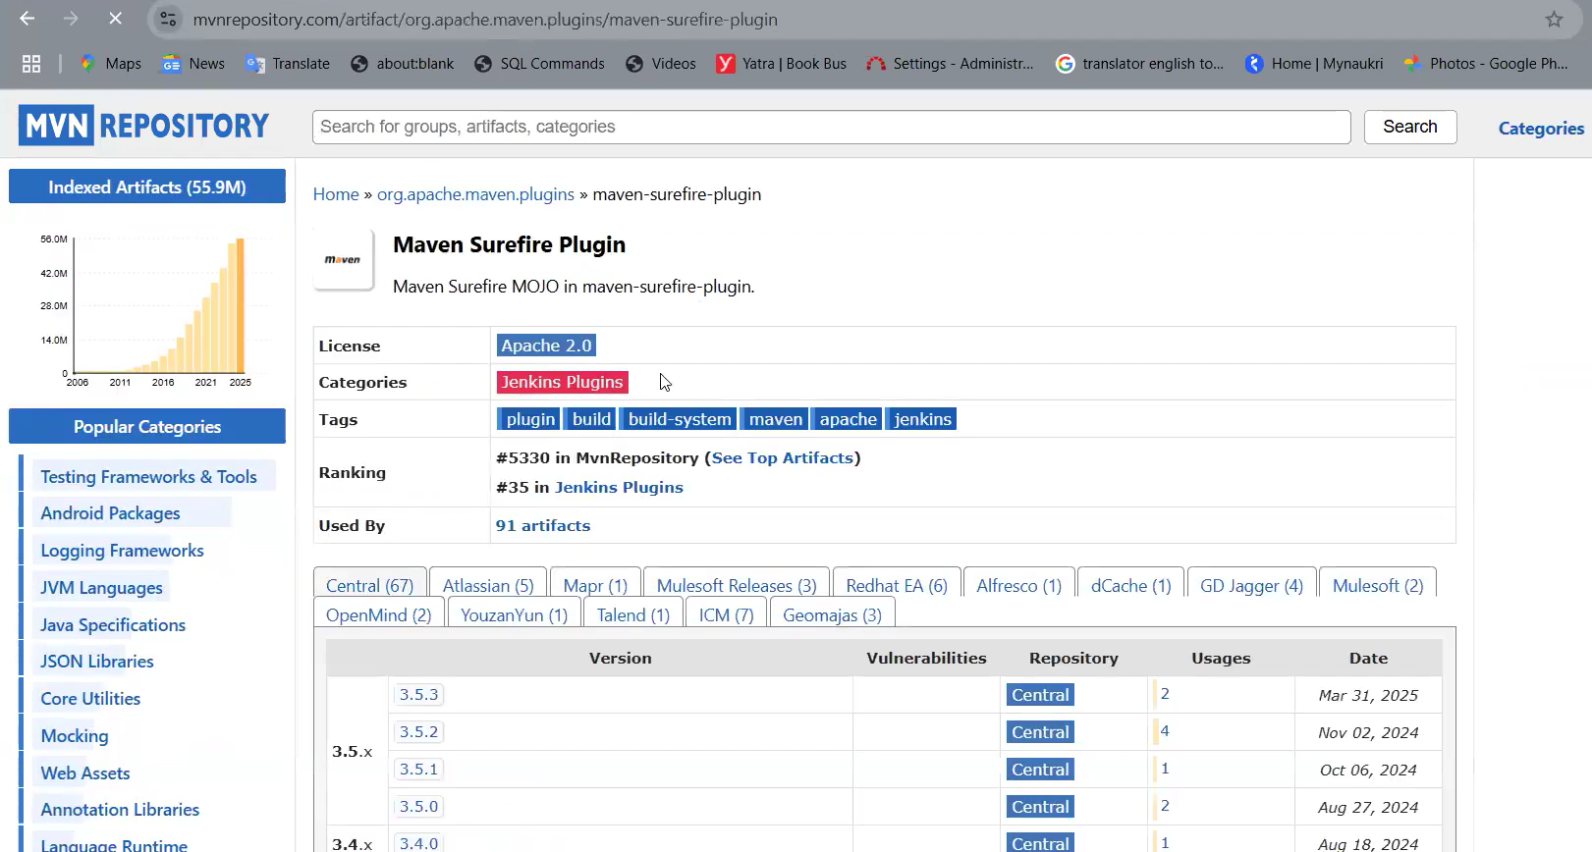

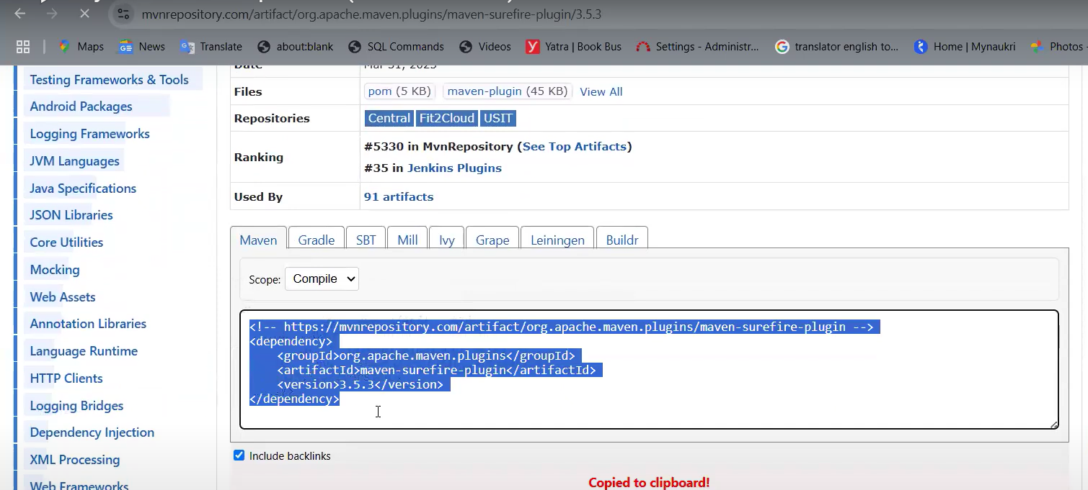

Paste the copied dependancy code, under plugin. And remove the dependancy tag.

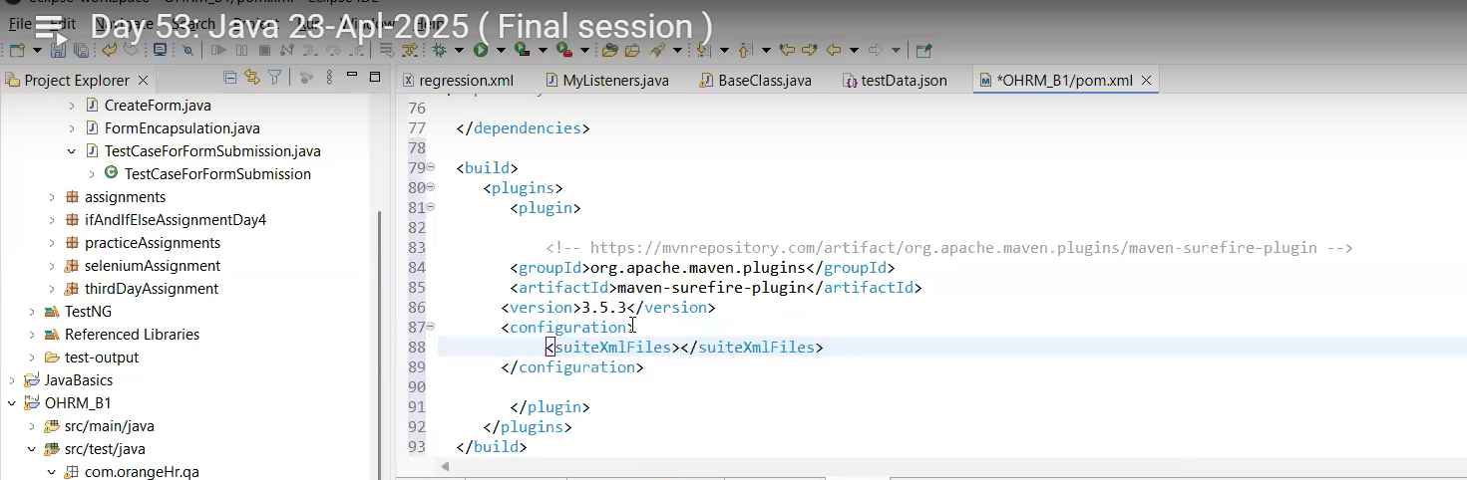

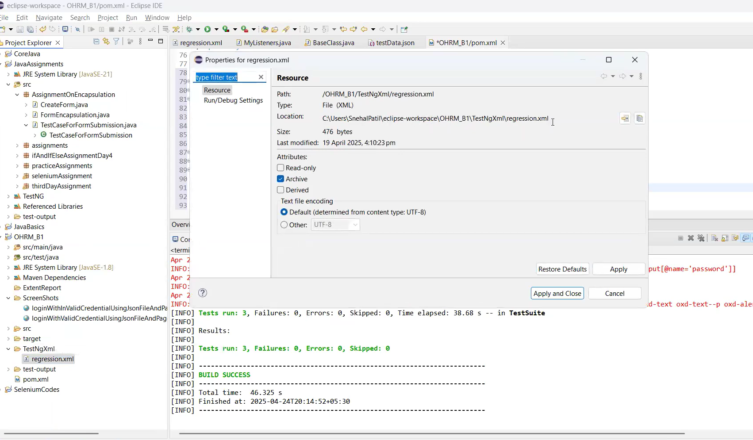

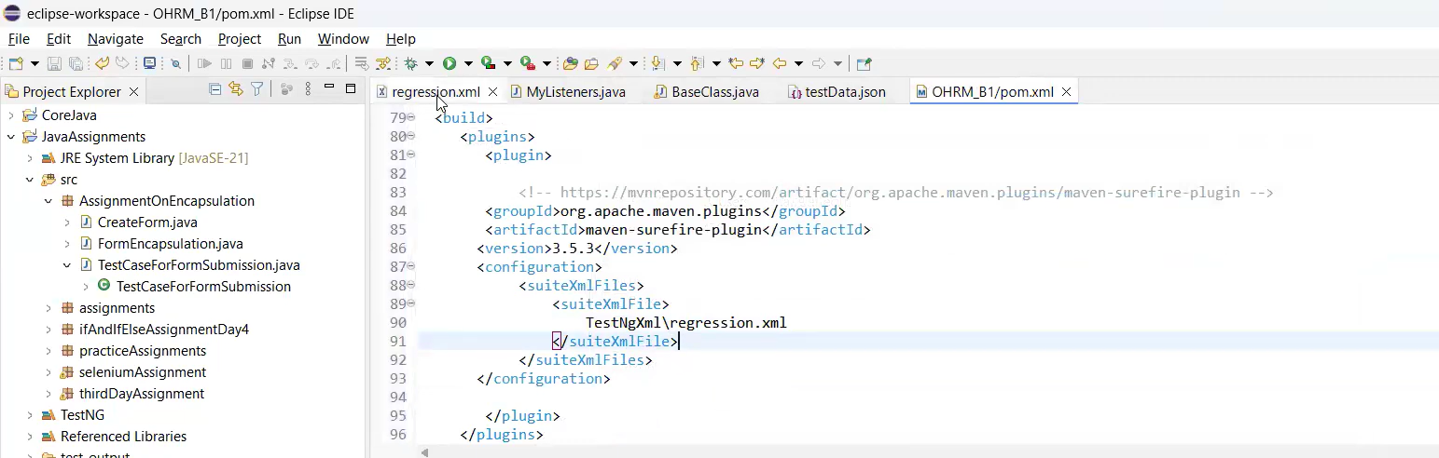



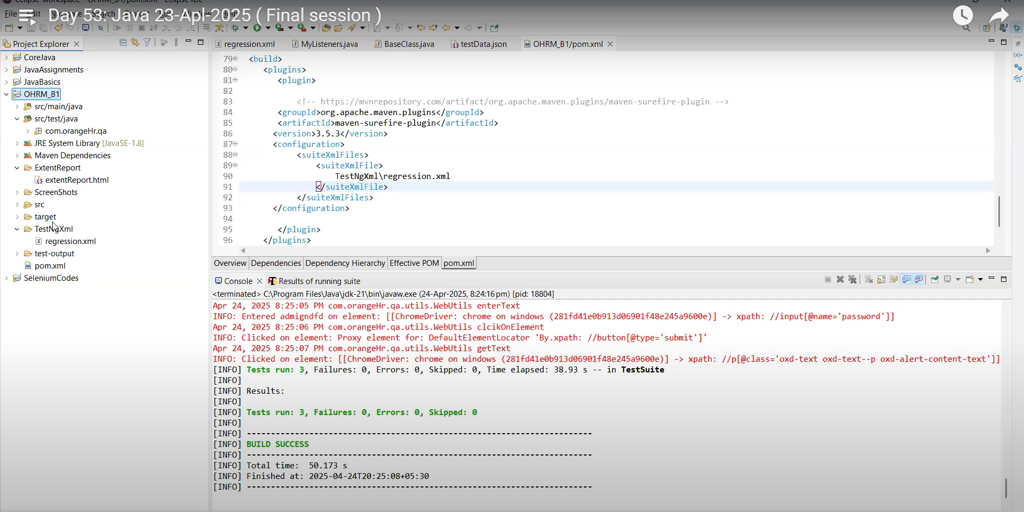

Extent Reports:

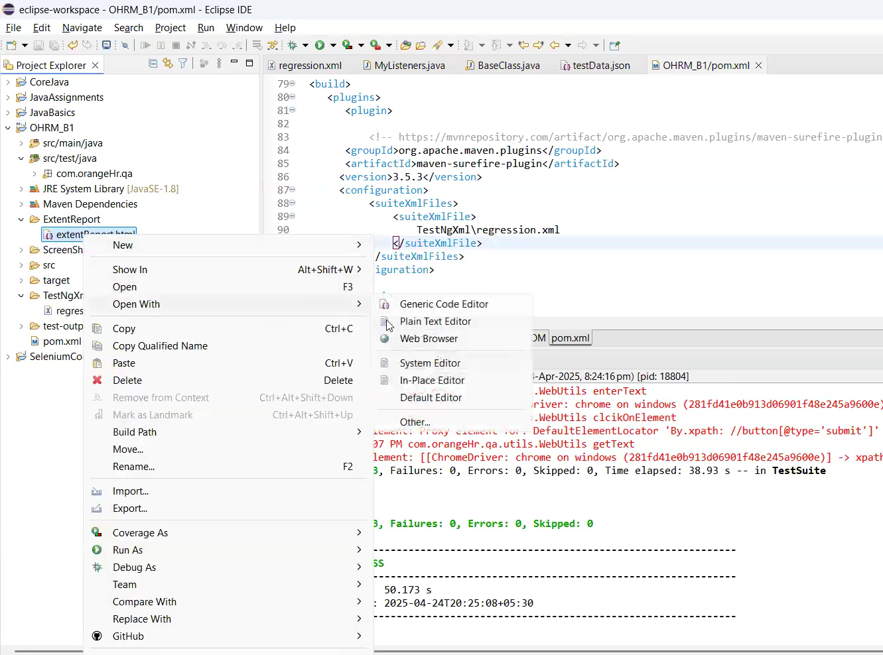

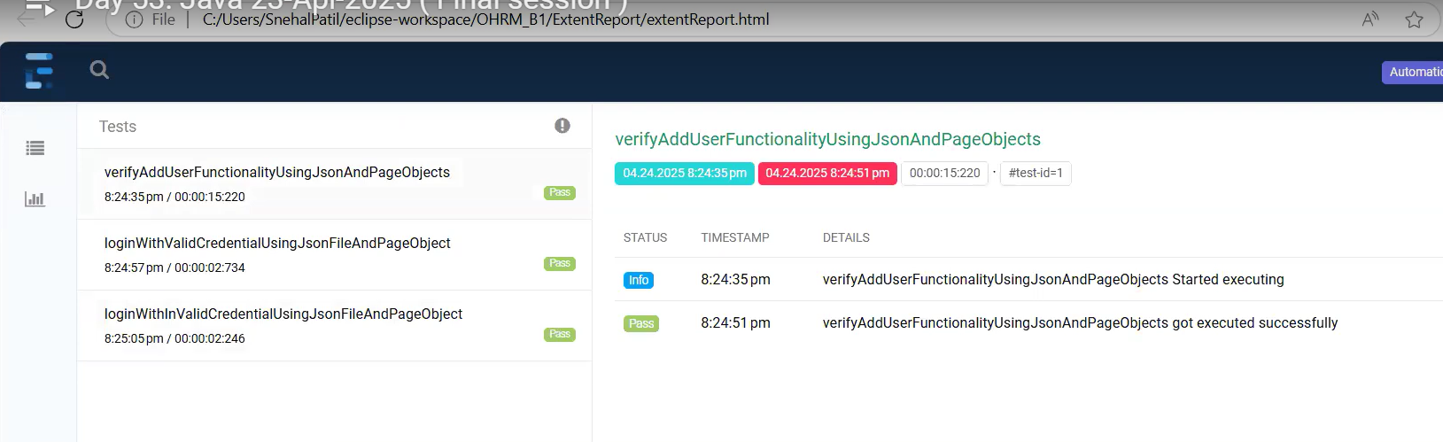

When we run through Maven test how it is deciding which test have to run?  
  
Remove the connection between pom.xml and testNg.

Project > Src/test/java >  
//Class name should include 'test' word

// Method should have @Test annotation

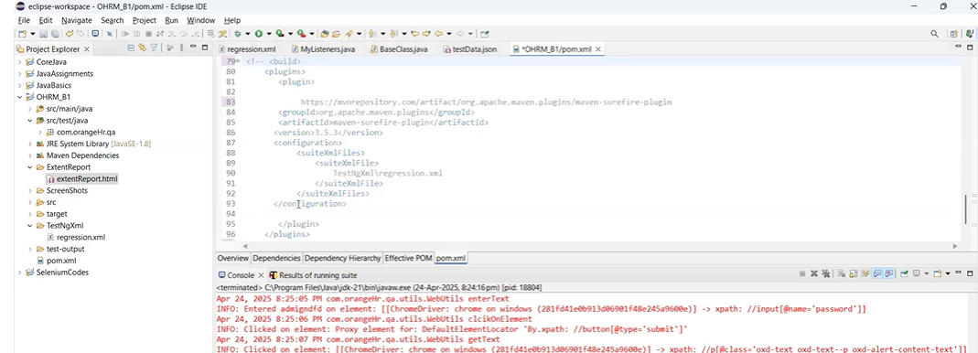

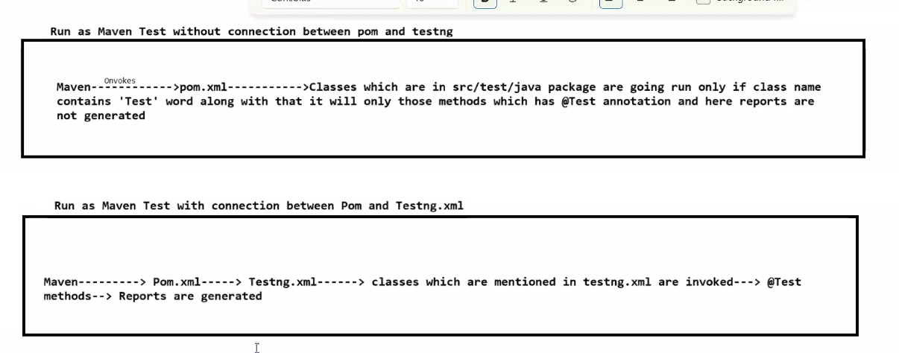

**Steps to Download Maven:**

* Download Maven
* Extract and keep it in the C folder

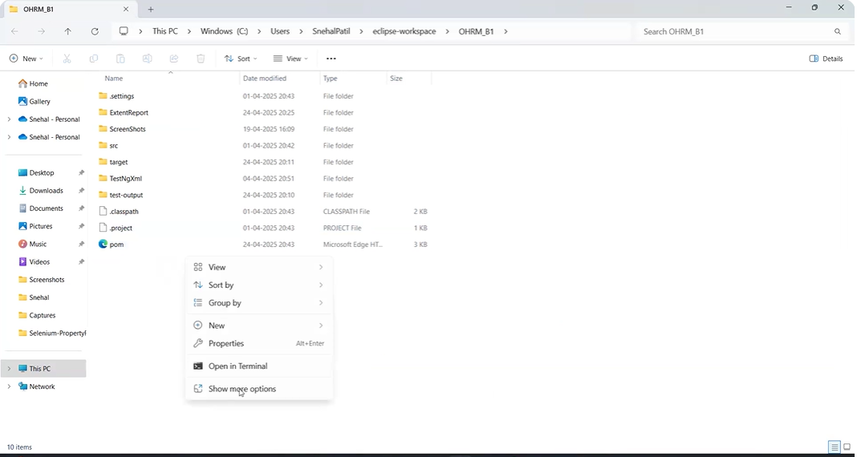

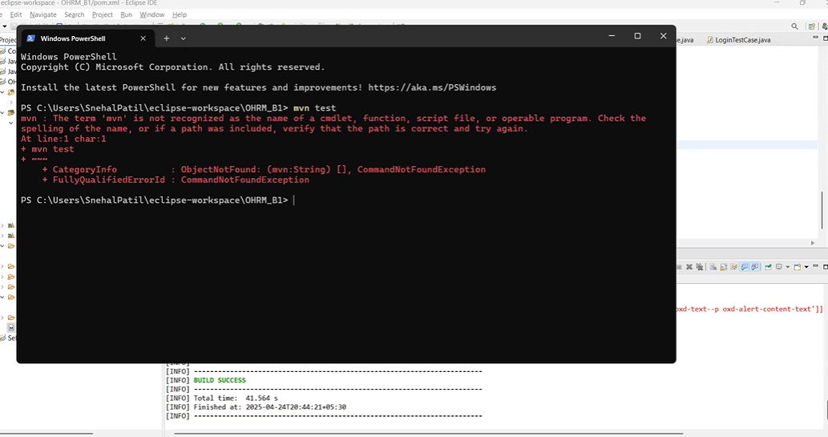

(Need to install the Maven following the above steps)

* Setup the path for Maven in Environment setup

MAVEN_HOME (maven folder path: C:\apache-maven-3.9.9)  
 Create/add New Path > PATH (Bin folder path: C:\apache-maven-3.9.9\bin)

* Go to pom.xml folder ---> open with terminal and run the commands.

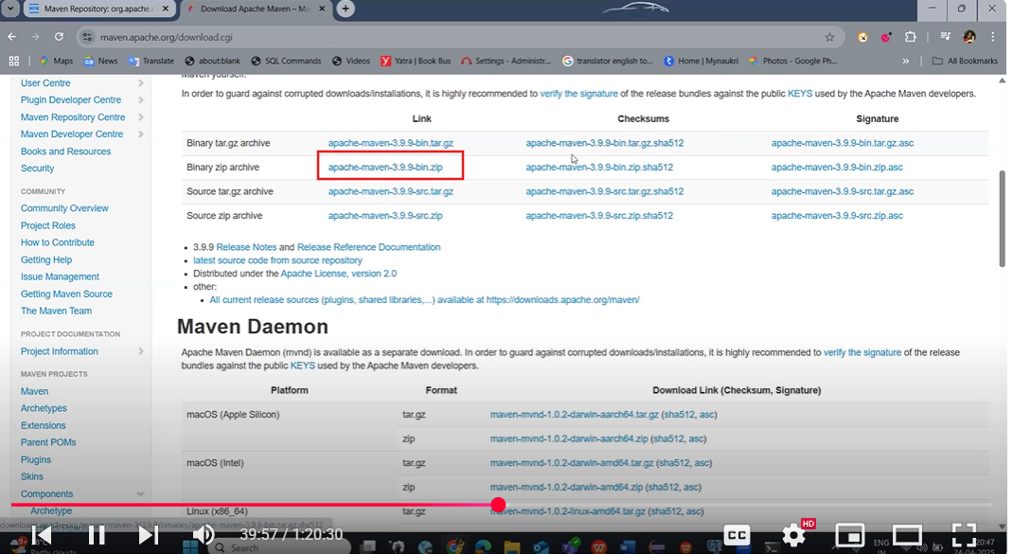

**Commands:**

mvn compile - compiles the source code

mvn test - run the test

mvn install - compile the code and run the testcase, checks for the dependancies required and gets it downloaded.

mvn clean - clean up the project

mvn clean install - we can use the mvn clean and mvn install bith the commands.

**Best Practice:**  
mvn clean --------> mvn compile -----------> mvn test

(once in a while we can use **mvn install**)

**JENKINS:**

Download Jenkins -

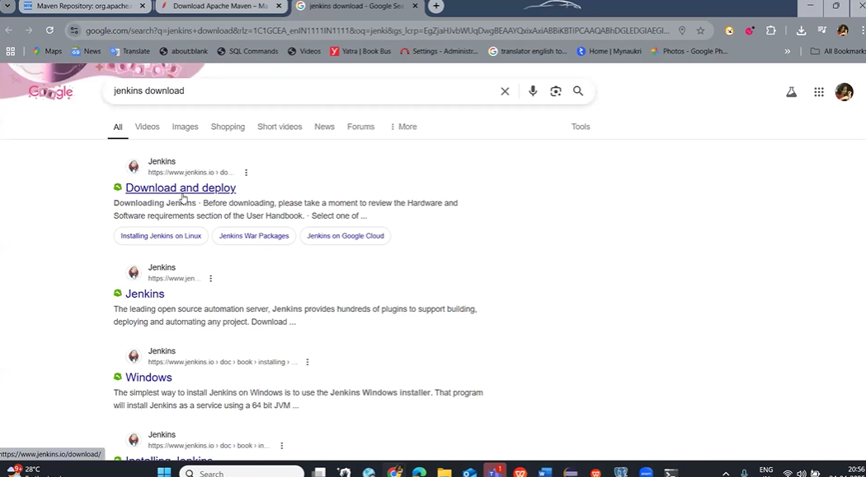

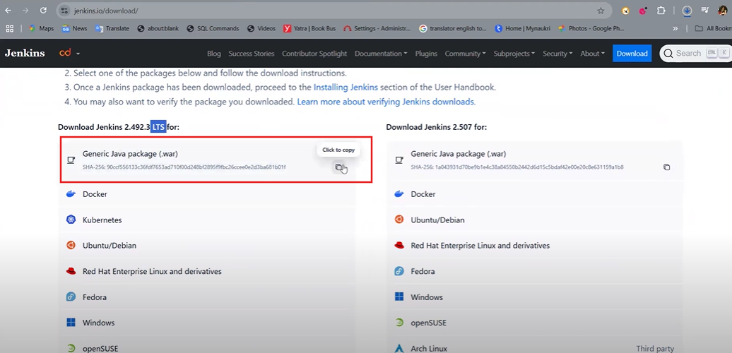

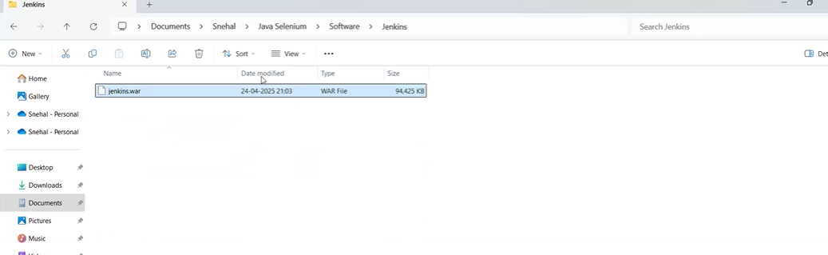

Open in terminal >

Execute this command --> Java -jar jenkins.war

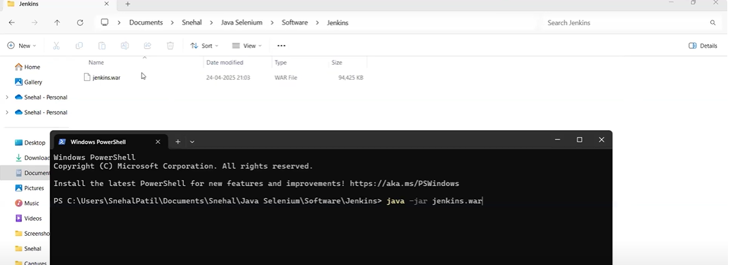

Copy the password and keep It saved in a notepad or note.

Now go to browser and in Url type - **localhost:8080**

& hit enrer (http://localhost:8080/

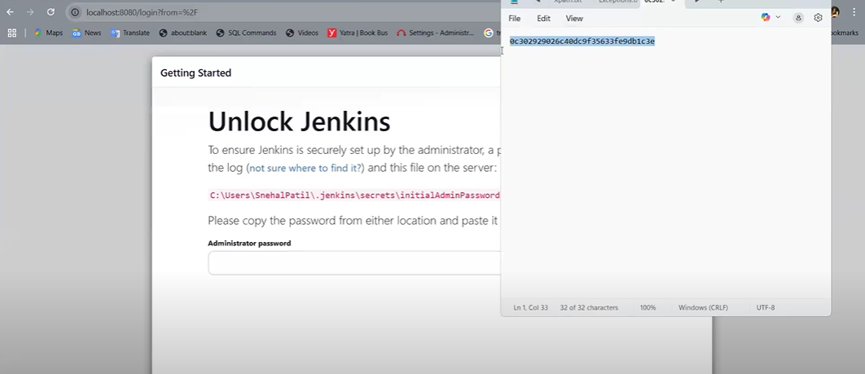

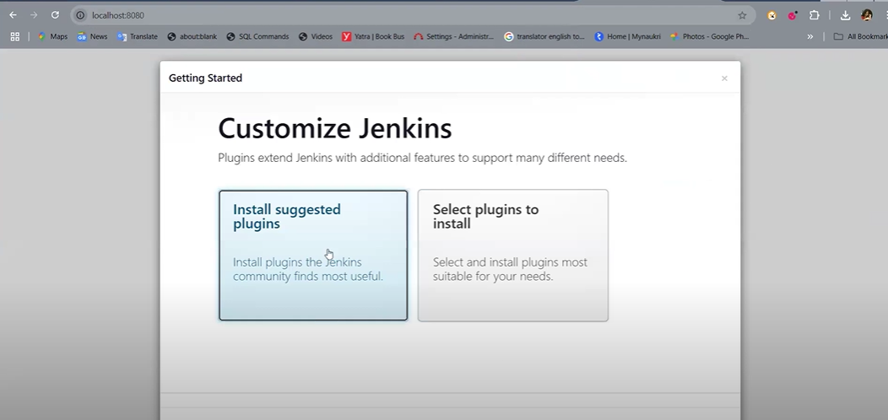

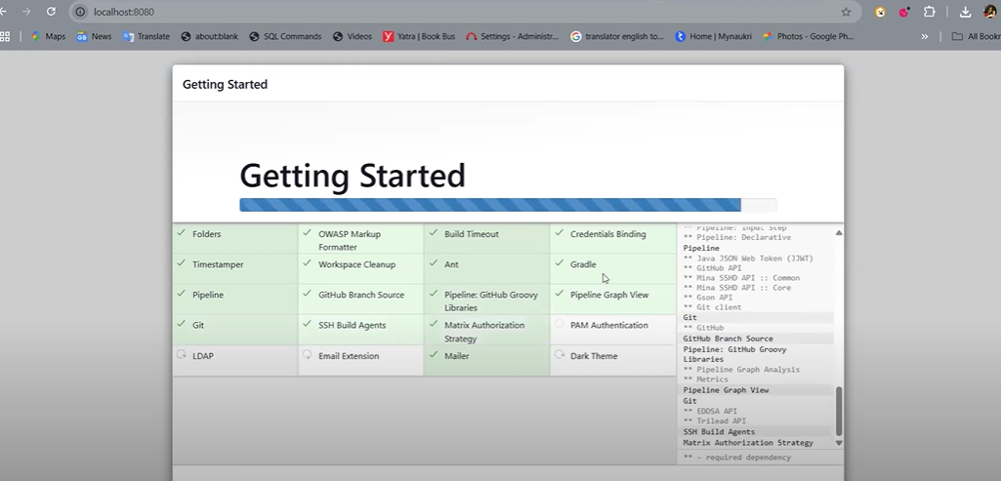

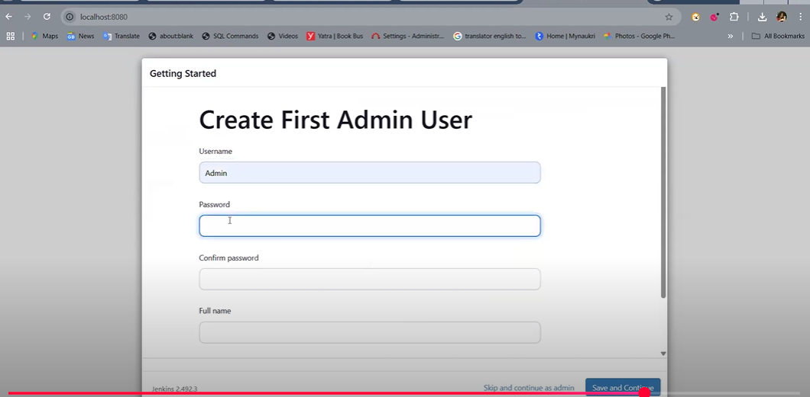

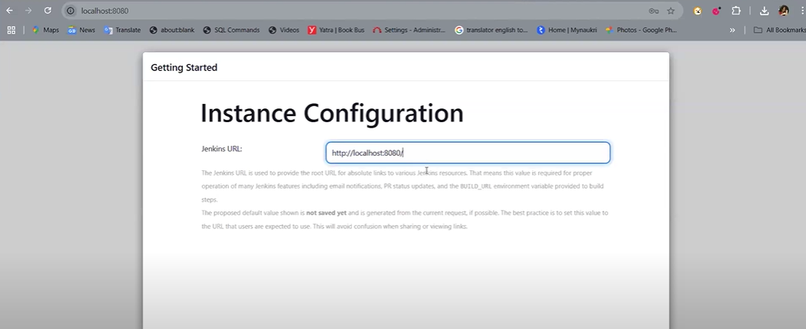

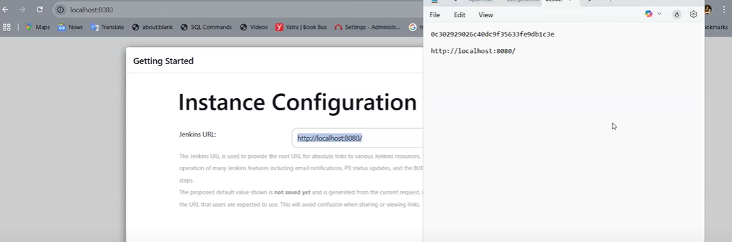

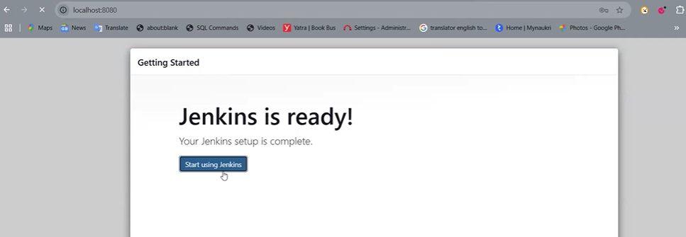

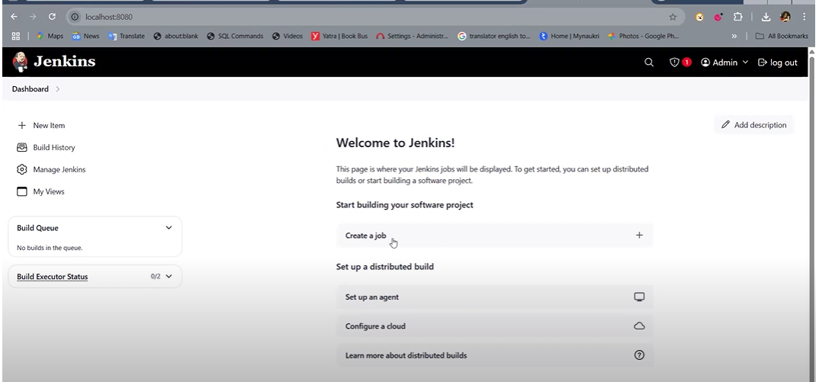

**Create a Jenkin Job :**

Install JDK before creating the new jobs/

Go to Manage Jenkins ---> Tools --->

Add JDK ---> JAVA_HOME ---> give the Java Home Path

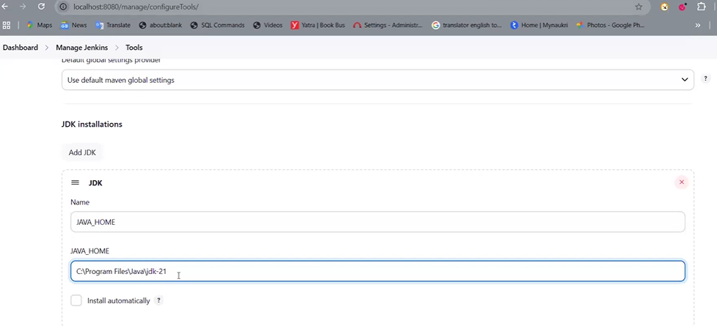

Maven Path :

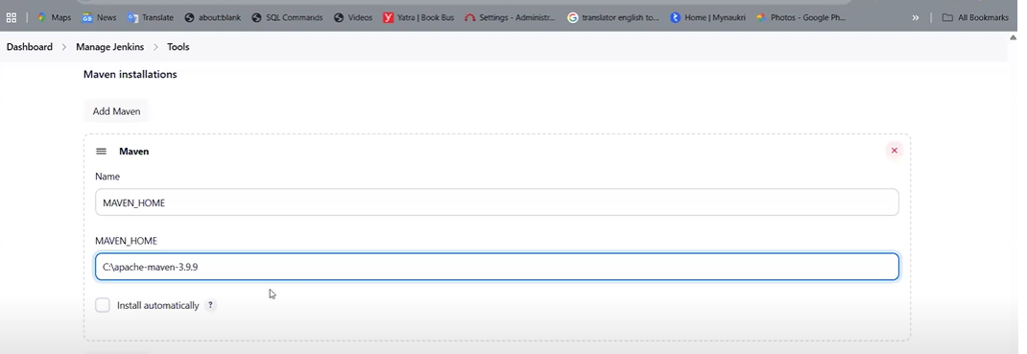

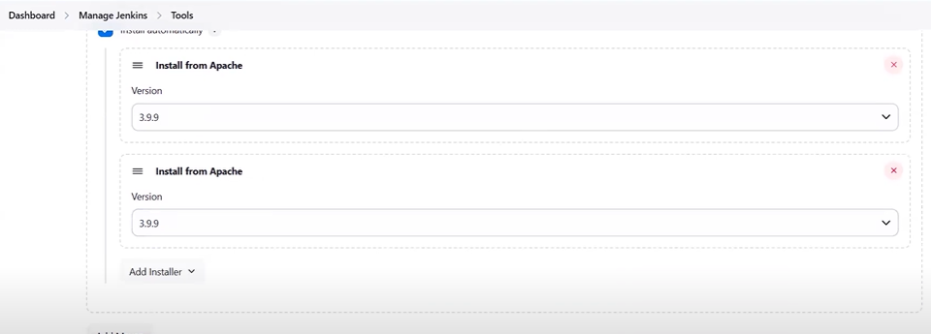

Apply and Save.

Go back to Dashbord,

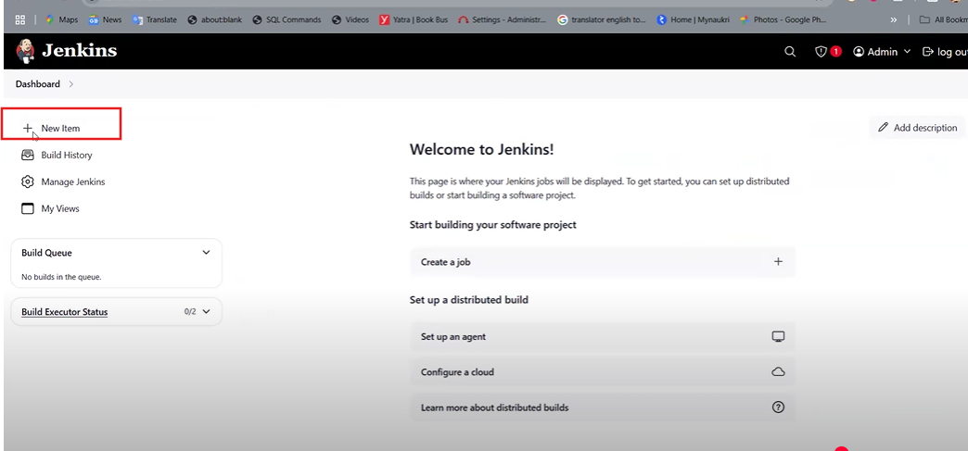

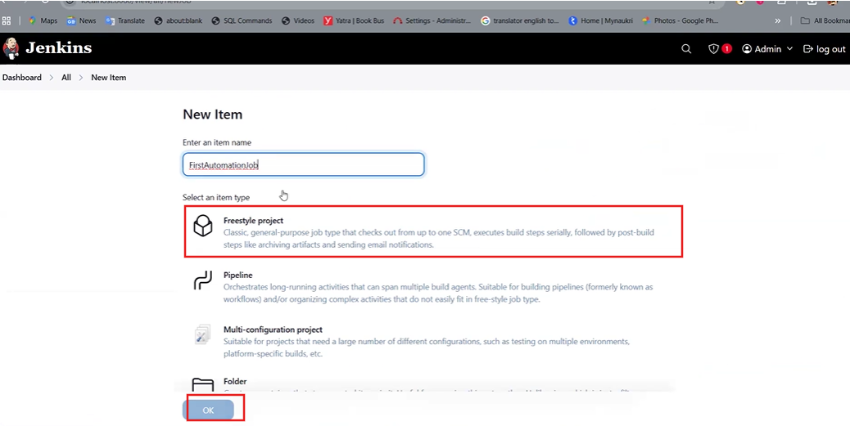

Enter Description,

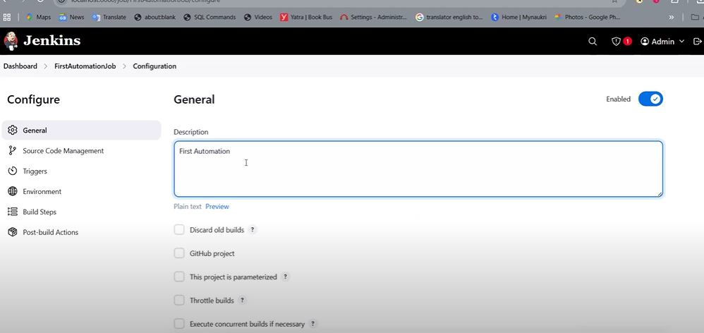

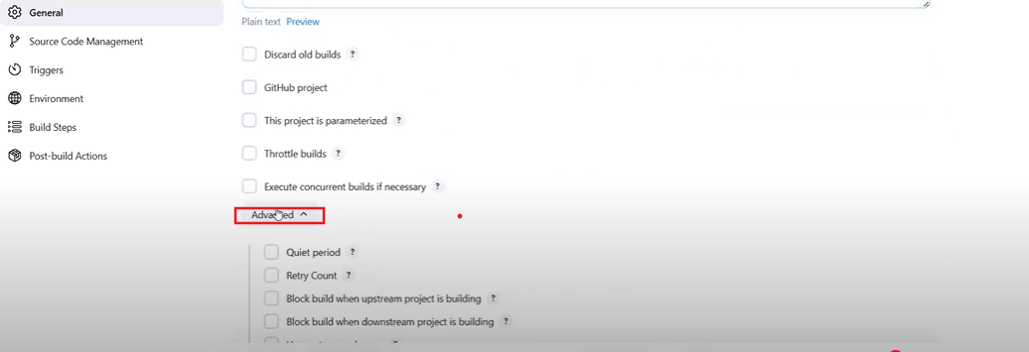

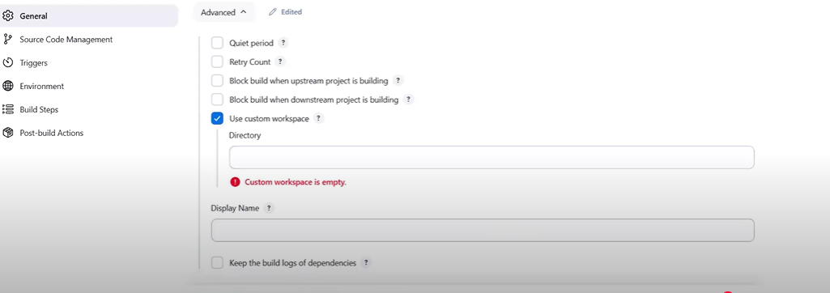

Select ‘Use custome Workplace”,

Provide the project path.

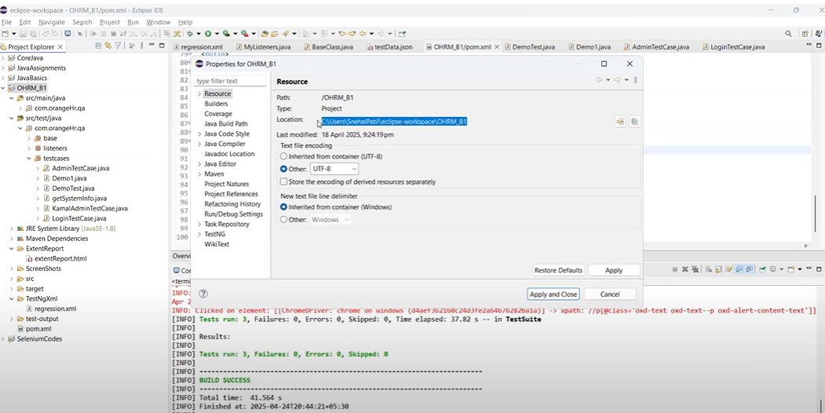

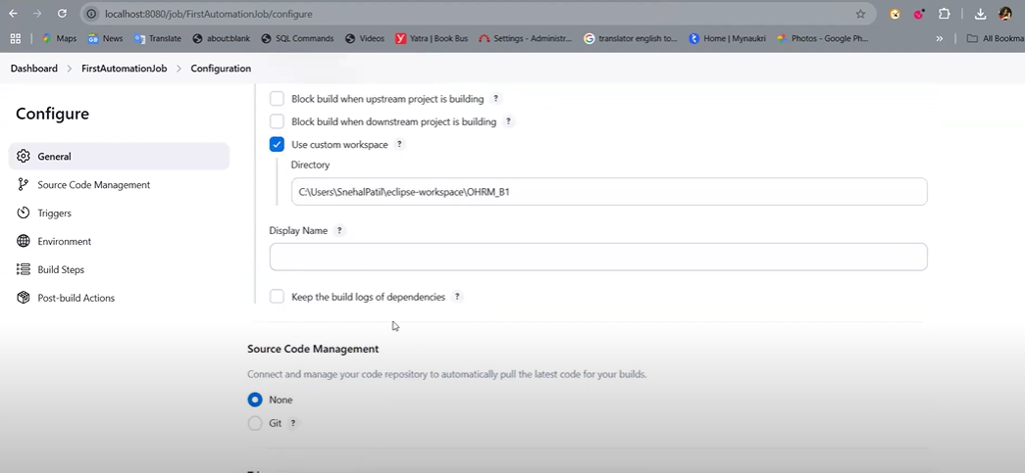

Build Steps -

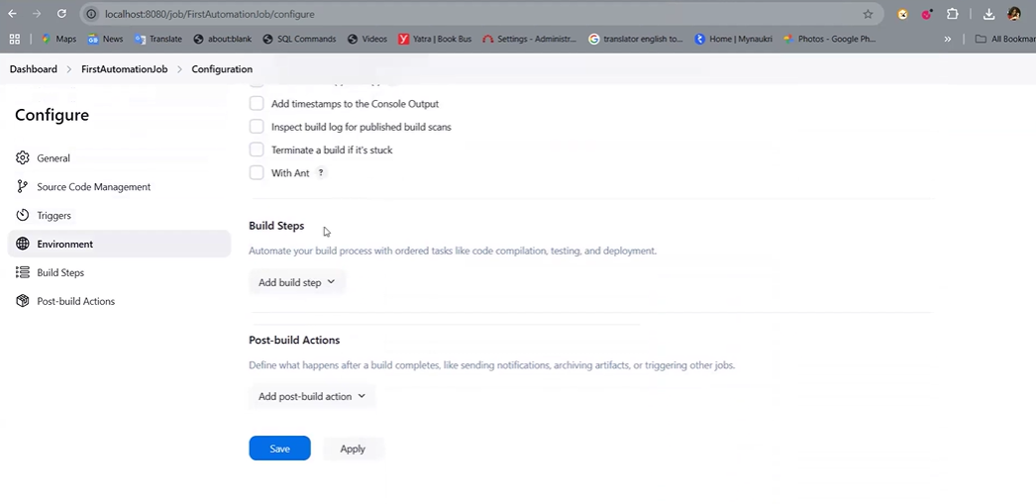

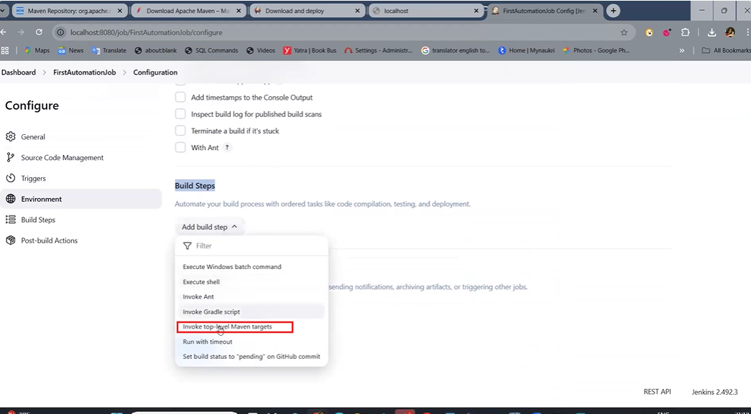

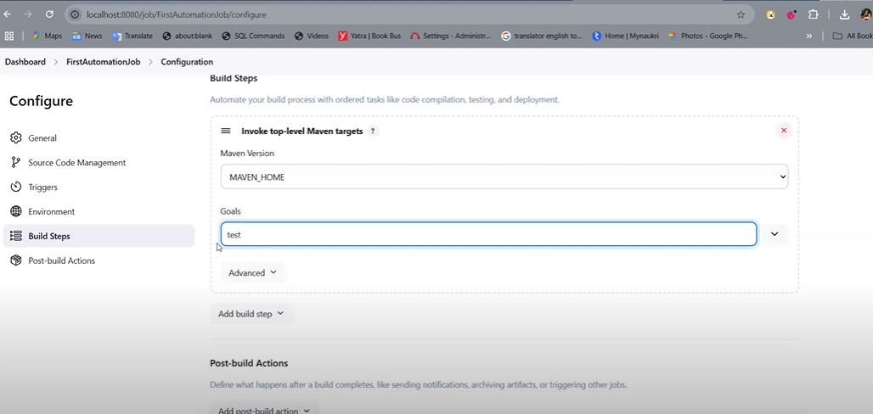

Apply & Save.

Go to Dashboard.   
We can click on Play button to run the automation scripts.

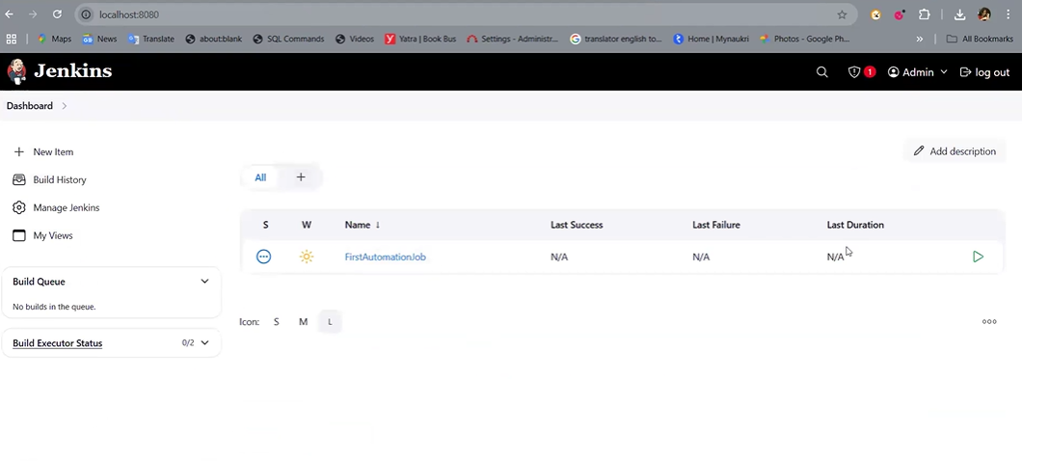

Plugins:

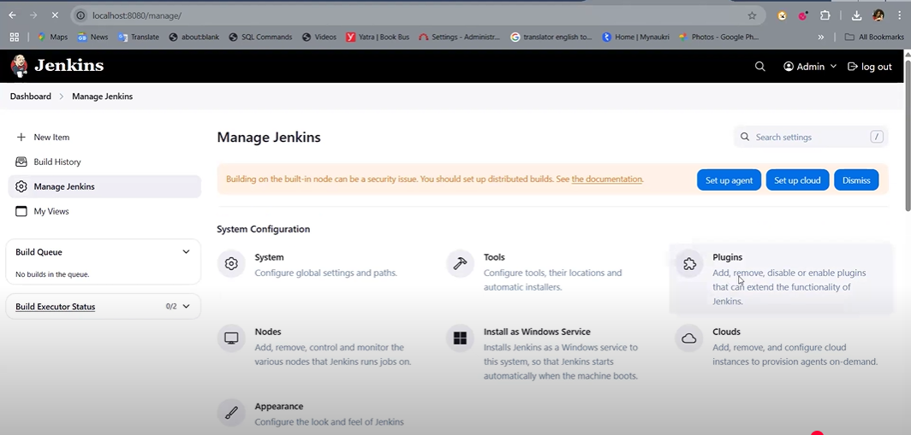

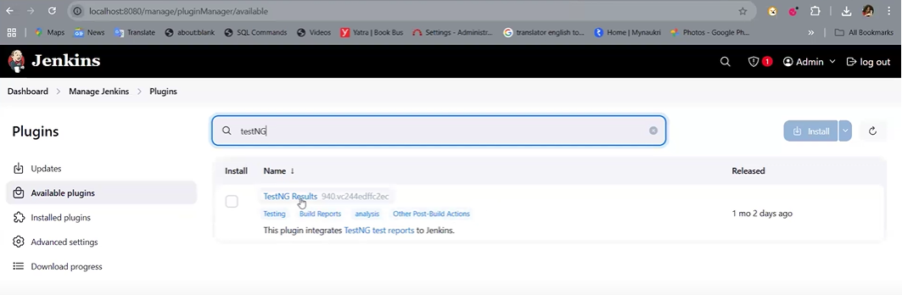

We can click on ‘Build Now’ to run the Automation scripts.

**Configure Reports:**

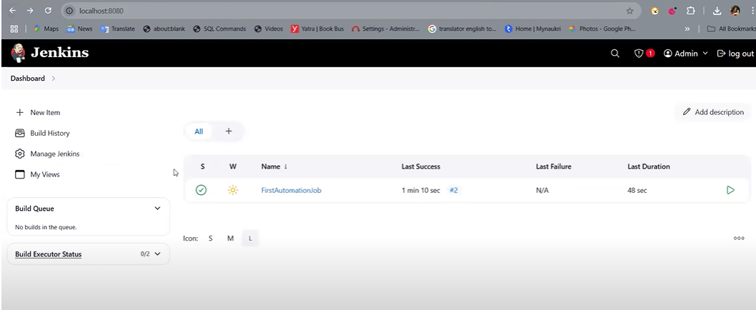

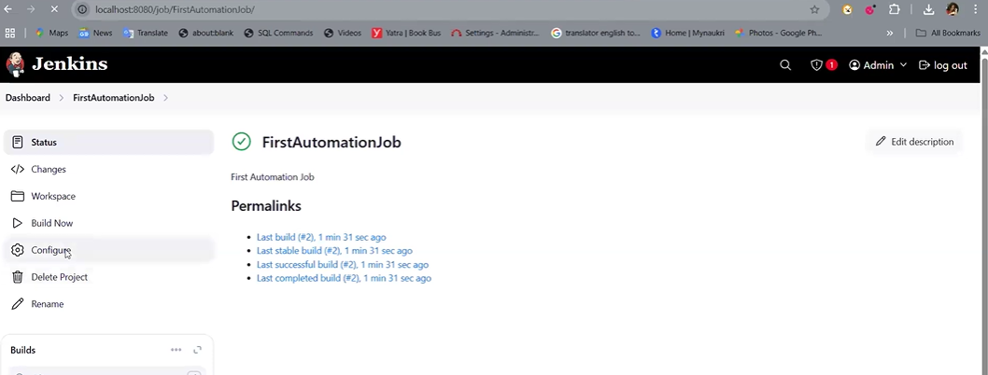

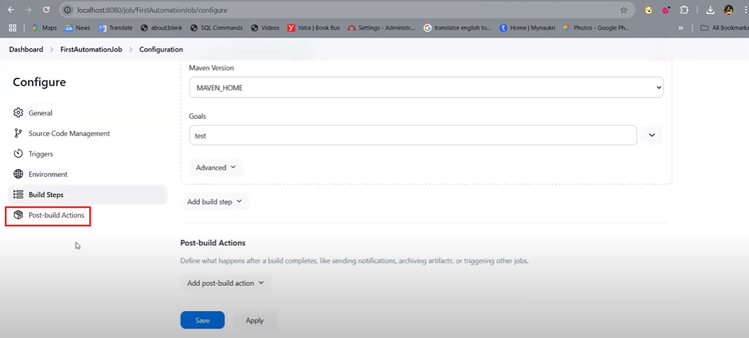

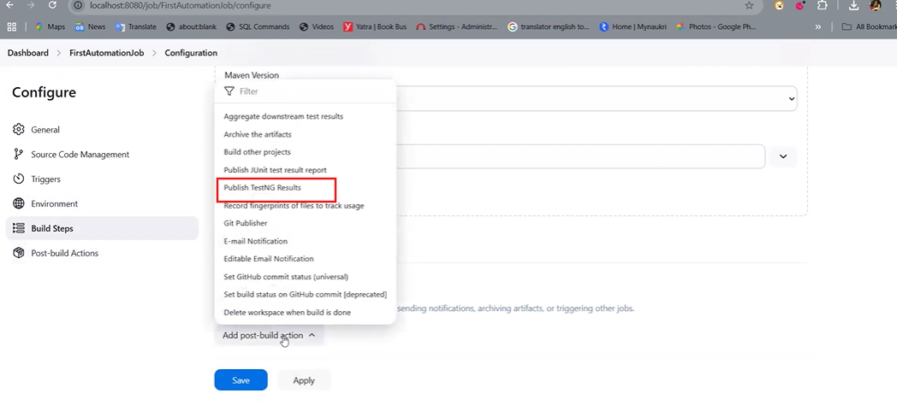

Apply and save.

